Supplementary Data
Control
Control
Control
Control
PF-543
DPF-543

SPTLC1 53 kDa
CerS4 45kDa
CerS6 45kDa
b-actin

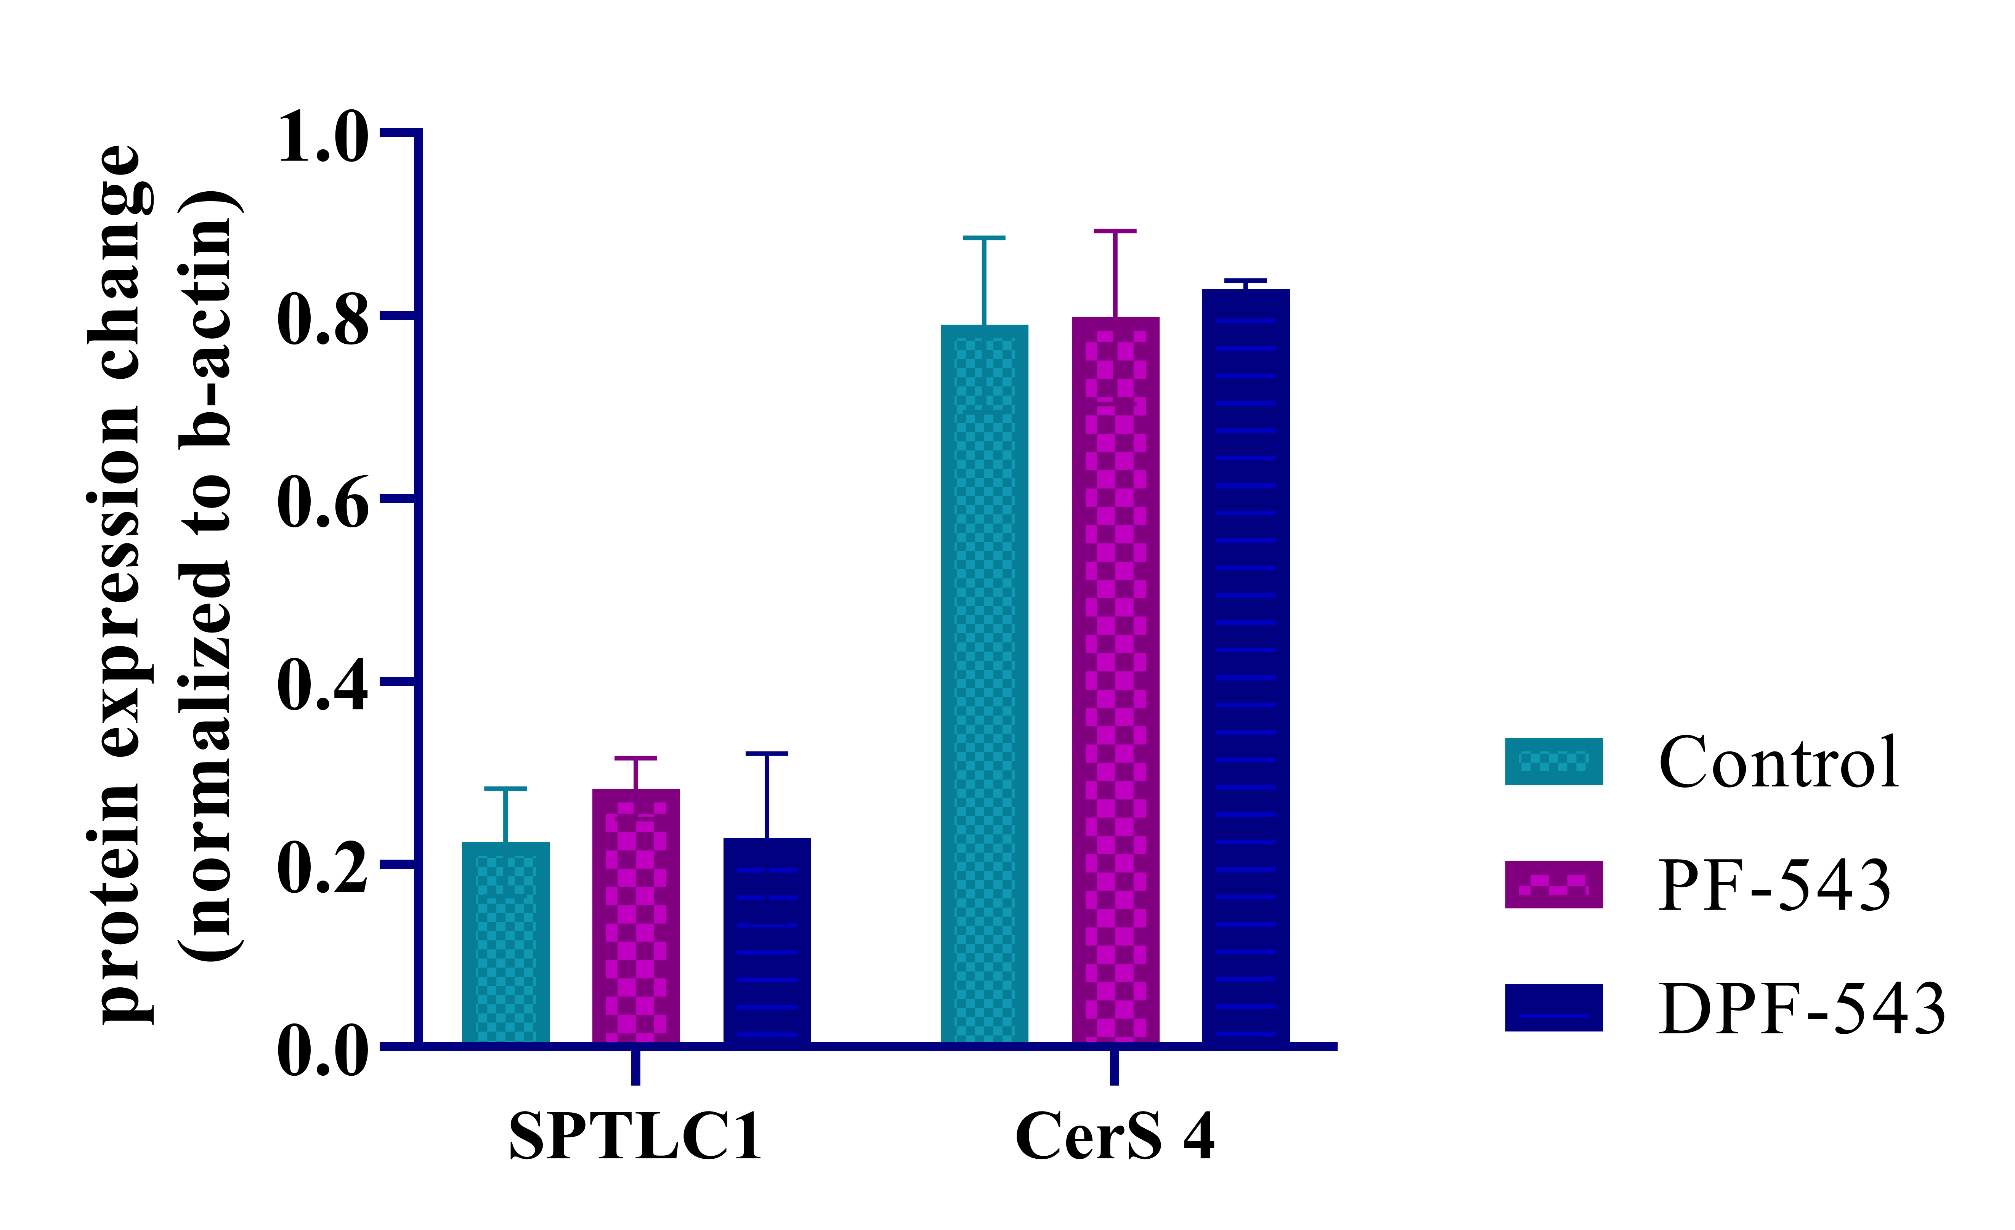
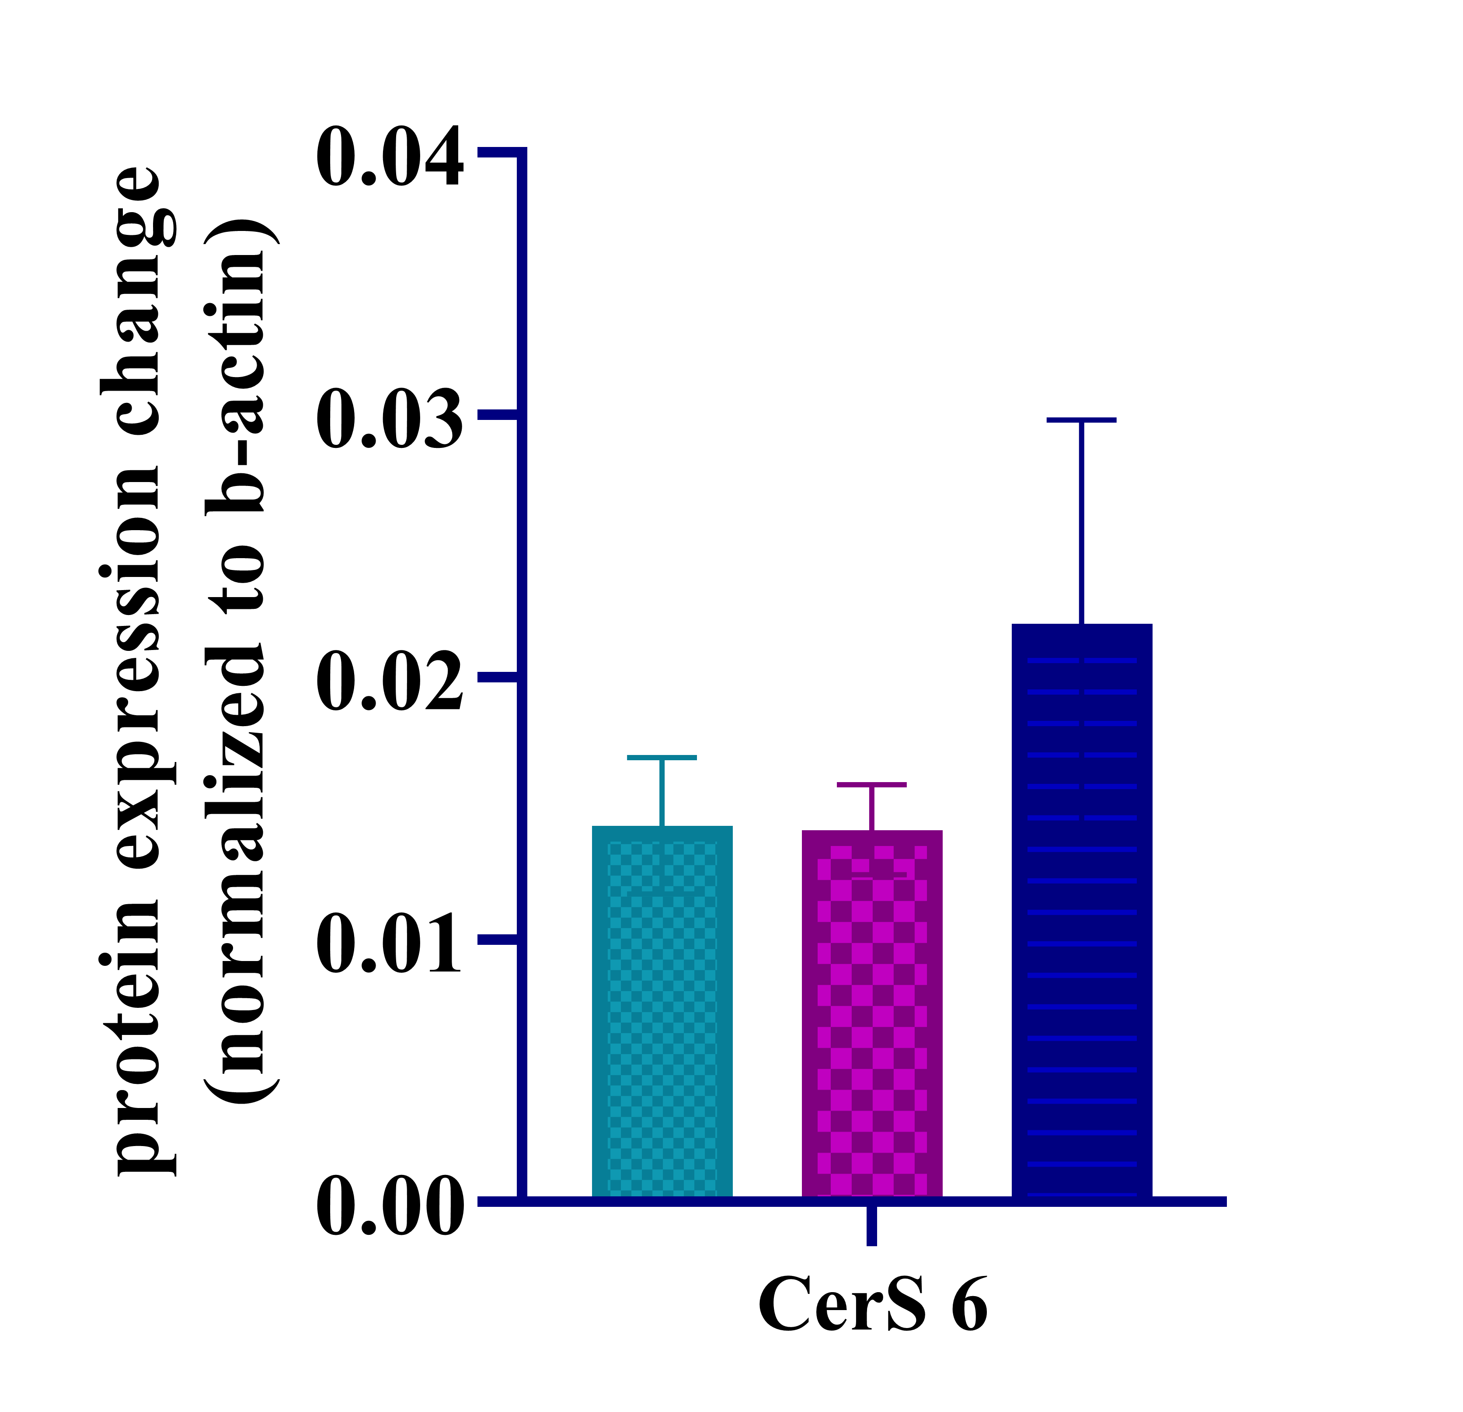
Fig. S1

Table S1. QTRAP 4500 mass spectrometer setting for C18:1 Ceramide analysis
ID | Q1 (Da) | Q3 (Da) | Dwell time (ms) | DP(volts) | EP(volts) | CE(volts) | CXP(volts)
Cer 16:0 | 538.3 | 264.3 | 50 | 40 | 5 | 35 | 15
Cer 17:0 | 552.2 | 264.3 | 50 | 50 | 5 | 35 | 8
Cer 18:1 | 564.3 | 264.3 | 50 | 50 | 5 | 35 | 15
Cer 18:0 | 566.3 | 264.3 | 50 | 50 | 5.5 | 35 | 10
Cer 20:0 | 594.3 | 264.3 | 50 | 55 | 5 | 35 | 15
Cer 24:1 | 648.4 | 264.3 | 50 | 55 | 6.25 | 35 | 15
Cer 24:0 | 650.4 | 264.3 | 50 | 55 | 6.25 | 35 | 15

Table S2. QTRAP 4500 mass spectrometer setting for C17-DHCer and C17-Cer analysis
ID | Q1 (Da) | Q3 (Da) | Dwell time (ms) | DP(volts) | EP(volts) | CE(volts) | CXP(volts)
Cer 16:0 | 524.3 | 250.3 | 50 | 40 | 5 | 35 | 15
Cer 17:0 | 552.2 | 264.3 | 50 | 50 | 5 | 35 | 8
Cer 18:1 | 550.4 | 250.3 | 50 | 50 | 5 | 35 | 15
Cer 18:0 | 552.4 | 250.3 | 50 | 50 | 5.5 | 35 | 10
Cer 20:0 | 580.4 | 250.3 | 50 | 55 | 5 | 35 | 15
Cer 22:0 | 608.6 | 250.3 | 50 | 55 | 5 | 35 | 15
Cer 24:1 | 634.4 | 250.3 | 50 | 55 | 6.25 | 35 | 15
Cer 24:0 | 636.4 | 250.3 | 50 | 55 | 6.25 | 35 | 15
DHCer 16:0 | 526.4 | 252.3 | 50 | 50 | 5.5 | 35 | 15
DHCer 18:1 | 550.4 | 252.3 | 50 | 50 | 5 | 35 | 14
DHCer 18:0 | 552.4 | 252.3 | 50 | 50 | 5 | 35 | 16
DHCer 20:0 | 582.4 | 252.3 | 50 | 50 | 5 | 35 | 15
DHCer 22:0 | 610.6 | 252.3 | 50 | 50 | 5 | 35 | 15
DHCer 24:1 | 636.4 | 252.3 | 50 | 50 | 6.5 | 35 | 15
DHCer 24:0 | 638.4 | 252.3 | 50 | 50 | 6.5 | 35 | 15

Table S3. QTRAP 4500 mass spectrometer setting for labeled and endogenous sphingolipid analysis

ID | Q1 (Da) | Q3 (Da) | Dwell time (ms) | DP(volts) | EP(volts) | CE(volts) | CXP(volts)
KDS-D2 | 302.2 | 272.3 | 150 | 35 | 5 | 35 | 15
SPA-D2 | 304.3 | 286.3 | 150 | 35 | 5 | 35 | 15
KDS | 300.2 | 270.3 | 150 | 35 | 5 | 35 | 15
SPA | 302.3 | 284.3 | 150 | 35 | 5 | 35 | 15
SPH | 300.3 | 282.3 | 150 | 35 | 5 | 35 | 15
C17-SPH | 286.3 | 268.3 | 150 | 35 | 5 | 35 | 15

Table S4. C17-DHCer conversion rate to C17-Cer in percentage
Groups/  Ceramides | C16:0 | C18:1 | C18:0 | C20:0 | C22:0 | C24:1 | C24:0
Control | 0.78 | 0.018 | 0.47 | 7.7 | 53.1 | 43.8 | 27.5
PF-543 | 1.92 | 0.018 | 1.30 | 22 | 110.2 | 40.5 | 21.3
DPF-543 | 1.84 | 0.019 | 1.02 | 19.6 | 268.3 | 78.5 | 14.9

