Supplementary Data for
Cytotoxic and cytostatic potential of bioactive secondary metabolites from Aspergillus flavus, an endophytic fungus isolated from Cynodon dactylon against breast cancer: in vitro and in silico studies
Arjun Kumar Kalimuthu¹, Pavadai Parasuraman², Theivendren Panneerselvam³, Ewa Babkiewicz⁴, Joanna Pijanowska⁴, Piotr Mrowka^{5,6}, Gopalan Rajagopal⁷, Venkataraman Deepak^{1,8}, Krishnan Sundar^{1*}, Piotr Maszczyk⁴*, Selvaraj Kunjiappan^{1*}
¹Department of Biotechnology, Kalasalingam Academy of Research and Education, Krishnankoil-626126, India.
²Department of Pharmaceutical Chemistry, Faculty of Pharmacy, M.S. Ramaiah University of Applied Sciences, Bengaluru-560054, India.
³Department of Pharmaceutical Chemistry, Swamy Vivekanandha College of Pharmacy, Elayampalayam-637205, India.
⁴Department of Hydrobiology, Faculty of Biology, University of Warsaw at Biology and Chemistry Research Center, 02-089 Warsaw, Poland.
⁵Department of Biophysics, Physiology and Pathophysiology, Medical University of Warsaw, 5 Chalubinskiego Street, 02-004 Warsaw, Poland.
⁶Department of Experimental Hematology, Institute of Hematology and Transfusion Medicine, 5 Chocimska Street, 00-791 Warsaw, Poland.
⁷Postgraduate and Research Department of Zoology, Ayya Nadar Janaki Ammal College, Sivakasi-626123, India.
⁸Maternal and Fetal Health Research Centre, 5th Floor St. Mary's Hospital, University of Manchester, Oxford Road Manchester, M13 9WL, United Kingdom.
*Correspondence address:
Krishnan Sundar: sundarkr@klu.ac.in; Ph: +91 9486953248
Piotr Maszczyk: fizbanek@wp.pl; Ph: +48 22 55 26568
Selvaraj Kunjiappan; selvapharmabio@gmail.com; Ph: +91 9994972108

This MS word file includes:
Supplementary Tables S1 to S2.

Table S1: MTT assay
Conc | control | 3.125 | 6.25 | 12.5 | 25 | 50 | 100 | Dox 0.25 μM
 | 100 | 85.12 | 64.84 | 53.19 | 47.45 | 38.24 | 28.09 | 45
 |  | 86.49 | 64.04 | 52.66 | 47.45 | 38.24 | 26.49 | 43.67
 |  | 87.29 | 60.85 | 53.99 | 48.24 | 39.31 | 26.22 | 43.14

Group Name | N | Missing | Mean | Std Dev | SEM
 |  |  | 100 | 0 | 0
Col 1 | 3 | 0 | 86.3 | 1.097 | 0.634
Col 2 | 3 | 0 | 63.243 | 2.111 | 1.219
Col 3 | 3 | 0 | 53.28 | 0.67 | 0.387
Col 4 | 3 | 0 | 47.713 | 0.456 | 0.263
Col 5 | 3 | 0 | 38.597 | 0.618 | 0.357
Col 6 | 3 | 0 | 26.933 | 1.011 | 0.584
Col 7 | 3 | 0 | 43.937 | 0.958 | 0.553
Source of Variation | DF | SS | MS | F | P
Between Groups | 6 | 6580.917 | 1096.82 | 888.816 | <0.001
Residual | 14 | 17.276 | 1.234
Total | 20 | 6598.193

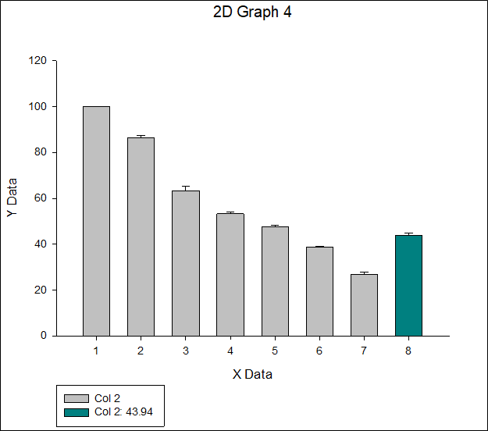

Table S2: ROS generation assay
 |  |  | ctrl | 24 | 48
 |  |  | 21.34 | 55.63 | 72.87
 |  |  | 20.56 | 54.34 | 73.38
 |  |  | 22.71 | 56.58 | 71.41
Group Name | N | Missing | Mean | Std Dev | SEM
Col 2 | 3 | 0 | 21.537 | 1.088 | 0.628
Col 3 | 3 | 0 | 55.517 | 1.124 | 0.649
Col 4 | 3 | 0 | 72.553 | 1.022 | 0.59
Source of Variation | DF | SS | MS | F | P
Between Groups | 2 | 4047.589 | 2023.794 | 1737.61 | <0.001
Residual | 6 | 6.988 | 1.165
Total | 8 | 4054.577

