Research Article
Molecular Characterization and Prevalence of Antimicrobial Resistant Escherichia coli Isolates Derived from Clinical Specimens and Environmental Habitats
Chrysoula Dioli¹, Olga Pappa¹, Eirini Siatravani^{1, 2}, Spyridoula Bratakou¹, Apostolos Tatsiopoulos³, Panagiota Giakkoupi⁴, Vivi Miriagou², Apostolos Beloukas^{1,}*
¹ Molecular Microbiology and Immunology laboratory, Department of Biomedical Sciences, University of West Attica, 28 Ag. Spyridonos str 12243 Athens, Attica, Greece; CD: cdioli@uniwa.gr; OP: opappa@uniwa.gr; ES: esiatravani@uniwa.gr; SB: spbrat@uniwa.gr; AB: abeloukas@uniwa.gr
Citation: To be added by editorial staff during production.
Academic Editor: Firstname Lastname
Received: date
Revised: date
Accepted: date
Published: date

Copyright: © 2023 by the authors. Submitted for possible open access publication under the terms and conditions of the Creative Commons Attribution (CC BY) license (https://creativecommons.org/licenses/by/4.0/).

Citation: To be added by editorial staff during production.
Academic Editor: Firstname Lastname
Received: date
Revised: date
Accepted: date
Published: date
Copyright: © 2023 by the authors. Submitted for possible open access publication under the terms and conditions of the Creative Commons Attribution (CC BY) license (https://creativecommons.org/licenses/by/4.0/).

² Hellenic Pasteur Institute, Laboratory of Bacteriology, 127 Vasilissis Sofias Avenue 11521, Athens, Greece; VM: miriagou@pasteur.gr
³ Microbiology Laboratory, General Hospital of Livadeia, Agiou Vlasiou, 32100, Livadia, Viotia, Greece; AT: apotatsiop@yahoo.com
Citation: To be added by editorial staff during production.
Academic Editor: Firstname Lastname
Received: date
Revised: date
Accepted: date
Published: date
Copyright: © 2023 by the authors. Submitted for possible open access publication under the terms and conditions of the Creative Commons Attribution (CC BY) license (https://creativecommons.org/licenses/by/4.0/).

⁴ Department of Public Health Policy, School of Public Health University of West Attica, 196 Alexandras Avenue, 11521 Athens, Greece; PG: pgiakkoupi@uniwa.gr
* Correspondence: abeloukas@uniwa.gr, orcid ID: 0000-0001-5639-0528 Apostolos Beloukas, PhD, Associate Professor in Molecular Microbiology and Virology Head of the Molecular Microbiology and Immunology Laboratory, Department of Biomedical Sciences, University of West Attica, Postal address: 28 Ag. Spyridonos str 12243 Athens, Attica, Greece

SUPPLEMENTARY MATERIAL
Supplementary Table S1: The E. coli isolates from environmental habitats and clinical specimens that exhibit multidrug resistance.
Supplementary Table S2: Observed patterns of R isolates (RP, resistant patterns).
Supplementary Table S3: Characteristics of environmental and clinical isolates harboring β-lactamase genes.
Supplementary Table S4: Sequencing results for the possible β-lactamase producers.
Supplementary Table S5a: Examination of the relationship between phylogenetic groups and origin of the sample; Sample and Group Crosstabulation.
Supplementary Table S5b: Examination of the relationship between phylogenetic groups and origin of the sample; Pearson's chi-square test results.
Supplementary Table S6a: Examination of the relationship between phylogenetic groups and resistance profile; Resistance profile and Group Crosstabulation.
Supplementary Table S6b: Examination of the relationship between phylogenetic groups and resistance profile; Pearson's chi-square test results.
Supplementary Figure S1: PFGE analysis; Diverse PFGE patterns of E. coli isolated from clinical and environmental samples.
Supplementary Figure S2: Maximum Likelihood phylogenetic trees for A) bla_{CTX-M-groups}, B) bla_{TEM} and C) bla_{SHV} nucleotide sequences

Supplementary Table S1. The E. coli isolates from environmental habitats and clinical specimens that exhibit multidrug resistance
Number of different antibiotic categories in which environmental MDR isolates presented resistance | Number of environmental isolates obtained from each sample source
 | HWW | WWTP effluents |  | RWS1 | RWS2 |  | Total
4 antibiotic categories | 5 | 8 |  | 16 | 6 |  | 35
5 antibiotic categories | 8 | 20 |  | 8 | 4 |  | 40
6 antibiotic categories | 10 |  |  | 3 |  |  | 13
7 antibiotic categories | 13 |  |  |  | 1 |  | 14
Total MDR | 36 | 28 |  | 27 | 11 |  | 102
Number of different antibiotic categories in which clinical MDR isolates presented resistance | Number of clinical isolates per specimen type
 | Urine |  | Blood |  |  | Tissue | Total
4 antibiotic categories | 2 |  | 1 |  |  |  | 3
5 antibiotic categories | 5 |  | 1 |  |  |  | 6
6 antibiotic categories | 5 |  | 1 |  |  | 1 | 7
7 antibiotic categories | 2 |  | 1 |  |  |  | 3
Total MDR | 14 |  | 4 |  |  | 1 | 19
Abbreviations: MDR, Multi-drug resistant; HWW, hospital wastewater; WWTP, wastewater treatment plant; RWS1, river water site 1; RWS2, river water site 2.

‍Supplementary Table S2: Observed patterns of R isolates (RP, resistant patterns)
 |  |  | Environmental isolates (source) | Clinical Isolates | Total
RP1: Related to ESBL production |  | PEN/ ESCs | 4 (2 RWS1, 2 RWS2) | - | 4
 |  | PEN/ ESCs/ ATM | - | 2 | 2
RP2: Related to Ampc β-lactamases production |  | PEN/ PEN.-inhibitor/ FOX | - | 1 | 1
RP3a |  | PEN/ PEN-inhibitor | 56 (30 WWTP, 18 RWS1, 8 RWS2) | 19 | 75
RP3b |  | PEN/ PEN-inhibitor + SXT | 20 (3 HWW, 8 WWTP, 5 RWS1, 4 RWS2) | 1 | 21
RP3c |  | PEN/ PEN-inhibitor + AMG | 4 (3 WWTP, 1 RWS1) | 2 | 6
RP3d |  | PEN/ PEN-inhibitor + QNs | 18 (2 HWW, 9 WWTP, 3 RWS1, 4 RWS2) | - | 18
RP4a |  | PEN | 33 (13 WWTP, 18 RWS1, 2 RWS2) | 8 | 41
RP4b |  | PEN + SXT | 14 (2 WWTP, 10 RWS1, 2 RWS2) | 4 | 18
RP4c |  | PEN + SXT+ QNs | 11 (3 WWTP, 8 RWS1) | - | 11
RP4d |  | PEN + QNs | 10 (3 WWTP, 5 RWS1, 2 RWS2) | - | 10
RP4e |  | PEN + AMG + QNs | - | 1 | 1
RP4f |  | PEN + AMG | 5 (1 WWTP, 2 RWS1, 2 RWS2) | 1 | 5
RP4g |  | PEN + SXT + AMG | - | 3 | 3
RP5 | Resistant only to  non β-lactam antibiotics | QNs | 5 (3 HWW, 2 WWTP) | 15 | 20
RP6 | Resistant only to  non β-lactam antibiotics | SXT | - | 4 | 4
RP6a | Resistant only to  non β-lactam antibiotics | SXT + QNs | 3 (2 RWS1, 1 RWS2) | 3 | 7
Abbreviations: RP, resistant patterns; ESBL, extended-spectrum-β-lactamase; PEN, penicillins; ESCs, extended-spectrum cephalosporins; ATM, aztreonam; PEN.-inhibitor, penicillin-inhibitor combination; FOX, cefoxitin; SXT, sulfamethoxazole-trimethoprim; AMG, aminoglycosides; QNs, quinolones; HWW, hospital wastewater; WWTP, wastewater treatment plant; RWS1, river water site 1; RWS2, river water site 2.

Supplementary Table S3. Characteristics of environmental and clinical isolates harboring β-lactamse genes
Isolate ID | Type of Sample/ Sampling site | Phylogenetic group | Resistance Pattern | Resistance Profile | DDST | β-lactamases
297 | Treated Wastewater/ WWTP outlet | A | AMP, AMC, PIP, CAZ, CRO, ATM, AN | MDR | + | SHV
326 | Treated Wastewater/ WWTP outlet | B2 | AMP, PIP, MEM, IMP | R |  | TEM
344 | HWW/ septic tank | A | AMP, PIP, CXM, CAZ, CTX, FEP, CRO, ATM, CIP, NAL | MDR | + | SHV
345 | HWW/ septic tank | A | AMP, PIP, CAZ, CTX, CRO, ATM, NAL | MDR | + | SHV
367 | River water/ RWS1 | A | AMP, AMC, TZP, PIP, CXM, CAZ, CTX, FEP, FOX, CRO, ATM, MEM, IMP | MDR | - | -
405 | River water/ RWS1 | D | AMP, AMC, PIP, CXM, CTX, CRO, ATM, CIP, NAL | MDR | + | CTX-M group 1
408 | River water/ RWS1 | D | AMP, AMC, TZP, PIP, TCC, CXM, CAZ, CTX, FEP, CRO, ATM, MEM, SXT | MDR | + | CTX-M group 1, OXA-48
426 | HWW/ septic tank | D | AMP, AMC, PIP, CXM, CAZ, CTX, CRO, ATM, CIP, NAL | MDR | + | SHV
427 | HWW/ septic tank | B2 | AMP, AMC, PIP, CXM, CAZ, CTX, CRO, ATM, AN, CIP, NAL | MDR | + | SHV
431 | HWW/ septic tank | B2 | AMP, PIP, CXM, CAZ, CTX, CRO, ATM, AN, CIP, NAL | MDR | + | SHV
434 | HWW/ septic tank | B2 | AMP, AMC, PIP, CAZ, CTX, CRO, ATM, CIP, NAL | MDR | + | SHV
436 | HWW/ septic tank | B2 | AMP, AMC, PIP, CXM, CAZ, CTX, CRO, ATM, AN, CIP, NAL | MDR | + | SHV
472 | River water/ RWS1 | A | AMP, AMC, PIP, CXM, CTX, CRO, ATM, NAL | MDR | + | CTX-M group 9, TEM
477 | River water/ RWS1 | B1 | AMP, PIP, CXM, CAZ, CRO, ATM, CIP, NAL | MDR | + | SHV
491 | Treated Wastewater/ WWTP outlet | A | AMP, AMC, PIP, CXM, CTX, CRO, FEP, ATM, NAL | MDR | + | CTX-M group 1
494 | Treated Wastewater/ WWTP outlet | B1 | AMP, AMC, PIP, CXM, CTX, CRO, SXT | MDR | + | TEM
497 | Treated Wastewater/ WWTP outlet | A | AMP, AMC, PIP, CXM, CAZ, CTX, FEP, CRO, ATM, NAL | MDR | + | CTX-M group 1
506 | Treated Wastewater/ WWTP outlet | D | AMP, PIP, CXM, CAZ, CTX, FEP, ATM, SXT, NAL | MDR | + | CTX-M group 1
510 | Treated Wastewater/ WWTP outlet | B2 | AMP, PIP, CXM, CTX, CRO, SXT, CIP, NAL | MDR | + | -
546 | HWW/ septic tank | B2 | AMP, AMC, PIP, CXM, CAZ, CTX, CRO, ATM, NAL | MDR | + | SHV
550 | HWW/ septic tank | A | AMP, AMC, TZP, PIP, CXM, FOX, FEP, GM, SXT, CIP, NAL | MDR | - | -
553 | HWW/ septic tank | A | AMP, AMC, PIP, CXM, CTX, CRO, ATM, SXT, CIP, NAL | MDR | + | CTX-M group 1
555 | HWW/ septic tank | A | AMP, AMC, PIP, CXM, CAZ, CTX, FEP, CRO, ATM, GM, SXT, CIP, NAL | MDR | + | CTX-M group 1
556 | HWW/ septic tank | A | AMP, PIP, CXM, CAZ, CTX, FEP, CRO, ATM, CIP, NAL | MDR | + | SHV
557 | HWW/ septic tank | A | AMP, AMC, PIP, CXM, CTX, FEP, CRO, ATM, GN, SXT, CIP, NAL | MDR | + | CTX-M group 1, TEM, SHV
581 | HWW/ septic tank | A | AMP, AMC, TZP, PIP, CXM, FOX, FEP, GM, SXT, NAL, CIP | MDR | - | FOX
594 | River water/ RWS1 | B1 | AMP, PIP, CXM, CAZ, CTX, CRO, ATM, CIP, NAL | MDR | + | SHV
595 | River water/ RWS1 | B2 | AMP, PIP, CXM, CAZ, CTX, FEP, CRO, ATM | MDR | + | CTX-M group 1
598 | River water/ RWS1 | D | AMP, PIP, CXM, CAZ, CTX, FEP, CRO, ATM, GN, SXT, NAL | MDR | + | CTX-M group 1
601 | River water/ RWS1 | A | AMP, PIP, CXM, CAZ, CTX, FEP, CRO | R | + | CTX-M group 9
602 | River water/ RWS1 | A | AMP, PIP, CXM, CAZ, CRO, ATM | MDR | + | -
610 | River water/ RWS1 | D | AMP, PIP, CXM, CAZ, CTX, FEP, CRO, ATM, GN, SXT, NAL | MDR | + | CTX-M group 1
611 | River water/ RWS1 | A | AMP, PIP, CXM, CTX, FEP, CRO | R | + | CTX-M group 9
614 | River water/ RWS2 | A | AMP, PIP, CXM, CTX, FEP, CRO | R | + | CTX-M group 9
616 | River water/ RWS2 | A | AMP, PIP, CXM, CTX, FEP, CRO | R | + | CTX-M group 9
618 | River water/ RWS2 | A | AMP, AMC, PIP, CXM, CAZ, CTX, FEP, CRO, ATM | MDR | + | CTX-M group 9
620 | River water/ RWS2 | A | AMP, PIP, CXM, CTX, FEP, CRO, ATM, AN | MDR | + | -
630 | River water/ RWS2 | A | AMP, AMC, PIP, CXM, CTX, FEP, CRO, ATM, AN | MDR | + | -
638 | Treated Wastewater/ WWTP outlet | D | AMP, PIP, CXM, CAZ, CTX, FEP, CRO, ATM, SXT, NAL | MDR | + | CTX-M group 1
645 | Treated Wastewater/ WWTP outlet | D | AMP, AMC, PIP, CXM, CAZ, CTX, FEP, CRO, ATM, NAL | MDR | + | CTX-M group 1
673 | HWW/ septic tank | A | AMP, PIP, CAZ, CRO, ATM, NAL | MDR | + | SHV
678 | HWW/ septic tank | A | AMP, AMC, PIP, CXM, CAZ, CTX, FEP, CRO, ATM, GN, SXT, CIP, NAL | MDR | + | CTX-M group 1
681 | HWW/ septic tank | A | AMP, PIP, CXM, CTX, FEP, CRO, ATM, GN, SXT, CIP, NAL | MDR | + | CTX-M group 1
682 | HWW/ septic tank | A | AMP, AMC, PIP, CXM, CAZ, CTX, FEP, CRO, ATM, GN, SXT, CIP, NAL | MDR | + | CTX-M group 1
683 | HWW/ septic tank | A | AMP, AMC, PIP, CXM, CAZ, CTX, FEP, CRO, ATM, GN, SXT, CIP, NAL | MDR | + | CTX-M group 1
738 | River water/ RWS1 | B2 | AMP, AMC, TZP, PIP, CXM, FOX, CAZ, GM, AN | MDR | - | TEM
739 | River water/ RWS1 | A | AMP, PIP, CXM, CAZ, CTX, CRO, ATM, CIP, NAL | MDR | + | SHV
740 | River water/ RWS1 | A | AMP, PIP, CXM, CAZ, CTX, FEP, CRO, ATM, SXT | MDR | + | CTX-M group 1
748 | River water/ RWS1 | D | AMP, AMC, PIP, CXM, CAZ, CTX, FEP, CRO, ATM, NAL | MDR | + | CTX-M group 1
785 | River water/ RWS2 | D | AMP, AMC, PIP, CXM, CAZ, CTX, FEP, CRO, ATM, IMP, SXT, NAL | MDR | + | CTX-M group 1
791 | River water/ RWS2 | D | AMP, PIP, CXM, CAZ, CTX, FEP, CRO, ATM, CIP, NAL | MDR | + | CTX-M group 1
792 | Treated Wastewater/ WWTP outlet | A | AMP, PIP, CXM, CAZ, CTX, FEP, CRO, ATM, SXT | MDR | + | CTX-M group 1
801 | Treated Wastewater/ WWTP outlet | A | AMP, PIP, CXM, CAZ, CTX, FEP, CRO, ATM, SXT | MDR | + | CTX-M group 1
802 | Treated Wastewater/ WWTP outlet | A | AMP, PIP, CXM, CAZ, CTX, FEP, CRO, ATM, SXT | MDR | + | CTX-M group 1
803 | Treated Wastewater/ WWTP outlet | A | AMP, PIP, CXM, CAZ, CTX, FEP, CRO, ATM, SXT | MDR | + | CTX-M group 1
806 | Treated Wastewater/ WWTP outlet | A | AMP, PIP, CXM, CAZ, CTX, FEP, CRO, ATM, STX | MDR | + | CTX-M group 1
810 | Treated Wastewater/ WWTP outlet | B2 | AMP, PIP, CXM, CAZ, CTX, FEP, CRO, ATM, STX | MDR | + | CTX-M group 9
838 | HWW/ septic tank | A | AMP, PIP, CXM, CAZ, CTX, FEP, CRO, ATM, GM, SXT, CIP, NAL | MDR | + | CTX-M group 1
839 | HWW/ septic tank | A | AMP, PIP, CXM, CAZ, CTX, FEP, CRO, ATM, GM, SXT, CIP, NAL | MDR | + | CTX-M group 1
852 | HWW/s eptic tank | B2 | AMP, PIP, CXM, CAZ, CTX, FEP, CRO, ATM, AN, CIP, NAL | MDR | + | CTX-M group 1
858 | HWW/ septic tank | A | AMP, AMC, PIP, CXM, CAZ, CTX, FOX, CRO, ATM, IMP | MDR | - | CMY
117cli | Clinical/ urine | A | AMP, AMC, PIP, CXM, CAZ, CTX, FEP, CRO, ATM, STX | MDR | + | CTX-M group 1, TEM
203cli | Clinical/ blood | D | AMP, AMC, PIP CXM, CAZ, CTX, FOX, CRO, ATM, STX, NAL | MDR | + | CTX-M group 1, TEM
22cli | Clinical/ urine | B2 | AMP, AMC, PIP, CXM, CAZ, CTX, FEP, CRO, ATM, AN (I), CIP, NAL | MDR | + | CTX-M group 1
294cli | Clinical/ urine | B2 | AMP, PIP, CXM, CTX, CRO, ATM | R | + | CTX-M group 1
325cli | Clinical/ blood | A | AMP, PIP, CXM, CAZ, CTX, CRO, ATM | R | + | CTX-M group 1
333cli | Clinical/ wound | B2 | AMP, AMC, PIP, CXM, CTX, FEP, CRO, ATM, GM, CIP, NAL | MDR | + | CTX-M group 1, SHV
350cli | Clinical/ urine | B2 | AMP, PIP, CXM, CAZ, CTX, CRO, FEP, ATM, SXT, CIP, NAL | MDR | + | CTX-M group 1
54cli | Clinical/ urine | B2 | AMP, AMC, PIP, TZP, TCC, CXM, CAZ, CTX, FEP, CRO, ATM, GM, AN, CIP, NAL | MDR | + | CTX-M group 1, TEM
59cli | Clinical/ blood | D | AMP, AMC, PIP, TZP, TCC, CXM, CAZ, CTX, FEP, CRO, ATM, SXT, NAL | MDR | + | CTX-M-group 1, TEM
60cli | Clinical/ urine | B2 | AMP, AMC, PIP, TCC, CXM, CTX (I), CRO, ATM (I), AN, SXT, CIP, NAL | MDR | + | CTX-M group 1
84cli | Clinical/ urine | D | AMP, AMC, PIP, CXM, CAZ, CTX, FEP, CRO, FOX, ATM | MDR | +
Abbreviations: DDST, double disk synergy test; HWW, hospital wastewater; WWTP, wastewater treatment plant; RWS1, river water site 1; RWS2, river water site 2; AMP, ampicillin; AMC, amoxicillin/clavulanic acid; TZP, piperacillin/ tazobactam; PIP, piperacillin; CXM, cefuroxime; CAZ, ceftazidime; CTX, cefotaxime; FOX, cefoxitin; FEP, cefepime; CRO, ceftriaxone; ATM, aztreonam; MEM, meropenem; IMP, imipenem; GM, gentamicin; AN, amikacin; SXT, sulfamethoxazole-trimethoprim; CIP, ciprofloxacin; NAL, nalidixic acid; MDR, multi-drug resistant; R, resistant.

Supplementary Table S4. Sequencing results for the possible β-lactamase producers
E. coli isolates | NCBI Reference Sequence | bla gene | Query cover | Identity value
E. coli-22_CTX-M-group 1  (clinical/ urine) | NG_048935.1 | bla_{CTX-M-15-like} (ESBL) | 99% | 99.04%
E. coli-59_CTX-M-group 1  (clinical/ blood) | NG_048935.1 | bla_{CTX-M-15-like} (ESBL) | 97% | 99.27%
E. coli-60_CTX-M-group 1  (clinical/ urine) | NG_048935.1 | bla_{CTX-M-15-like} (ESBL) | 99% | 99.74%
E. coli-491_CTX-M group 1 (environmental/ WWTP) | NG_048897.1 | bla_{CTX-M-1-like} (ESBL) | 96% | 99.27%
E. coli-678_CTX-M-group 1  (environmental/ HWW) | NG_048935.1 | bla_{CTX-M-15-like} (ESBL) | 95% | 99.51%
E. coli-472_CTX-M-group 9 (environmental/ RWS1) | NG_049043.1 | bla_{CTX-M-9-like} (ESBL) | 90% | 99.39%
E. coli-616_CTX-M-group 9 (environmental/ RSW2) | NG_049043.1 | bla_{CTX-M-9} (ESBL) | 90% | 100%
E. coli-618_CTX-M-group 9 (environmental/ RSW2) | NG_049043.1 | bla_{CTX-M-9} (ESBL) | 98% | 100%
E. coli-858_CMY-2 like AmpC (environmental/ HWW) | NG_048834.1 | bla_{CMY-4-like} (AmpC type β-lactamases) | 97% | 99.81%
E. coli-581_FOX like AmpC (environmental/ HWW) | NG_068170.1 | bla_{FOX-17} (AmpC type β-lactamases) | 98% | 100%
E. coli-408_ΟΧΑ-48 like (environmental/ RWS1) | NG_049539.1 | bla _{OXA-244} (carbapenemase_OXA-48 family class D β-lactamase) | 99% | 100%
E. coli-297_SHV-like  (environmental/ WWTP) | NG_050087.1 | bla_{SHV-5-like} (ESBL) | 97% | 99.14%
E. coli-333_SHV-like  (clinical/ wound) | NG_050008.1 | bla_{SHV-13-like} (ESBL) | 97% | 99.57%
E._coli-427_SHV-like_(environmental/HWW) | NG_050008.1 | bla_{SHV-13-like} (ESBL) | 97% | 99.13%
E. coli-739_SHV-like (environmetal/RWS1) | NG_050008.1 | bla_{SHV-13} (ESBL) | 97% | 100%
E. coli-203_TEM-like  (clinical/ blood) | NG_050186.1 | bla_{TEM-143-like} (ESBL) | 99% | 99.88%
E. coli-494_TEM-like  (environmental/ WWTP) | NG_050239.1 | Bla_{TEM-207} (ESBL) | 99% | 99.75%
E. coli-738_TEM-like  (environmental/ RWS1) | NG_050186.1 | bla_{TEM-143-like} (ESBL) | 99% | 99.88%
Abbreviations: ESBL, extended-spectrum-β-lactamase; HWW, hospital wastewater; WWTP, wastewater treatment plant; RWS1, river water site 1; RWS2, river water site 2.

Supplementary Table S5a: Examination of the relationship between phylogenetic groups and origin of the sample; Sample and Group Crosstabulation
 |  |  | Groups |  |  |  | Total
 |  |  | B1 | B2 | D | A | Total
Samples | RWS1 | Count | 28 | 31 | 28 | 76 | 163
Samples | RWS1 | Expected Count | 23.1 | 47.3 | 24.7 | 67.9 | 163.0
Samples | RWS1 | Residual | 4.9 | -16.3 | 3.3 | 8.1
Samples | RWS1 | Standardized Residual | 1.0 | -2.4 | .7 | 1.0
Samples | RWS1 | Adjusted Residual | 1.3 | -3.3 | .8 | 1.5
Samples | RWS2 | Count | 12 | 7 | 10 | 34 | 63
Samples | RWS2 | Expected Count | 8.9 | 18.3 | 9.5 | 26.2 | 63.0
Samples | RWS2 | Residual | 3.1 | -11.3 | .5 | 7.8
Samples | RWS2 | Standardized Residual | 1.0 | -2.6 | .2 | 1.5
Samples | RWS2 | Adjusted Residual | 1.2 | -3.3 | .2 | 2.1
Samples | WWTP | Count | 25 | 38 | 30 | 78 | 171
Samples | WWTP | Expected Count | 24.3 | 49.6 | 25.9 | 71.2 | 171.0
Samples | WWTP | Residual | .7 | -11.6 | 4.1 | 6.8
Samples | WWTP | Standardized Residual | .1 | -1.6 | .8 | .8
Samples | WWTP | Adjusted Residual | .2 | -2.3 | 1.0 | 1.2
Samples | HWW | Count | 20 | 26 | 5 | 54 | 105
Samples | HWW | Expected Count | 14.9 | 30.5 | 15.9 | 43.7 | 105.0
Samples | HWW | Residual | 5.1 | -4.5 | -10.9 | 10.3
Samples | HWW | Standardized Residual | 1.3 | -.8 | -2.7 | 1.6
Samples | HWW | Adjusted Residual | 1.6 | -1.1 | -3.2 | 2.2
Samples | Clinical | Count | 6 | 84 | 24 | 25 | 139
Samples | Clinical | Expected Count | 19.7 | 40.3 | 21.0 | 57.9 | 139.0
Samples | Clinical | Residual | -13.7 | 43.7 | 3.0 | -32.9
Samples | Clinical | Standardized Residual | -3.1 | 6.9 | .6 | -4.3
Samples | Clinical | Adjusted Residual | -3.8 | 9.2 | .8 | -6.4
Total |  | Count | 91 | 186 | 97 | 267 | 641
 |  | Expected Count | 91.0 | 186.0 | 97.0 | 267.0 | 641.0

Supplementary Table S5b: Examination of the relationship between phylogenetic groups and origin of the sample; Pearson's chi-square test results
 | Value | df | Asymptotic Significance (2-sided)
Pearson Chi-Square | 110.630ª | 12 | <.001
Likelihood Ratio | 113.156 | 12 | <.001
Linear-by-Linear Association | 10.731 | 1 | .001
N of Valid Cases | 641
ª 0 cells (0.0%) have expected count less than 5. The minimum expected count is 8.94.

Supplementary Table S6a. Examination of the relationship between phylogenetic groups and resistance profile; Resistance profile and Group Crosstabulation
 |  |  | Groups |  |  |  | Total
 |  |  | B1 | A | B2 | D | Total
Environmental Resistance profile | MDR | Count | 6 | 53 | 23 | 20 | 102
Environmental Resistance profile | MDR | Expected Count | 16.4 | 42.5 | 27.7 | 15.4 | 102.0
Environmental Resistance profile | MDR | Residual | -10.4 | 10.5 | -4.7 | 4.6
Environmental Resistance profile | MDR | Standardized Residual | -2.6 | 1.6 | -.9 | 1.2
Environmental Resistance profile | MDR | Adjusted Residual | -3.1 | 2.3 | -1.1 | 1.4
Environmental Resistance profile | R | Count | 19 | 92 | 43 | 28 | 182
Environmental Resistance profile | R | Expected Count | 29.2 | 75.8 | 49.4 | 27.5 | 182.0
Environmental Resistance profile | R | Residual | -10.2 | 16.2 | -6.4 | .5
Environmental Resistance profile | R | Standardized Residual | -1.9 | 1.9 | -.9 | .1
Environmental Resistance profile | R | Adjusted Residual | -2.4 | 2.9 | -1.3 | .1
Environmental Resistance profile | N-WT | Count | 1 | 8 | 3 | 1 | 13
Environmental Resistance profile | N-WT | Expected Count | 2.1 | 5.4 | 3.5 | 2.0 | 13.0
Environmental Resistance profile | N-WT | Residual | -1.1 | 2.6 | -.5 | -1.0
Environmental Resistance profile | N-WT | Standardized Residual | -.8 | 1.1 | -.3 | -.7
Environmental Resistance profile | N-WT | Adjusted Residual | -.8 | 1.5 | -.3 | -.8
Environmental Resistance profile | WT | Count | 71 | 89 | 21 | 24 | 205
Environmental Resistance profile | WT | Expected Count | 32.9 | 85.4 | 55.6 | 31.0 | 205.0
Environmental Resistance profile | WT | Residual | 38.1 | 3.6 | -34.6 | -7.0
Environmental Resistance profile | WT | Standardized Residual | 6.6 | .4 | -4.6 | -1.3
Environmental Resistance profile | WT | Adjusted Residual | 8.8 | .6 | -6.6 | -1.7
Clinical Resistance profile | S clinical | Count | 1 | 11 | 38 | 6 | 56
Clinical Resistance profile | S clinical | Expected Count | 9.0 | 23.3 | 15.2 | 8.5 | 56.0
Clinical Resistance profile | S clinical | Residual | -8.0 | -12.3 | 22.8 | -2.5
Clinical Resistance profile | S clinical | Standardized Residual | -2.7 | -2.6 | 5.8 | -.8
Clinical Resistance profile | S clinical | Adjusted Residual | -3.0 | -3.5 | 7.2 | -1.0
Clinical Resistance profile | MDR | Count | 0 | 2 | 11 | 6 | 19
Clinical Resistance profile | MDR | Expected Count | 3.1 | 7.9 | 5.2 | 2.9 | 19.0
Clinical Resistance profile | MDR | Residual | -3.1 | -5.9 | 5.8 | 3.1
Clinical Resistance profile | MDR | Standardized Residual | -1.7 | -2.1 | 2.6 | 1.8
Clinical Resistance profile | MDR | Adjusted Residual | -1.9 | -2.8 | 3.1 | 2.0
Clinical Resistance profile | R | Count | 5 | 12 | 35 | 12 | 64
Clinical Resistance profile | R | Expected Count | 10.3 | 26.7 | 17.4 | 9.7 | 64.0
Clinical Resistance profile | R | Residual | -5.3 | -14.7 | 17.6 | 2.3
Clinical Resistance profile | R | Standardized Residual | -1.6 | -2.8 | 4.2 | .7
Clinical Resistance profile | R | Adjusted Residual | -1.9 | -3.9 | 5.2 | .9
Total |  | Count | 103 | 267 | 174 | 97 | 641
 |  | Expected Count | 103.0 | 267.0 | 174.0 | 97.0 | 641.0

Supplementary Table S6b. Examination of the relationship between phylogenetic groups and resistance profile; Pearson's chi-square test results
 | Value | df | Asymptotic Significance (2-sided)
Pearson Chi-Square | 184.099ª | 18 | <.001
Likelihood Ratio | 179.391 | 18 | <.001
Linear-by-Linear Association | 4.029 | 1 | .045
N of Valid Cases | 641
ª 5 cells (17.9%) have expected count less than 5. The minimum expected count is 1.97.

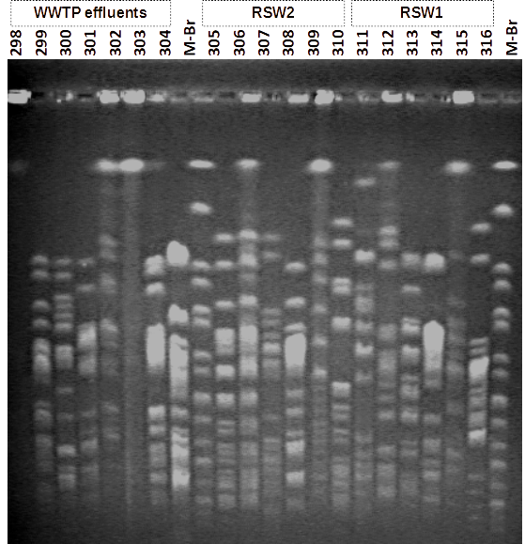 | 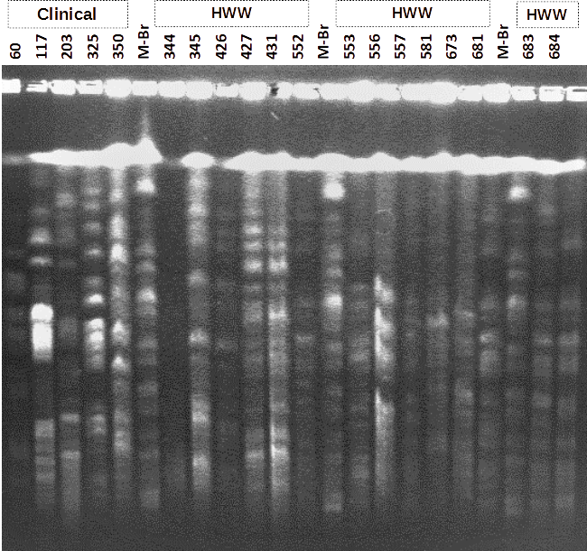
Supplementary Figure S1. PFGE analysis; Diverse PFGE patterns of E. coli isolated from clinical and environmental samples.
Abbreviations: HWW, hospital wastewater; WWTP, wastewater treatment plant; RWS1, river water site 1; RWS2, river water site 2.

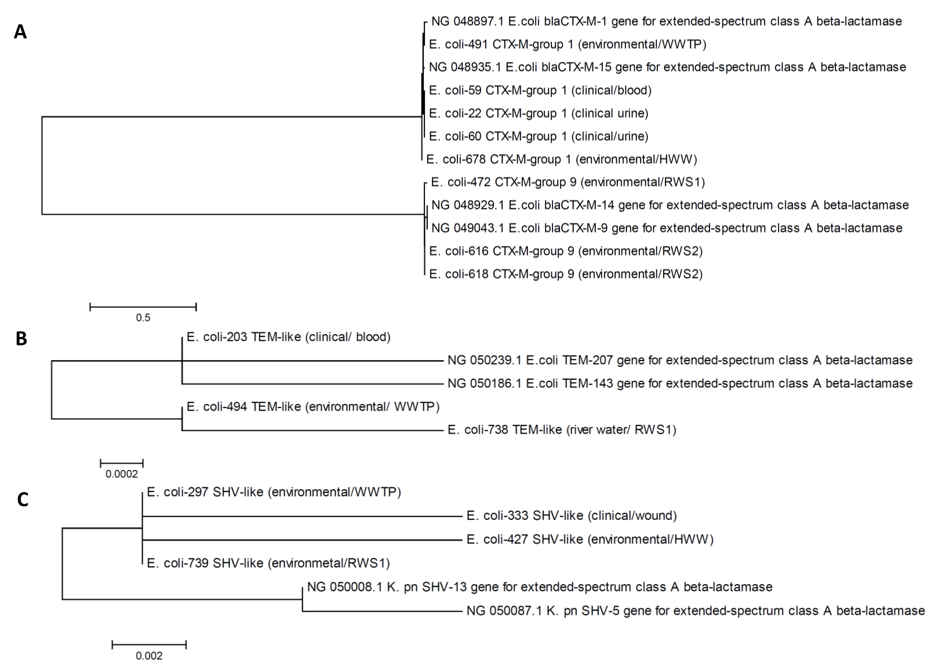

Supplementary Figure S2: Maximum Likelihood phylogenetic trees for A) bla_{CTX-M-groups}, B) bla_{TEM} and C) bla_{SHV} nucleotide sequences.

