Supplementary Material
Supplementary Tables

Table. S1 Data preprocessing statistics table
Sample ID | Insert  size (bp) | Raw  data | Clean  data | Clean  Q20 | Clean  Q30 | Clean  GC (%) | Effective  (%)
NJDZ01 | 350 | 6,300.09 | 6,273.77 | 97.06 | 91.75 | 42.45 | 99.582
NJDZ02 | 350 | 6,159.60 | 6,135.73 | 97.19 | 91.92 | 42.30 | 99.612
NJDZ03 | 350 | 6,345.68 | 6,309.27 | 96.03 | 90.31 | 44.75 | 99.426
YNDZ01 | 350 | 12,079.83 | 12,023.87 | 97.58 | 93.41 | 42.08 | 99.537
YNDZ02 | 350 | 12,975.04 | 12,903.89 | 97.41 | 93.02 | 52.22 | 99.452
YNDZ03 | 350 | 12,258.91 | 12,165.99 | 97.03 | 92.56 | 43.43 | 99.242
WHDZ01 | 350 | 8,632.31 | 8,620.90 | 97.83 | 93.52 | 48.48 | 99.868
WHDZ02 | 350 | 8,508.37 | 8,470.83 | 98.05 | 94.31 | 55.78 | 99.559
WHDZ03 | 350 | 8,351.63 | 8,341.43 | 97.30 | 92.44 | 47.12 | 99.878

Table. S2 Assembly results of scaftigs statistics
Sample ID | Total len.(bp) | Num. | Average len.(bp) | N50 Len.(bp) | N90 Len.(bp) | Max len.(bp)
NJDZ01 | 290,645,811 | 261,344 | 1,112.12 | 1,174 | 568 | 67,860
NJDZ02 | 296,307,488 | 196,027 | 1,511.56 | 2,121 | 625 | 85,152
NJDZ03 | 400,006,748 | 237,800 | 1,682.11 | 2,421 | 708 | 60,595
YNDZ01 | 5,815,047 | 8,722 | 666.71 | 618 | 515 | 30,251
YNDZ02 | 692,737 | 1,098 | 630.91 | 596 | 512 | 2,077
YNDZ03 | 119,012,136 | 149,150 | 797.94 | 738 | 529 | 26,910
WHDZ01 | 230,893,252 | 205,409 | 1,124.07 | 1,190 | 573 | 514,363
WHDZ02 | 450,958,246 | 406,972 | 1,108.08 | 1,199 | 569 | 94,853
WHDZ03 | 360,929,708 | 362,829 | 994.77 | 1,021 | 559 | 64,501

Supplementary Figures
Supplementary Figure 1. Annotation of EggNOG functional taxa

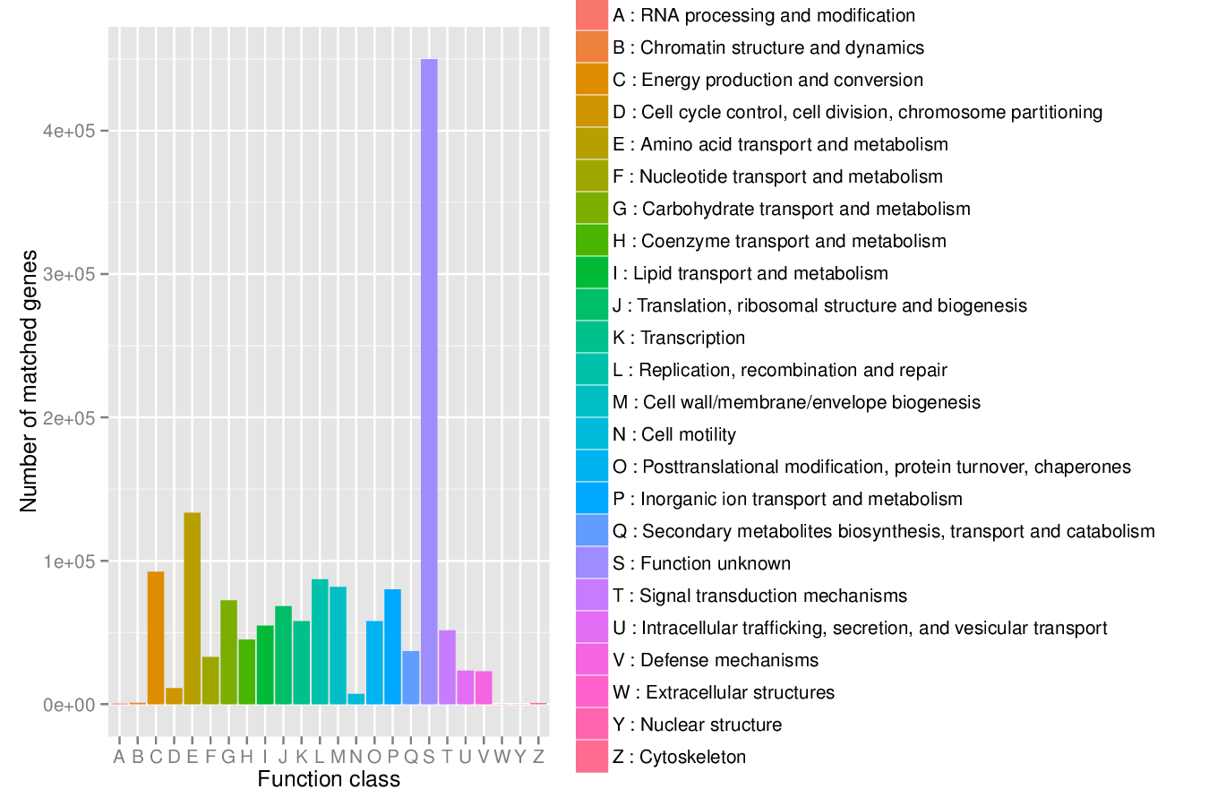
Fig. S1

Supplementary Figure 2. Abundance of different antibiotic resistance ontology in each sample
a: the relative abundance of all genes of ARO in each sample was amplified 10⁶ times by the original relative abundance data; b: top20 relative abundance of AROs among all AROs.
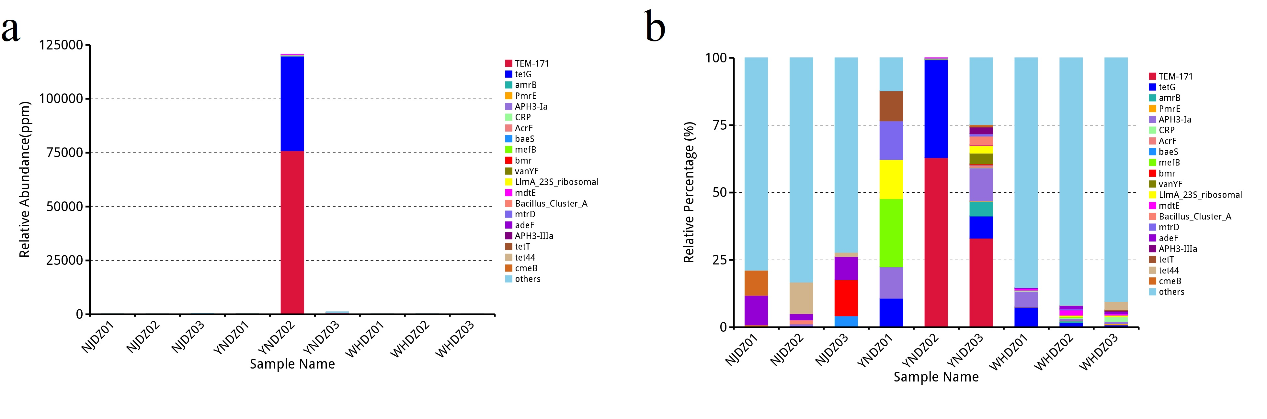

Fig. S2

