The original image of Figure 3C. The three leftmost lines are negative series, anti E tenella, anti His. The rest are bands from other experiments.
The original image of Figure 4, with the three lines on the left showing the original images of anti rEtROP27, anti E tenella, and anti His. The rest are bands from other experiments.
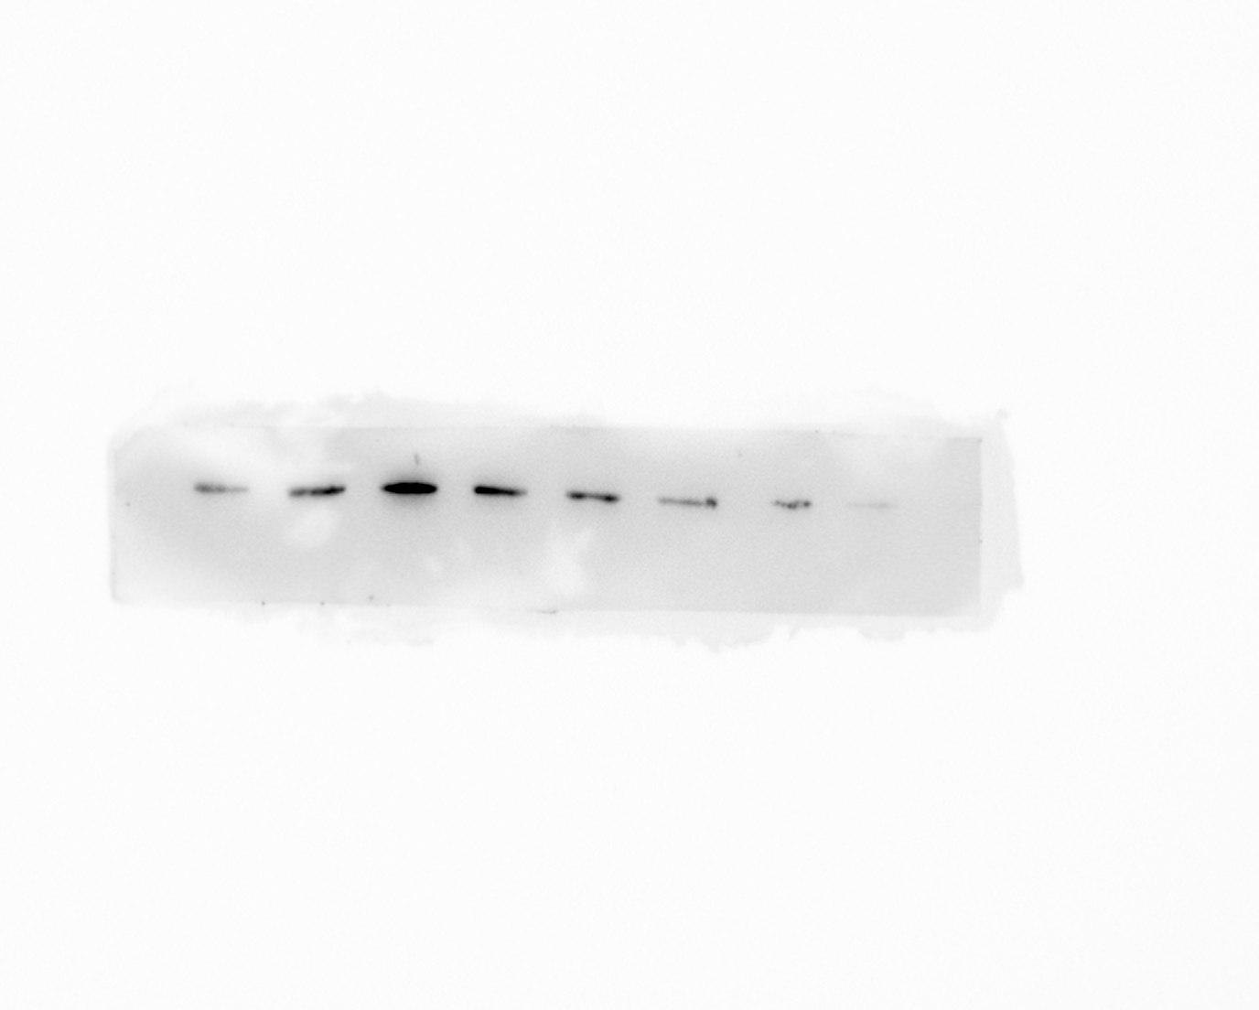
The original images of EtROP27 and GAPDH in Figure 5C.
The original images of EtROP27 and GAPDH in Figure 5D.

