Supplementary Materials
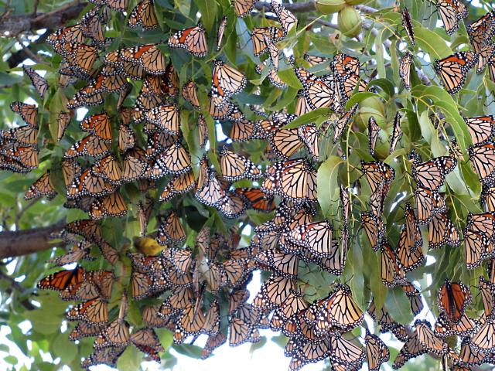

Figure S1. Photograph of a typical migratory roost, submitted by a Journey North participant in Texas (taken 10/06/15). Full record of the observation is available at: https://journeynorth.org/sightings/query_result.html?record_id=1444313582
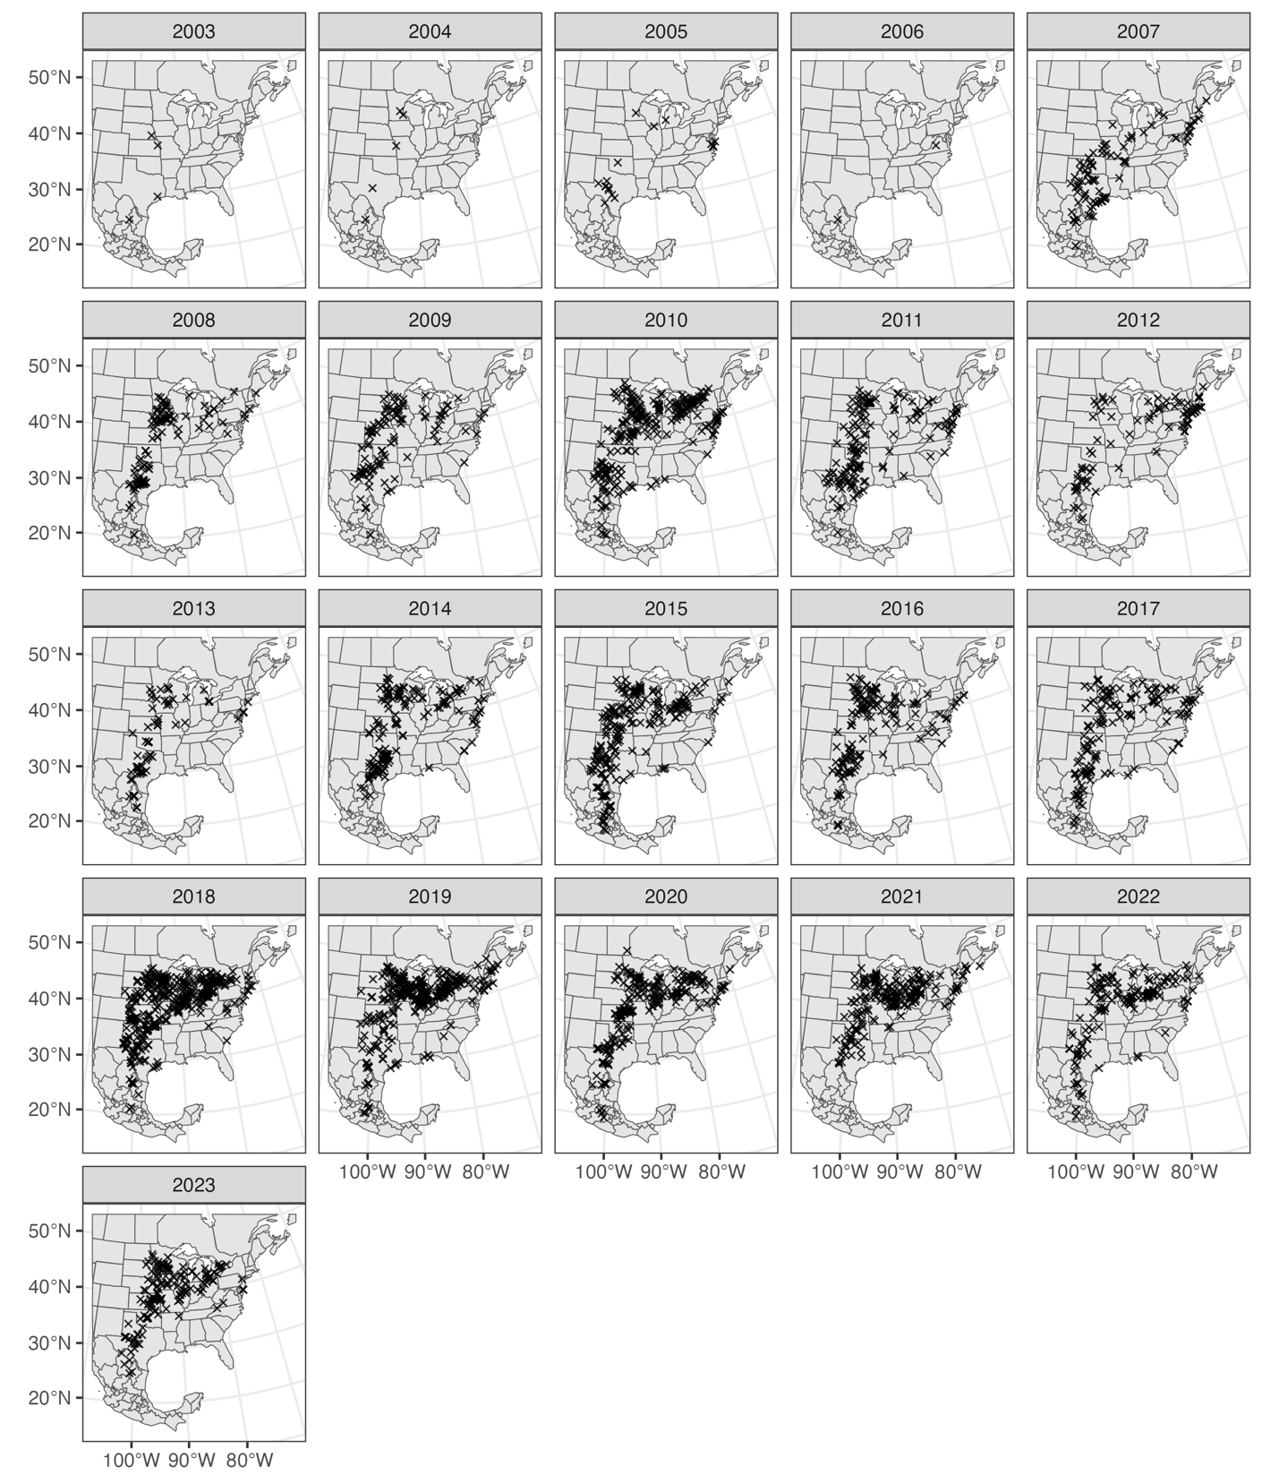
Figure S2. Map of observations recorded from 2003-2023. We only include data from 2007-2023 due to adequate sample size (minimum = 71 obs/yr; median = 162 obs/yr) and spatial coverage of the Midwest flyway.

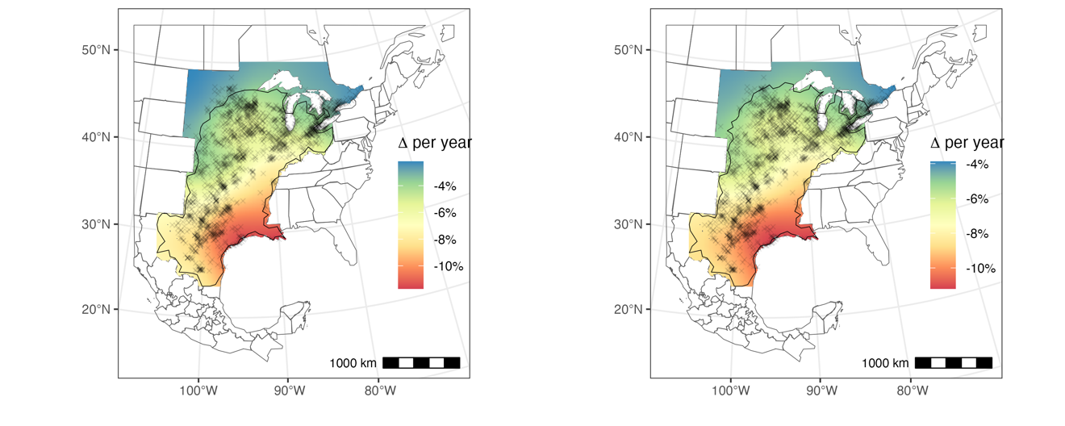

Figure S3. Map of monarch roost size trends for space-time model without (left) and with (right) covariates. Blue regions indicate relatively stable roost patterns over time and red regions indicating severe annual decline rates. Roost observation locations are marked with black X’s and regions where trends are significantly difference from zero are demarcated by the black polygon.
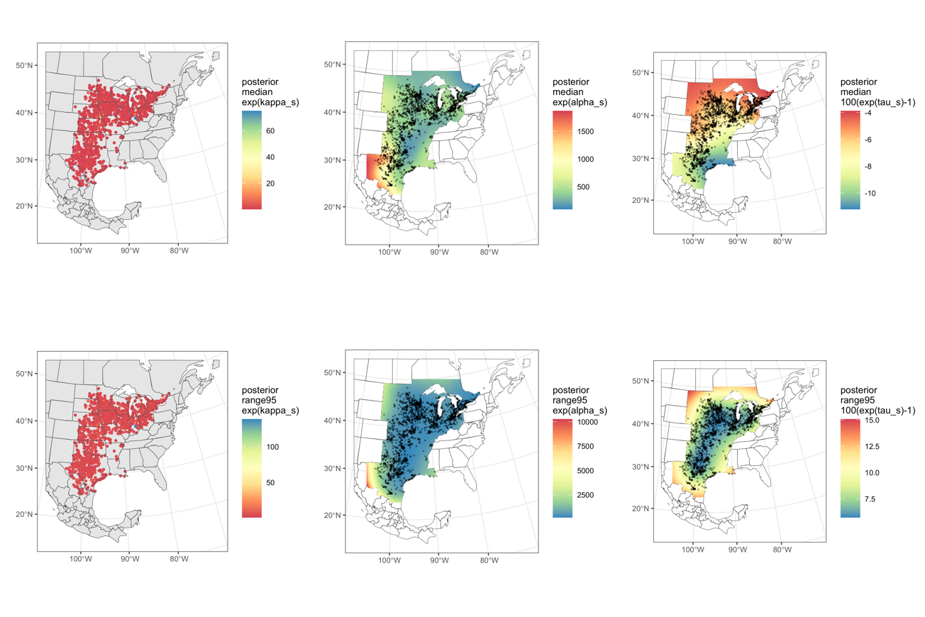
Figure S4. Spatial surfaces for the posterior medians (top row) and 95% credible interval ranges (bottom) for the site-level intercept (𝜅_{s}; left), spatial intercept (𝛼_{s}; middle), and spatially-varying year effect (𝜏_{s}; right). Abundances (𝜅_{s}, 𝛼_{s}) were exponentiated and reflect roost size estimates. Annual change rates (𝜏_{s}) were converted into % change/year. 95% C.I. ranges were obtained by subtracting the lower credible interval estimates from the upper credible interval estimates.

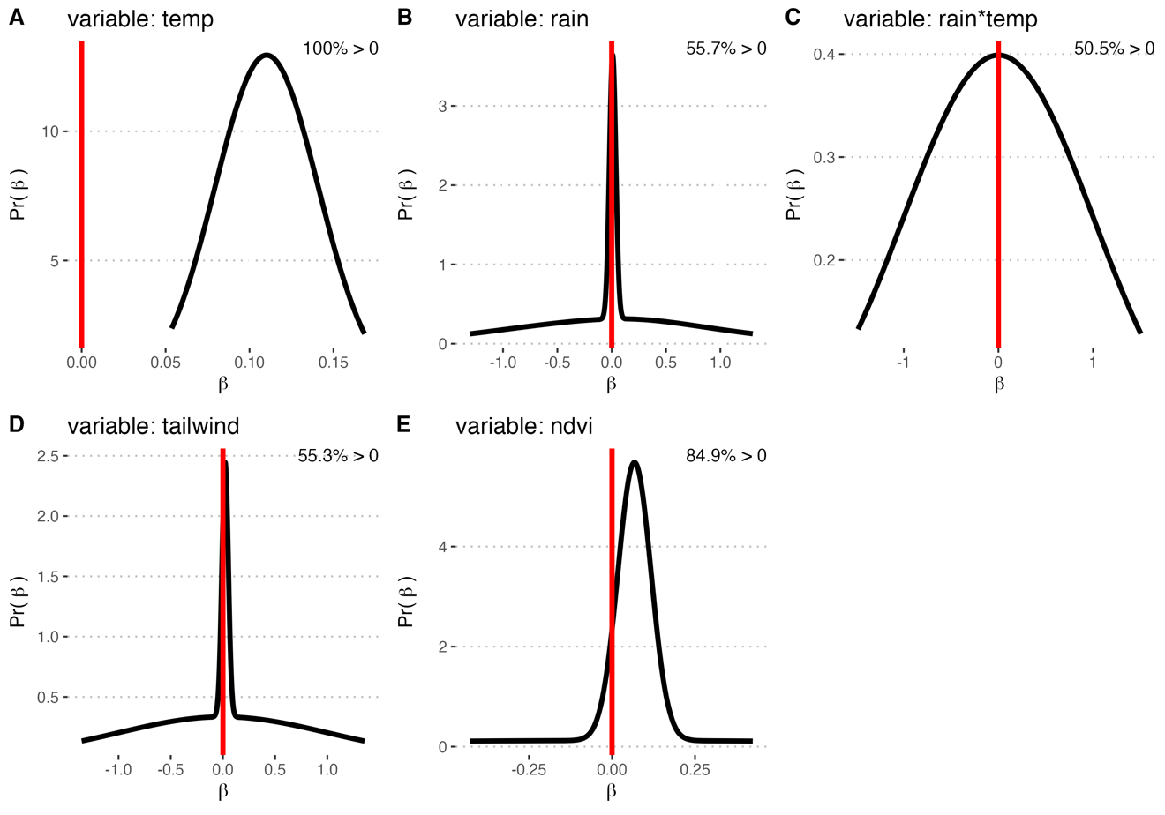

Figure S5. Marginal posterior distributions of each covariate estimate averaged across models ranked above the year-only model (Table 1) and weighted by relative model weight. When variables were absent from a model, we used zero-centered priors with a standard deviation = 1. Vertical red lines at 0 are included to visualize the proportion of estimates differing from 0.
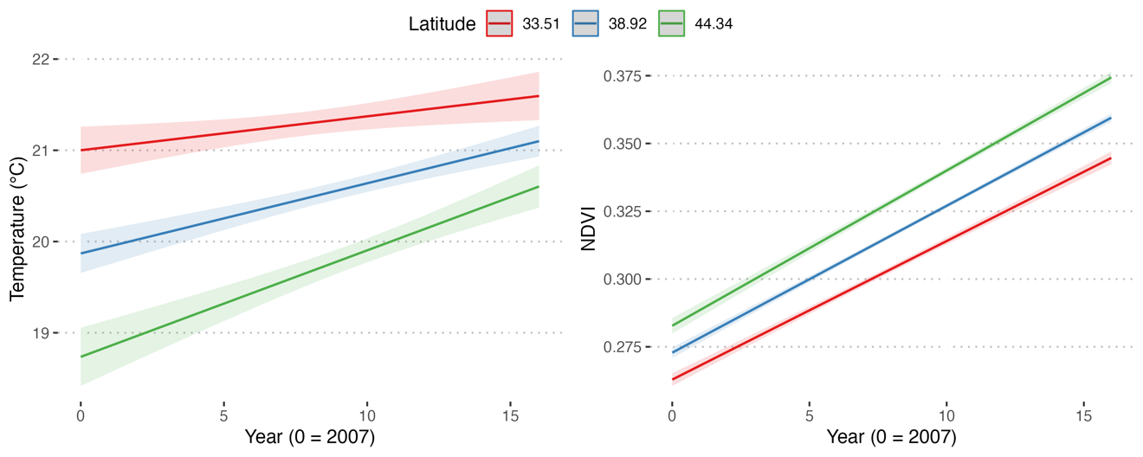

Figure S6. Changes in temperature and NDVI over time across observation locations. From north to south, temperatures and NDVI are generally increasing.

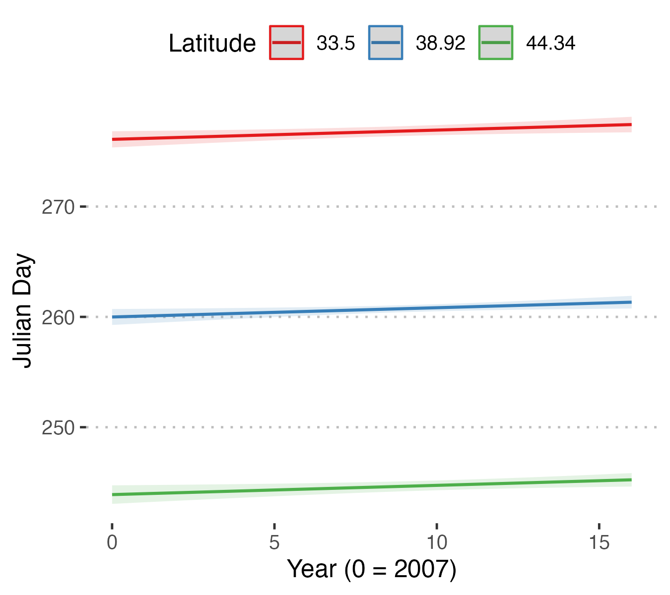

Figure S7. Timing of the monarch observations over the 17-year period of citizen scientist monitoring. Separate lines are plotted for low-, medium-, and high-latitudes. The relationship between Julian day and year (after accounting for latitude) is significant ($χ^{2}$ = 5.39, P = 0.02), but the change over time is small (delayed 0.08 days/year).

Table S1. Mean and standard deviations of the hyperparameters resulting from the top model (Table 1).

Parameter | Mean | S.D.
size for the nbinomial observations (1/overdispersion) | 0.94 | 0.03
Precision for kappa | 1.05 | 0.07
Range for alpha | 4813.57 | 1959.57
SD for alpha | 3.74 | 3.48
Range for tau | 3190.02 | 1001.85
SD for tau | 0.08 | 0.08

