Figure S1 - Cross-sections of Santarém samples S1 to S20.
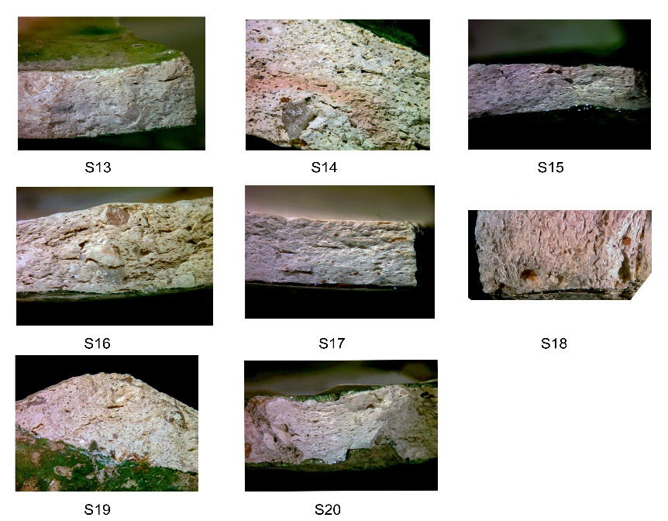
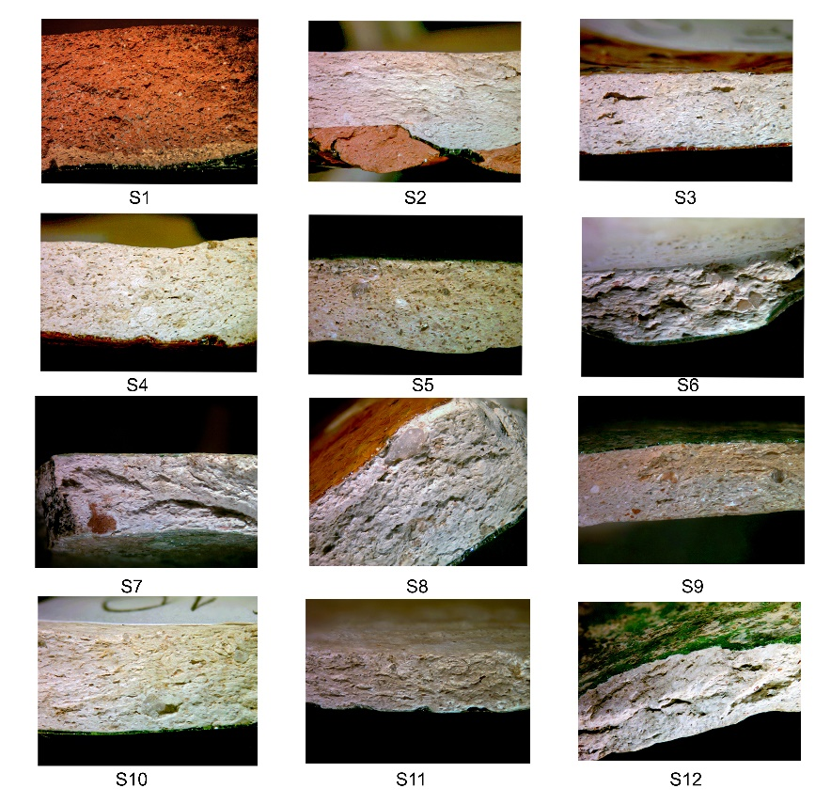

Figure S2 – Cross-sections of European sherds.
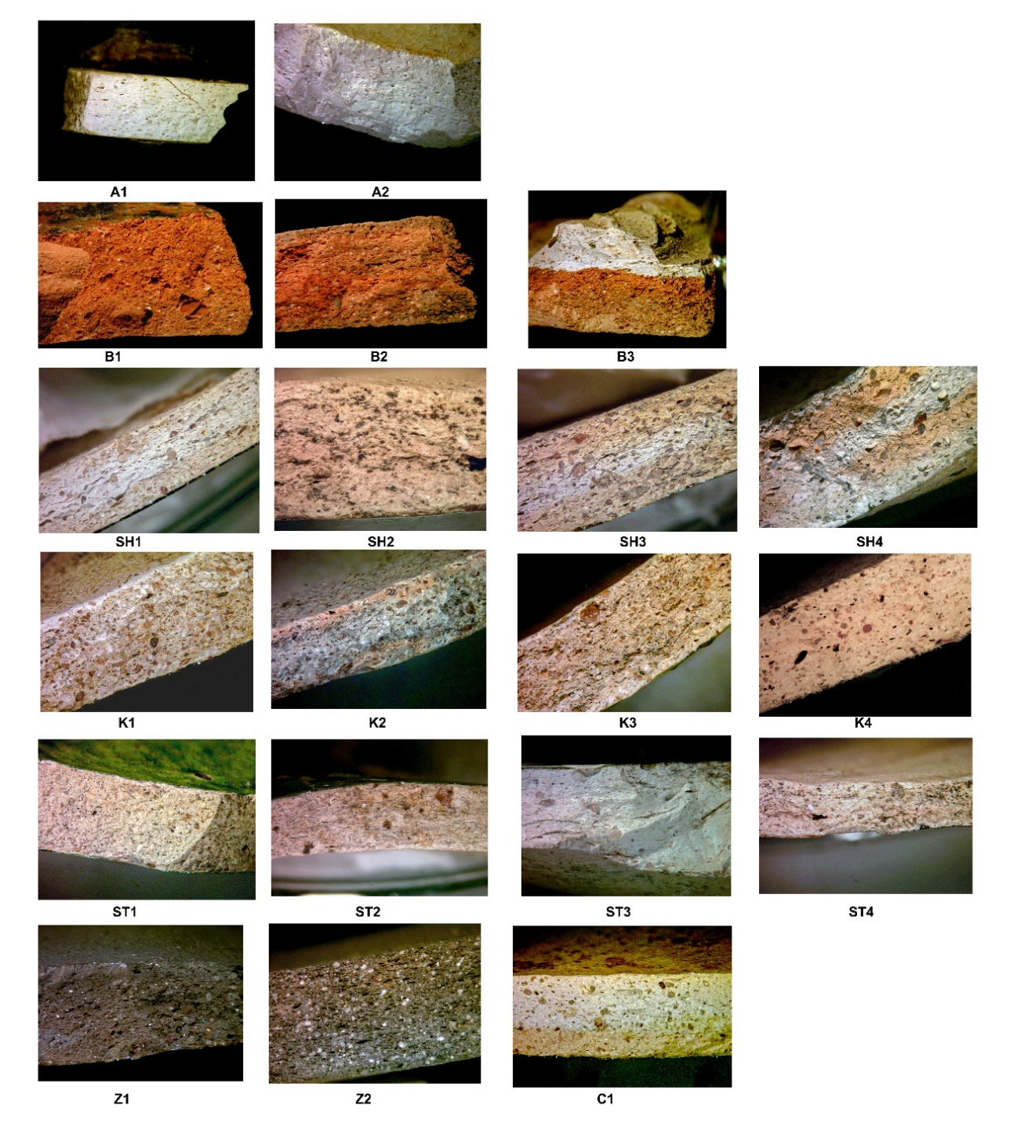

Table S1 – Santarém stereomicroscope fabric sherd characterization
Sample | Colour 1 | Colour 2 | Pores | Pore Orientation | Temper | Distribution | Size | Quartz Colour | Sherd  Thickness  (mm) | Notes
S1 | Brick | Yellow | V | N | H | UM | F | Grey | 5
S2 | Light | Rose | NV |  | L | UM | F | Grey | 3
S3 | Light |  | V | Y | L-M | UM | F | Grey | 4
S4 | Light |  | V | Y | L-M | UM | F | Grey | 5
S5 | Light |  | V | N | M | UM | I | Rose/Red | 4
S6 | Light |  | V | Y | L-M | BM | F-C | Rose | 2-3.5
S7 | Light |  | V | Y | M | UM | F | Mixed | 4
S8 | Light |  | V | Y | L-M | UM | F | Grey | 6 | Large Quartz Particles
S9 | Light | Cream | NV |  | M | UM | F | Mixed | 3 | Large Quartz Particles;  Red Particles
S10 | Light |  | V | Y | L | UM | F | Grey | 5 | Large Quartz Particles
S11 | Light |  | V | Y | L | UM | F | Grey | 2-2.5
S12 | Light |  | V | Y | L | UM | F | Mixed | 3 | Red Particles
S13 | Light |  | V | Y | L | UM | F | Grey | 4
S14 | Light | Rose | V | Y | M | UM | I | Grey | 8 | Large Quartz Particles
S15 | Light |  | V | Y | M | A | F-I-C | Grey | 2
S16 | Light |  | V | Y | M | BM | F-C | Mixed | 4 | Lithic Feldspar
S17 | Light |  | NV |  | L | UM | F | Mixed | 4 | Red Particles
S18 | Light |  | NV |  | H | A | F-I-C | Mixed | 10
S19 | Light |  | V | Y | M | BM | F-C | Mixed | 14X28
S20 | Light |  | V | Y | L | UM | F | Grey | 4

V - Visible | Y - Yes | L - Low | UM -Unimodal | F - Fine | Grey - Grey/Colourless
NV - Not Visible | N - No | M - Medium | BM - Bimodal | I - Intermediate
 |  | H - High | A- All classes | C - Coarse

Table S2 – European Stereomicroscope fabric sherd characterization
Sample | Colour 1 | Colour 2 | Pores | Pore Orientation | Temper | Distribution | Size | Quartz Colour | Sherd  Thickness  (mm) | Notes
A1 | Light |  | V | Y | L | UM | F | Mixed | 3
A2 | Light |  | V | Y | L | UM | F | Mixed | 4-5
B1 | Brick |  | V | N | H | UM | I | Grey | 5
B2 | Brick |  | V | Y | H | UM | I | Grey | 5
B3 | Brick |  | V | N | H | UM | I | Grey | 4-5
K1 | Light | White | NV |  | H | BM | F-I | Rose | 5-5.5 | Black Particles
K2 | Light | Rose | NV |  | H | UM | I | Mixed | 3.5-4
K3 | Light |  | V | Y | H | A | F-I-C | Orange | 5
K4 | Light |  | V | N | H | UM | I | Mixed | 4
Z1 | Dark Brown |  | V | Y | H | BM | F-I | Grey | 4
Z2 | Dark Brown |  | V | Y | H | UM | I | Grey | 5
SH1 | Light | Cream | NV |  | H | A | F-I-C | Mixed | 3.5-4
SH2 | Light |  | NV |  | M | UM | F | Grey | 5 | Mica Orientation
SH3 | Light | Cream | V | Y | H | BM | F-C | Mixed | 6-9
SH4 | Light | Cream | NV |  | I | UM | I | Grey | 11 | Large Pores; Redish Particles
ST1 | Light |  | NV |  | L-M | UM | F | Mixed | 4
ST2 | Light |  | NV |  | L-M | UM | F | Mixed | 3.5-4 | Large Quartz Particles
ST3 | Light |  | NV |  | L-M | UM | I | Mixed | 4
ST4 | Light |  | NV |  | L-M | UM | F | Mixed | 2 | Mica
C1 | Light | Cream | NV |  | I | BM | F-I | Grey | 4

V - Visible | Y - Yes | L - Low | UM -Unimodal | F - Fine | Grey - Grey/Colourless
NV - Not Visible | N - No | M - Medium | BM - Bimodal | I - Intermediate
 |  | H - High | A- All classes | C - Coarse

