A novel sodium-potassium anode supported by fluorinated aluminum foam

Jin Lou ^{1,}*, Jingan Zhou ², Xiaosong Ma ², Kanghua Chen ¹, Songyi Chen¹,
¹ Light Alloy Metal Research Institute, Central South University, Changsha 410083, China; jinlou@csu.edu.cn (J.L.); khchen@csu.edu.cn (K.C.); sychen08@csu.edu.cn (S.C.)
² Hunan Provincial Key Laboratory of Carbon Neutrality and Intelligent Energy, School of Resources & Environment, Hunan University of Technology and Business, Changsha 410205, China;17373564507@163.com (J.Z.); ma15367552578@163.com (X.M.);
*Correspondence: jinlou@csu.edu.cn

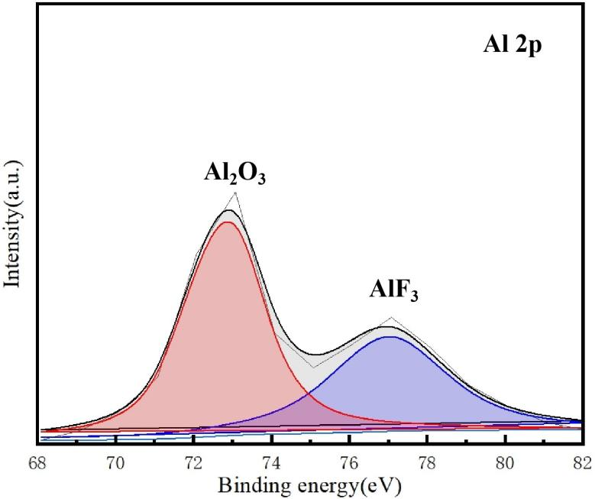
Figure S1 X-ray photoelectron spectroscopy (XPS) spectra of the Al element of FAF electrode.

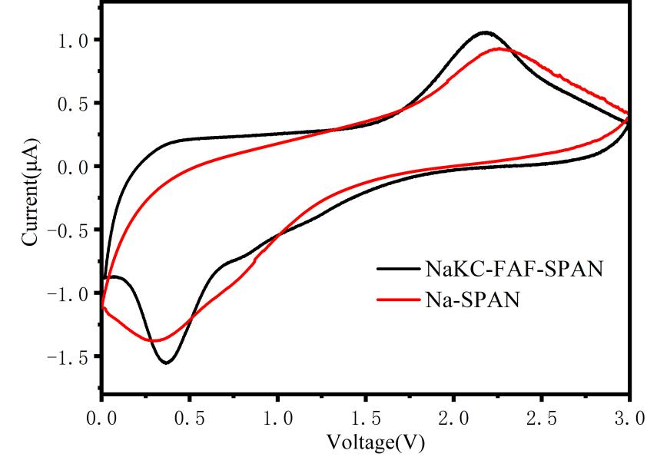
Figure S2 The CV curves of Na-SPAN/NaKC-FAF-SPAN at 0.1 mV s⁻¹
.

