Development of flaxseed gum/konjac glucomannan with agar as gelling agents with enhanced elastic properties
Ji Soo Yang^{1†}, Junghoon Kim^{4†}, Jungwoo Hahn²* & Young Jin Choi^{1,2,3}*
¹Department of Agricultural Biotechnology, ²Center for Food and Bioconvergence, and ³Research Institute of Agriculture and Life Sciences, Seoul National University, 1 Gwanakro, Gwanakgu, Seoul 08826, Republic of Korea
⁴Department of Food Science and Biotechnology, Sejong University, 209 Neungdong-ro, Kwangjin-gu, Seoul, 05006, Korea; Intake
⁵Intake, 116 Myeongdal-ro, Seocho-gu, Seoul, 06659, Korea

*Corresponding authors
Young Jin Choi
choiyj@snu.ac.kr
+82 2 880 4851

Jungwoo Hahn
wjddnek1@snu.ac.kr
+82 2 880 4858

Creep and recovery for Burger’s model
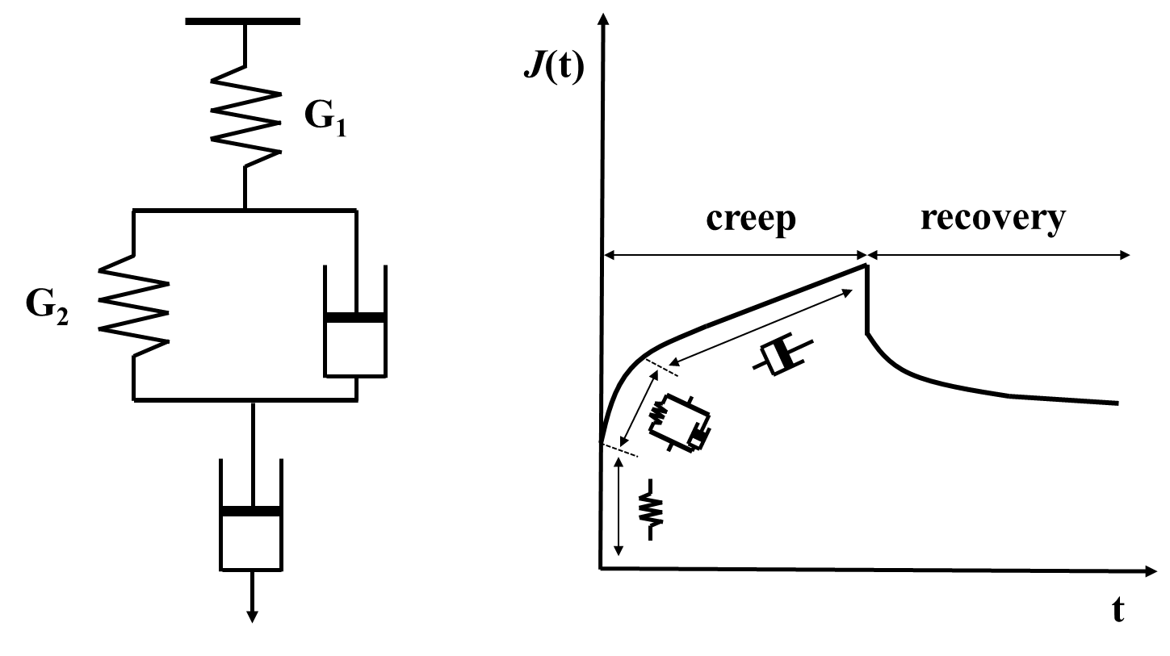
(B)
(A)

Figure S1. Mechanical model used to describe the rheological properties of proposed gels. (a) the Burger’s model and (b) a creep and recovery plot described by the Burger’s model.

