Table S1: Survey Instructions and Question Items (Date Collection Form)

Before-Intervention Survey

Section Instructions
In this section, we will be asking you to provide us with your mobile number that is linked to your Whatsapp account as part of the study requirement. In addition, we will be asking some background information. Please respond to all of the questions below.
Please enter the mobile number linked to your WhatsApp account.

Mobile No: ___________
Please indicate your gender.
*Female
*Male
Please select your age range.
*21-24 years old
*25-34 years old
*35-44 years old
*45-54 years old
*55-64 years old
*65 years old or older
Please indicate your ethnicity.
*Chinese
*Malay
*Indian
*Others
Please indicate your total household income per month ($SGD)?
*Less than $2,000
*$2,001 to $4,000
*$4,001 to $6,000
*$6,001 to $8,000
*$8,001 to $10,000
*$10,001 to $15,000
>$15,000
Please indicate your body height.

Height: _________ CM
Please indicate your bodyweight.

Weight: _________ KG
Please indicate your waistline (Refer to this <https://www.wikihow.com/Measure-Your-Waist> for instructions on measuring waistline.)

Waistline: _________ CM
If you are to go on a diet now, how confident are you that you will succeed?
*Not confident at all
*A little confident
*Somewhat confident
*Quite confident
*Very confident
If you are to go on a diet now, how long do you think you can sustain it?
*A few hours
*A few days
*A few weeks
*A few months
*A few years

Section Instructions
In this section, we will be asking a series of questions to understand how important the health and weight control factors are in determining your choice of food on a typical day. Please answer each question to your best ability, noting that there are no right or wrong answers.
Using the following scale, please indicate how important it is to you that the food you eat on a typical day…
 | Not important at all | A little important | Moderately important | Very important
…is high in fibre and roughage
…is nutritious
…contains lots of vitamins and minerals
…is high in protein
…keeps me healthy
…is good for your skin/teeth/hair/nails, etc.
…is low in calories
…is low in fat
…helps you control your weight

Section Instructions
In this section, we will be asking a series of questions that seeks to understand your eating behaviours. Please answer each of the following questions as best as you can and there are no right or wrong answers.
Using the following scale, please indicate the extent to which you find yourself feeling or experiencing what is being described in the following statements below.
 | Definitely false | Mostly false | Mostly true | Definitely true
In the presence of the smell of delicious food, I find it very difficult to keep from eating, even if I have just finished a meal.
I deliberately take small helpings as a means of controlling my weight.
When I feel anxious, I find myself eating.
Sometimes when I start eating, I just can’t seem to stop.
Being with someone who is eating often makes me hungry to want to eat as well.
When I feel blue, I often overeat.
When I see a real delicacy, I often get so hungry that I have to eat right away.
I get so hungry that my stomach often seems like a bottomless pit.
I am always hungry so it is hard for me to stop eating before I finish the food on my plate.
When I feel lonely, I console myself by eating.
I consciously hold back on meals in order not to weight gain.
I do not eat some foods because they make me fat.
I am always hungry enough to eat at any time.
 | Only at meal times | Sometimes between meals | Often between meals | Almost always
How often do you feel hungry?
 | Almost never | Seldom | Usually | Almost always
How frequently do you avoid 'stocking up' on tempting foods?
 | Unlikely | Slightly Likely | Moderately likely | Very likely
How likely are you to consciously eat less than you want?
 | Never | Rarely | Sometimes | At least once a week
Do you go on eating binges even though you are not hungry?
On a scale of 1 to 8, where 1 means no restraint in eating (eating whatever you want whenever you want it) and 8 means total restraint (constantly limiting food intake and never 'giving in') what number would you give yourself?

Rating: __________

Section Instructions
In this section, we would be presenting you with 10 sets of photos containing different food items and in various portion sizes. As such, we seek to understand the ideal portion size that you would consume for a given food item, regardless of your food preferences and dietary restriction. Please answer each question to the best of your estimation.

Imagine that you are having ONE of the following food items for lunch (around 12 pm) and you know you would not be eating until dinner (around 7 pm). Ignoring food preference and dietary restriction, which portion size for a given food item would stop you from feeling hungry?

Fried Rice (Plate Diameter: 30cm) 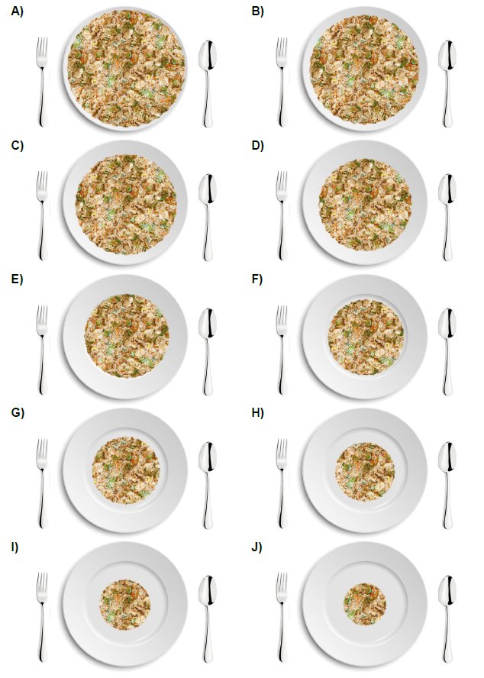

Grilled Chicken Fillet (Plate Diameter: 30cm)

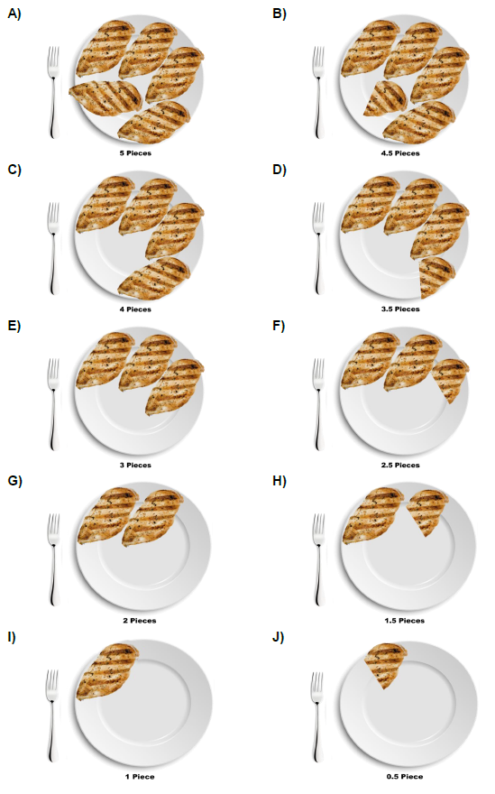

Mixed Salad (Plate Diameter: 30cm)
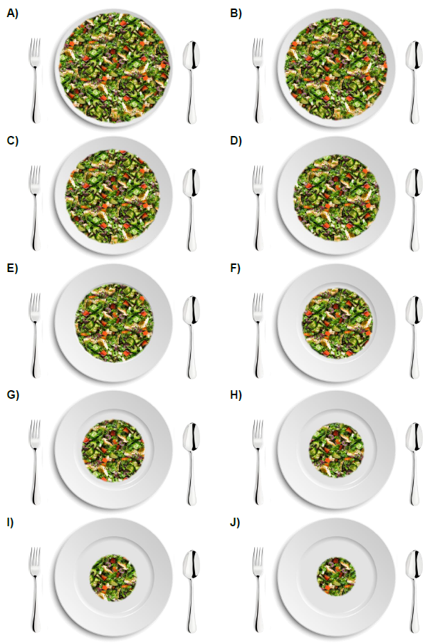

Chicken Corn Soup (Bowl Diameter: 20cm)
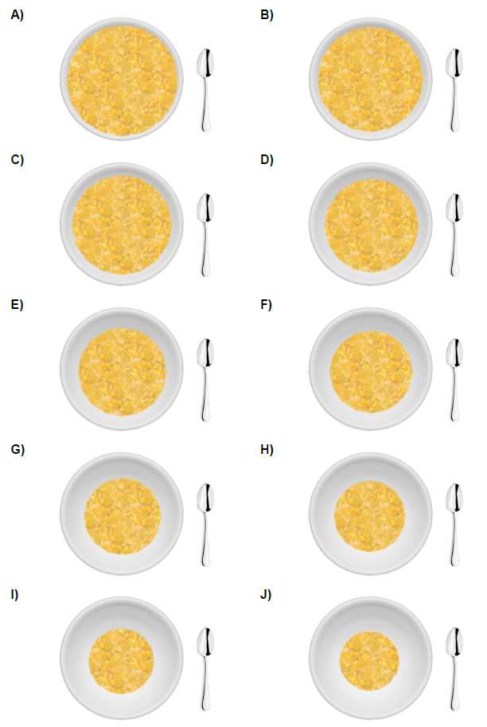

Extra-large Pizza (Plate Diameter: 35 cm)
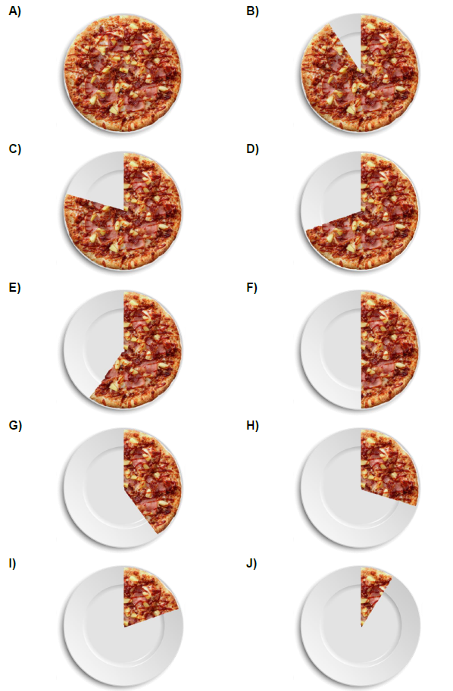

Chicken Curry Rice (Plate Diameter: 30cm)

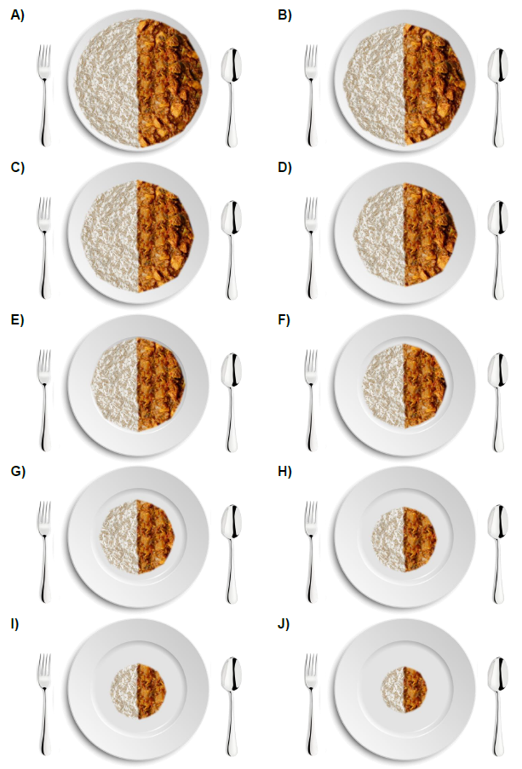

Porridge (Bowl Diameter: 20cm)

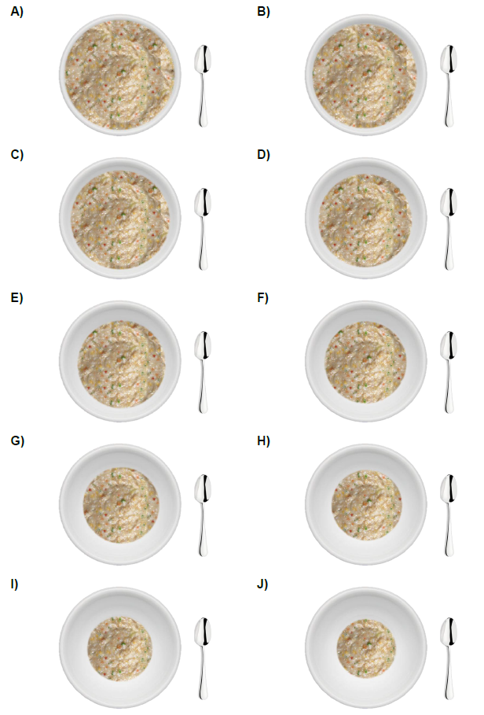

Instant Noodles (Plate Diameter: 30cm)

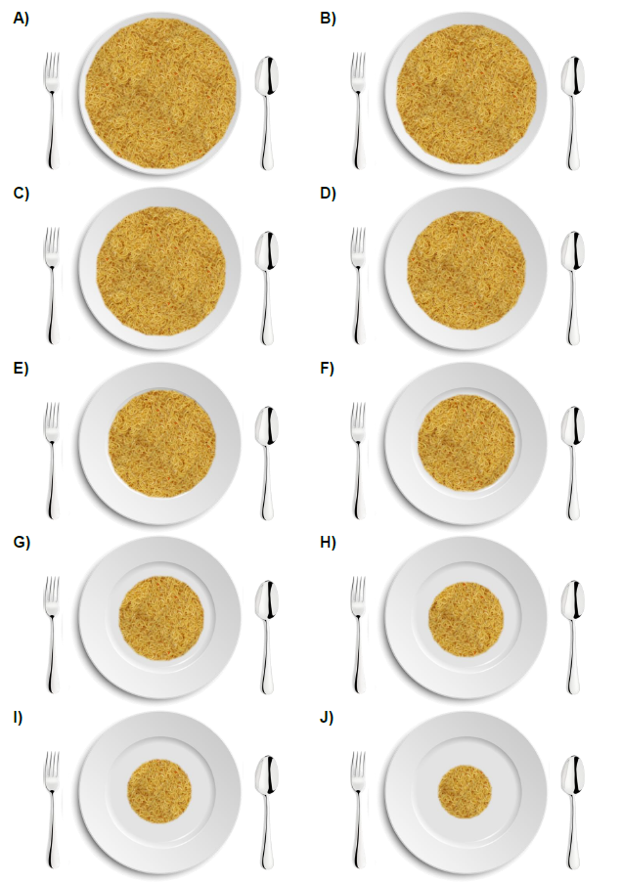

Roti Prata (Plate Diameter: 30cm)

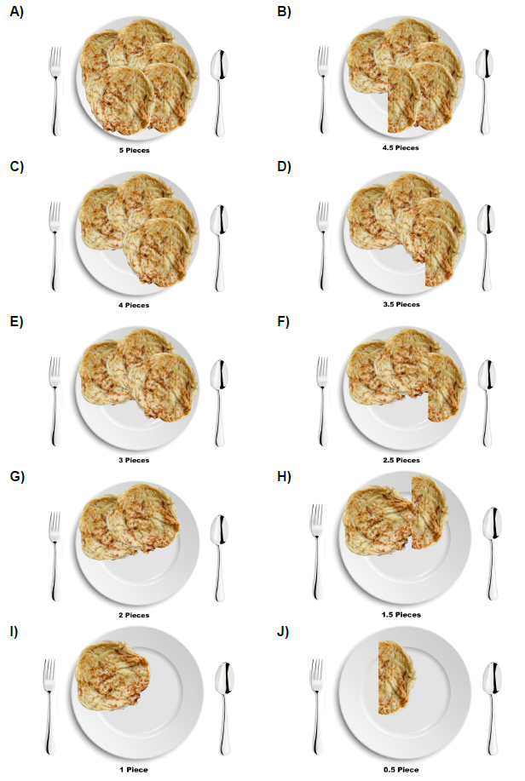

Mixed Fruits (Bowl Diameter: 20 cm)

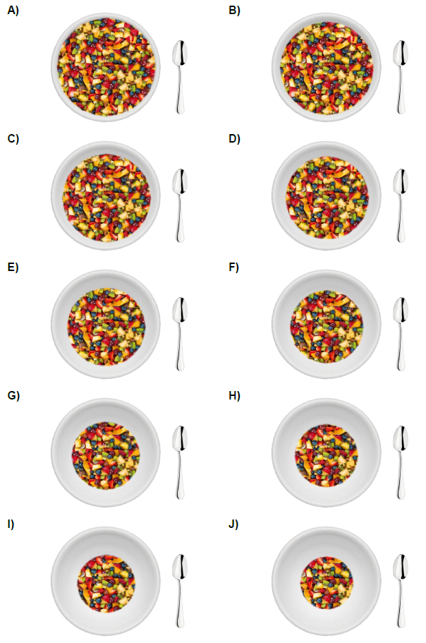

Section Instructions
In this section, we would be asking a series of questions that seek to measure your consumption of certain food types in the past 4 weeks. Please answer each question as accurately and to the best as you can. There are no right or wrong answers.

Recall for the past weeks, how often do you drink pre-packed sugar-sweetened drinks on average PER WEEK? (e.g. soft drinks, fruit drinks, packet drinks, cordials, yoghurt-based drinks and cultured milk drinks, etc.)

__________ Times per WEEK.
Recall for the past weeks, how often do you drink freshly-prepared tea, coffee or other beverages with sugar added on average PER WEEK?

__________ Times per WEEK.
Recall for the past weeks, how often do you eat sweet desserts and snacks on average PER WEEK? (e.g. cakes, kuehs, jellies, candies, chocolates, cookies, ice-cream, etc.)

__________ Times per WEEK.

Section Instructions
In this section, we would be asking a series of questions that seek to understand your belief towards your health condition.
Using the following scale, please indicate the extent to which you agree or disagree with the following statements that describe your belief towards your health condition.
 | Strongly Disagree | Disagree | Neither disagree nor agree | Agree | Strongly Agree
If I become sick, I have the power to make myself well again.
I am directly responsible for my health.
Whatever goes wrong with my health is my own fault.
My physical well-being depends on how well I take care of myself.
When I feel ill, I know it is because I have not been taking care of myself properly.
I can pretty much stay healthy by taking good care of myself.

Section Instructions
In this section, we would be asking a series of questions that seek to understand your behaviours, feelings and thinking across different situations.
Using the following scale, please indicate the extent to you disagree or agree with each of the following statements about you as you generally are now, not as you wish to be in the future.

In general, I…
 | Strongly Disagree | Somewhat  Disagree | Neither disagree nor agree | Somewhat  Agree | Strongly Agree
Am the life of the party.
Sympathize with others’ feelings.
Get chores done right away.
Have frequent mood swings.
Have a vivid imagination.
Don’t talk a lot.
Am not interested in other people’s problems.
Often forget to put things back in their proper place.
Am relaxed most of the time.
Am not interested in abstract ideas.
Talk to a lot of different people at parties.
Feel others’ emotions
Like order.
Get upset easily.
Have difficulty understanding abstract ideas.
Keep in the background.
Am not really interested in others.
Make a mess of things.
Seldom feel blue.
Do not have a good imagination.
Section Instructions
In this section, we would be asking a series of questions that seek to measure the level of stress you have experienced during the last year or two. Please answer each question as best as you can and there are no right or wrong answers.
Using the following scale, please indicate how often during the last year or two you felt or thought based on each of the statement below.

How often have you…
 | Never | Almost Never | Sometimes | Fairly Often | Often
…been upset about something that has happened unexpectedly?
…felt that you were unable to control the important things in your life?
…felt nervous and ‘stressed’?
…felt confident about your ability to handle your personal problems?
…felt that things were going your way?
…found that you could not cope with all the things that you had to do?
…been able to control the irritations in your life?
…felt that you were on top of things?
…been angered because of things that were outside your control?
…felt difficulties were piling up so high that you could not overcome them?

Section Instructions
In this section, we would be asking a question that seek to understand the dimensions of narcissism (i.e. egotistical, self-focused, and vanity).

Using the following scale, please indicate the extent to which you agree with the following statement:

"I am a narcissist*.” (*Note: The word “narcissist” means egotistical, self-focused, and vain.)

Not very true of me | ... | ... | ... | ... | ... | Very true of me.

Section Instructions
In this section, we would be asking a series of questions that seek to understand your motivation goals and the way in which you would go about achieving those goals. Please answer each question as best as you can and there are no right or wrong answers.
Using the following scale, please indicate the extent to which each of the following statements describes who you are.
 | Not very true of me. | ... | ... | ... | ... | ... | Very true of me.
I prefer to work without instructions from others.
Rules and regulations are helpful and necessary for me.
For me, it is very important to carry out the obligations placed on me.
I generally solve problems creatively.
I’m not bothered about reviewing or checking things really closely.
I like to do things in a new way.
I always try to make my work as accurate and error free as possible.
I like trying out lots of different things, and am often successful in doing so.
It is important to me that my achievements are recognised and valued by other people.
I often think about what other people expect of me.

Mid-Intervention Survey

Section Instructions
In this section, we will be asking a series of questions that seek to determine your body measurements. In addition, we will be asking for your views towards the messages that we have sent you throughout the study. Your responses are important to us as it could help us further enhance our messages.

Please indicate your bodyweight.

Weight: _________ KG
Please indicate your waistline (Refer to this <https://www.wikihow.com/Measure-Your-Waist> for instructions on measuring waistline.)

Waistline: _________ CM
How often do you read the content in the messages sent to you during the study?
*Never at all
*Rarely
*Seldom
*Often
*Always
Do you agree that the messages sent to your during the study have led you consciously think about your diet and eating habits?
*Strongly disagree
*Disagree
*Neither disagree nor agree
*Agree
*Strongly agree
Do you agree that the messages sent to you during the study help you to manage your diet or eating habits?
*Strongly disagree
*Disagree
*Neither disagree nor agree
*Agree
*Strongly agree
Do you agree that you feel healthier after the intervention?
*Strongly disagree
*Disagree
*Neither disagree nor agree
*Agree
*Strongly agree
If you are to go on a diet after this study, how confident do you think it will succeed?
*Not confident at all
*A little confident
*Somewhat confident
*Quite confident
*Very confident
If you are to go on a diet after this study, how long do you think you can sustain it?
*A few hours
*A few days
*A few weeks
*A few months
*A few years

Section Instructions
In this section, we will be asking a series of questions that seeks to understand the health and weight control factors in determining your choice of food on a typical day. Please answer each question as best as you can and there are no right or wrong answers.
Using the following scale, please indicate how important it is to you that the food you eat on a typical day…
 | Not important at all | A little important | Moderately important | Very important
…is high in fibre and roughage
…is nutritious
…contains lots of vitamins and minerals
…is high in protein
…keeps me healthy
…is good for your skin/teeth/hair/nails, etc.
…is low in calories
…is low in fat
…helps you control your weight

Section Instructions
In this section, we will be asking a series of questions that seek to understand your eating behaviours.
Using the following scale, please indicate the extent to which you find yourself feeling or experiencing what is being described in the following statements below.
 | Definitely false | Mostly false | Mostly true | Definitely true
In the presence of the smell of delicious food, I find it very difficult to keep from eating, even if I have just finished a meal.
I deliberately take small helpings as a means of controlling my weight.
When I feel anxious, I find myself eating.
Sometimes when I start eating, I just can’t seem to stop.
Being with someone who is eating often makes me hungry to want to eat as well.
When I feel blue, I often overeat.
When I see a real delicacy, I often get so hungry that I have to eat right away.
I get so hungry that my stomach often seems like a bottomless pit.
I am always hungry so it is hard for me to stop eating before I finish the food on my plate.
When I feel lonely, I console myself by eating.
I consciously hold back on meals in order not to weight gain.
I do not eat some foods because they make me fat.
I am always hungry enough to eat at any time.
 | Only at meal times | Sometimes between meals | Often between meals | Almost always
How often do you feel hungry?
 | Almost never | Seldom | Usually | Almost always
How frequently do you avoid 'stocking up' on tempting foods?
 | Unlikely | Slightly Likely | Moderately likely | Very likely
How likely are you to consciously eat less than you want?
 | Never | Rarely | Sometimes | At least once a week
Do you go on eating binges though you are not hungry?
On a scale of 1 to 8, where 1 means no restraint in eating (eating whatever you want whenever you want it) and 8 means total restraint (constantly limiting food intake and never 'giving in') what number would you give yourself?

Rating: __________

Section Instructions
In this section, we would be presenting you with 10 sets of photos containing different food items and in various portion sizes. As such, we seek to understand the ideal portion size that you would consume for a given food item, regardless of your food preferences and dietary restriction. Please answer each question to the best of your estimation.

Imagine that you are having ONE of the following food items for lunch (around 12 pm) and you know you would not be eating until dinner (around 7 pm). Ignoring food preference and dietary restriction, which portion size for a given food item would stop you from feeling hungry?

Fried Rice (Plate Diameter: 30cm)

Grilled Chicken Fillet (Plate Diameter: 30cm)

Mixed Salad (Plate Diameter: 30cm)

Chicken Corn Soup (Bowl Diameter: 20cm)

Extra-large Pizza (Plate Diameter: 35 cm)

Chicken Curry Rice (Plate Diameter: 30cm)

Porridge (Bowl Diameter: 20cm)

Instant Noodles (Plate Diameter: 30cm)

Roti Prata (Plate Diameter: 30cm)

Mixed Fruits (Bowl Diameter: 20 cm)

Section Instructions
In this section, we would be asking a series of questions that seek to measure your consumption of certain food types in the past 2 weeks.

Recall for the past weeks, how often do you drink pre-packed sugar-sweetened drinks on average PER WEEK? (e.g. soft drinks, fruit drinks, packet drinks, cordials, yoghurt-based drinks and cultured milk drinks, etc.)

__________ Times per WEEK.

Recall for the past weeks, how often do you drink freshly-prepared tea, coffee or other beverages with sugar added on average PER WEEK?

__________ Times per WEEK.

Recall for the past weeks, how often do you eat sweet desserts and snacks on average PER WEEK? (e.g. cakes, kuehs, jellies, candies, chocolates, cookies, ice-cream, etc.)

__________ Times per WEEK.

Section Instructions
In this section, we would be asking a series of questions that seek to understand your belief towards your health condition.
Using the following scale, please indicate the extent to which you agree or disagree with the following statements that describe your belief towards your health condition.
 | Strongly Disagree | Disagree | Neither disagree nor agree | Agree | Strongly Agree
If I become sick, I have the power to make myself well again.
I am directly responsible for my health.
Whatever goes wrong with my health is my own fault.
My physical well-being depends on how well I take care of myself.
When I feel ill, I know it is because I have not been taking care of myself properly.
I can pretty much stay healthy by taking good care of myself.

After-Intervention Survey

Section Instructions
In this section, we will be asking a series of questions that seek to determine your body measurements. In addition, we will be asking for your views towards the messages that we have sent you throughout the study. Your responses are important to us as it could help us further enhance our messages.

Please indicate your bodyweight.

Weight: _________ KG
Please indicate your waistline (Refer to this <https://www.wikihow.com/Measure-Your-Waist> for instructions on measuring waistline.)

Waistline: _________ CM
How often do you read the content in the messages sent to you during the study?
*Never at all
*Rarely
*Seldom
*Often
*Always
Do you agree that the messages sent to your during the study have led you consciously think about your diet and eating habits?
*Strongly disagree
*Disagree
*Neither disagree nor agree
*Agree
*Strongly agree
Do you agree that the messages sent to you during the study help you to manage your diet or eating habits?
*Strongly disagree
*Disagree
*Neither disagree nor agree
*Agree
*Strongly agree
Do you agree that you feel healthier after the intervention?
*Strongly disagree
*Disagree
*Neither disagree nor agree
*Agree
*Strongly agree
If you are to go on a diet after this study, how confident do you think it will succeed?
*Not confident at all
*A little confident
*Somewhat confident
*Quite confident
*Very confident
If you are to go on a diet after this study, how long do you think you can sustain it?
*A few hours
*A few days
*A few weeks
*A few months
*A few years

Section Instructions
In this section, we will be asking a series of questions that seeks to understand how important are the health and weight control factors in determining your choice of food on a typical day. Please answer each question as best as you can and there are no right or wrong answers.
Using the following scale, please indicate how important it is to you that the food you eat on a typical day…
 | Not important at all | A little important | Moderately important | Very important
…is high in fibre and roughage
…is nutritious
…contains lots of vitamins and minerals
…is high in protein
…keeps me healthy
…is good for your skin/teeth/hair/nails, etc.
…is low in calories
…is low in fat
…helps you control your weight

Section Instructions
In this section, we will be asking a series of questions that seeks to understand your eating behaviours. Please answer each of the following questions as best as you can and there are no right or wrong answers.
Using the following scale, please indicate the extent to which you find yourself feeling or experiencing what is being described in the following statements below.
 | Definitely false | Mostly false | Mostly true | Definitely true
In the presence of the smell of delicious food, I find it very difficult to keep from eating, even if I have just finished a meal.
I deliberately take small helpings as a means of controlling my weight.
When I feel anxious, I find myself eating.
Sometimes when I start eating, I just can’t seem to stop.
Being with someone who is eating often makes me hungry to want to eat as well.
When I feel blue, I often overeat.
When I see a real delicacy, I often get so hungry that I have to eat right away.
I get so hungry that my stomach often seems like a bottomless pit.
I am always hungry so it is hard for me to stop eating before I finish the food on my plate.
When I feel lonely, I console myself by eating.
I consciously hold back on meals in order not to weight gain.
I do not eat some foods because they make me fat.
I am always hungry enough to eat at any time.
 | Only at meal times | Sometimes between meals | Often between meals | Almost always
How often do you feel hungry?
 | Almost never | Seldom | Usually | Almost always
How frequently do you avoid 'stocking up' on tempting foods?
 | Unlikely | Slightly Likely | Moderately likely | Very likely
How likely are you to consciously eat less than you want?
 | Never | Rarely | Sometimes | At least once a week
Do you go on eating binges though you are not hungry?
On a scale of 1 to 8, where 1 means no restraint in eating (eating whatever you want whenever you want it) and 8 means total restraint (constantly limiting food intake and never 'giving in') what number would you give yourself?

Rating: __________

Section Instructions
In this section, we would be presenting you with 10 sets of photos containing different food items and in various portion sizes. As such, we seek to understand the ideal portion size that you would consume for a given food item, regardless of your food preferences and dietary restriction. Please answer each question to the best of your estimation.

Imagine that you are having ONE of the following food items for lunch (around 12 pm) and you know you would not be eating until dinner (around 7 pm). Ignoring food preference and dietary restriction, which portion size for a given food item would stop you from feeling hungry?

Fried Rice (Plate Diameter: 30cm)

Grilled Chicken Fillet (Plate Diameter: 30cm)

Mixed Salad (Plate Diameter: 30cm)

Chicken Corn Soup (Bowl Diameter: 20cm)

Extra-large Pizza (Plate Diameter: 35 cm)

Chicken Curry Rice (Plate Diameter: 30cm)

Porridge (Bowl Diameter: 20cm)

Instant Noodles (Plate Diameter: 30cm)

Roti Prata (Plate Diameter: 30cm)

Mixed Fruits (Bowl Diameter: 20 cm)

Section Instructions
In this section, we would be asking a series of questions that seek to measure your consumption of certain food types in the past 1 week. Please answer each question as best as you can and there are no right or wrong answers.

Recall for the past weeks, how often do you drink pre-packed sugar-sweetened drinks on average PER WEEK? (e.g. soft drinks, fruit drinks, packet drinks, cordials, yoghurt-based drinks and cultured milk drinks, etc.)

__________ Times per WEEK.

Recall for the past weeks, how often do you drink freshly-prepared tea, coffee or other beverages with sugar added on average PER WEEK?

__________ Times per WEEK.

Recall for the past weeks, how often do you eat sweet desserts and snacks on average PER WEEK? (e.g. cakes, kuehs, jellies, candies, chocolates, cookies, ice-cream, etc.)

__________ Times per WEEK.

Section Instructions
In this section, we would be asking a series of questions that seek to understand your belief towards your health condition.
Using the following scale, please indicate the extent to which you agree or disagree with the following statements that describe your belief towards your health condition.
 | Strongly Disagree | Disagree | Neither disagree nor agree | Agree | Strongly Agree
If I become sick, I have the power to make myself well again.
I am directly responsible for my health.
Whatever goes wrong with my health is my own fault.
My physical well-being depends on how well I take care of myself.
When I feel ill, I know it is because I have not been taking care of myself properly.
I can pretty much stay healthy by taking good care of myself.

Table S2: Study Procedure Instructions

Photo Composition Requirements
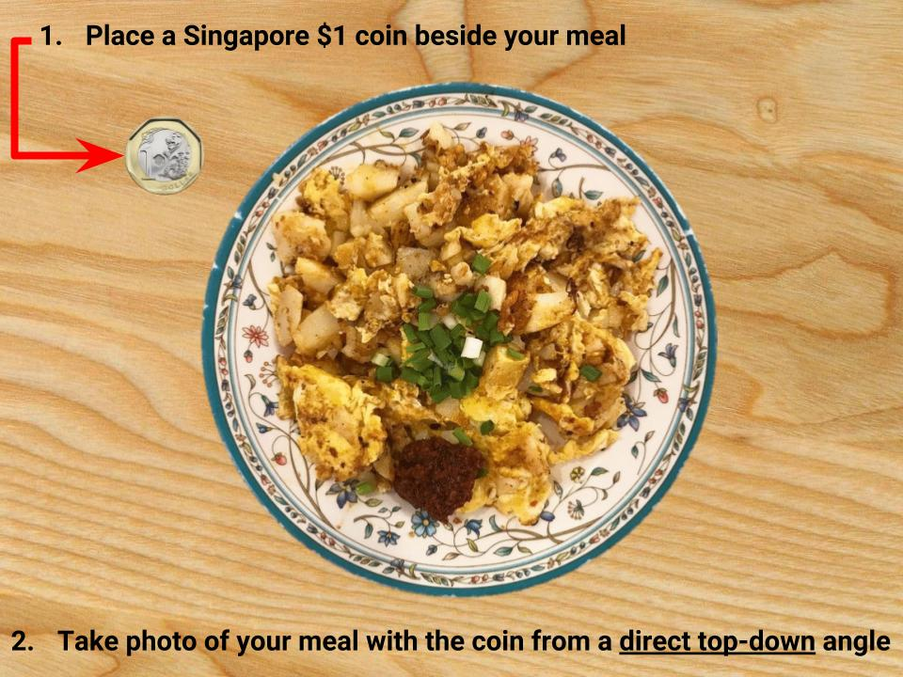
Before Intervention
- The following email message is sent to participants upon their acceptance and response to the invitation to participate in the current research study.

“Dear <Name of Participant>,

We have received your interest to participate in the study on <The Impact of Behavioural Nudges Administered via WhatsApp>. Please visit this website via: (https://tinyurl.com/whatsappnudge) for the participation information sheet and to formally provide your informed consent to participate in this study.

Thank you!”

- The following WhatsApp message is sent to notify participants of the commencement of the food snapshot phase, hence, a photo of each of their meals on any of the whole day over a three days period is requested.

“Thank you for participating in the study on <The Impact of Behavioural Nudges Administered via WhatsApp>.

You are kindly requested to take a photo of each of your meals for any whole day over the next three days, and send them through WhatsApp. Please follow this photo composition specification above when photographing your meals.”

- The following WhatsApp message serves as a reminder for participants to submit the photos they took the previous day, and also, to remind them to take a photo of each of their meals for the ongoing day if they have not done so.

“You are kindly reminded to submit the photos of your meals taken yesterday. We want to thank those who have already submitted their photos.

If you have not done so, please be reminded to take a photo of each of your meals for the whole of today and send them through WhatsApp tomorrow. Please follow this photo composition specification above when photographing your meals. Thank you!”

- The following WhatsApp message is sent to participants on the last day, reminding them to submit the photos taken the previous day.

“You are kindly reminded to submit the photos of your meals taken yesterday if you have not done so. We want to thank those who have already submitted their photos. After this, you are not required to take photos of your meals anymore for now.

Starting tomorrow, you will receive a behavioural message from us through WhatsApp every two days at 7 a.m. over a span of 23 days. Please do read the messages sent to you.”

Intervention
- The following WhatsApp message is sent to cue participants towards undertaking and completing the Mid-intervention survey.

“Thank you for your continued participation! Today is Day 16 and as previously mentioned, you are kindly requested to complete the second survey of the study. The survey can be accessed online via (https://tinyurl.com/whatsappnudge2). It should take no more than 10 minutes to complete it.”

After Intervention
- The following WhatsApp message is sent to cue participants towards undertaking and completing the After-intervention survey, and to begin taking a photo of each of meals from a whole day.

“Thank you for your continued participation! As previously mentioned, you are kindly requested to complete the final survey of the study. The survey can be accessed online via (https://tinyurl.com/whatsappnudge3 ). It should take no more than 10 minutes to complete.

Also, you are requested to begin taking a photo of each of your meals for a whole day and send them through WhatsApp tomorrow. Please follow the photo composition specification above when photographing your meals.”
- The following WhatsApp message is sent to participants, serving as a reminder to submit the photos taken the previous day, as well as in reminding participants to take a photo of each of meals for an entire day if they have not done so.

“You are kindly reminded to submit the photos of your meals taken yesterday. We want to thank those who have already submitted their photos.

If you have not done so, please be reminded to take a photo of each of your meals for the whole of today and send them through WhatsApp tomorrow. Please follow this photo composition specification above when photographing your meals. Thank you!”

- The following WhatsApp message is sent to participants on the last day, serving as a reminder to submit the photos they took the day before.

“You are kindly reminded to submit the photos of your meals taken yesterday if you have not done so. We want to thank those who have already submitted their photos.”

- The following WhatsApp message is sent to participants on the last day after they have submitted their last set of photos.

“Thank you for your valued participation and cooperation over the past weeks! You are not required to take photos of your meals anymore.

You have now reached the end of the study. Feel free to email us if you have any queries. Thank you for your contribution to our research.”

Table S3: List of Behavioral Change Messages

Day | Control | Health Consequences | Behavior substitution | Social comparison
1 | 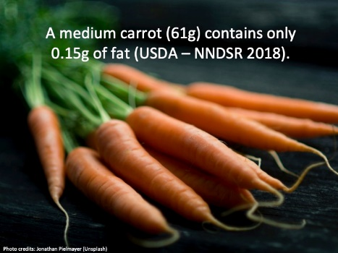 | 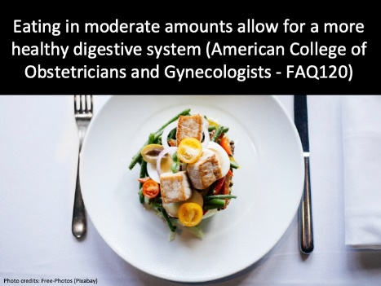 | 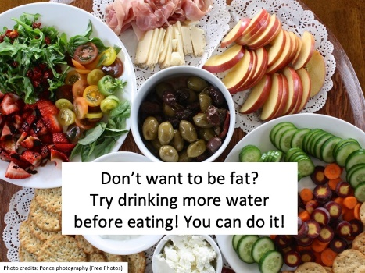 | 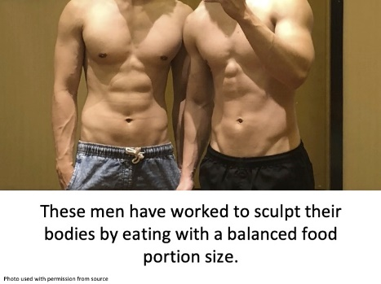
2 | 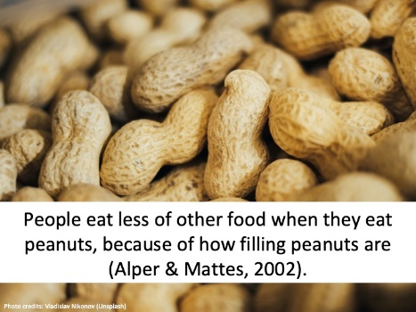 | 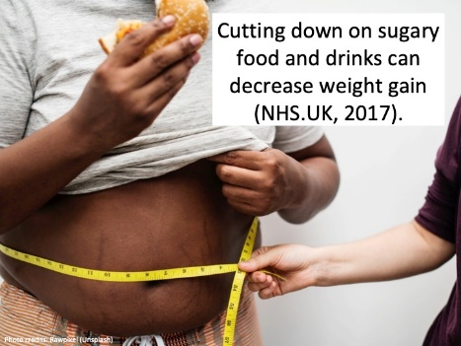 | 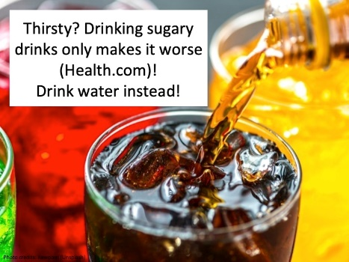 | 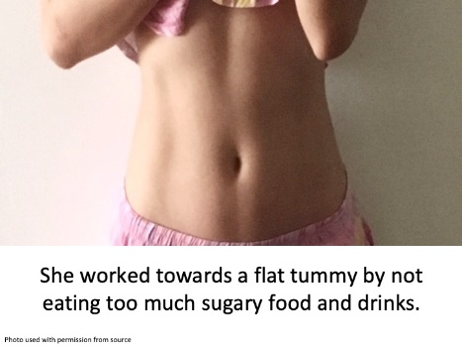
3 | 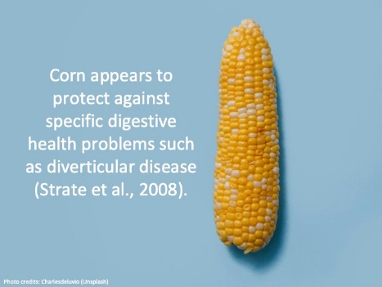 | 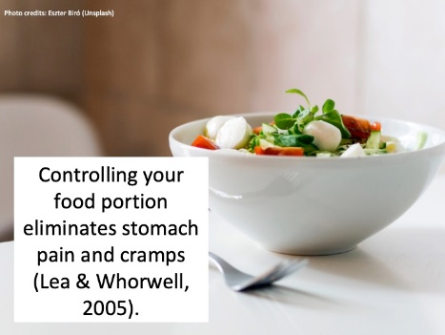 | 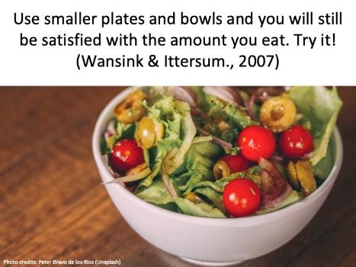 | 
4 | 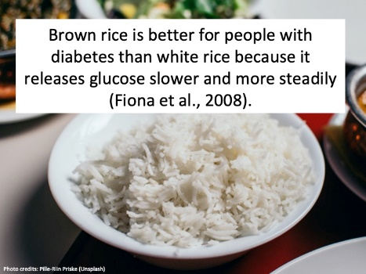 | 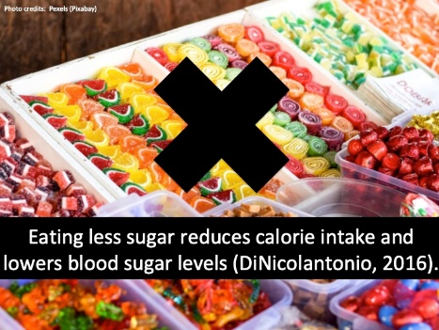 | 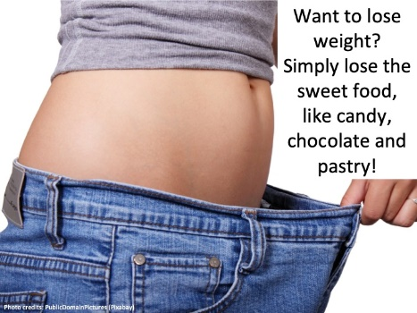 | 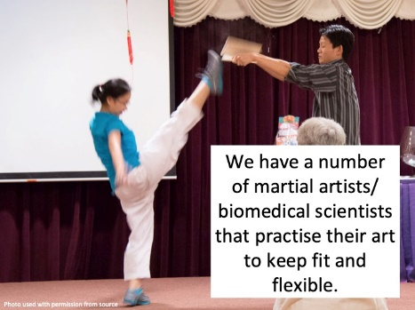
5 | 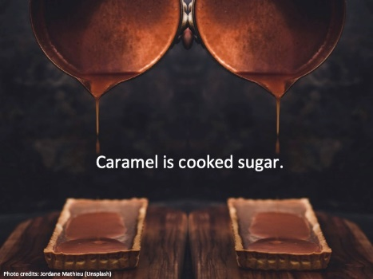 | 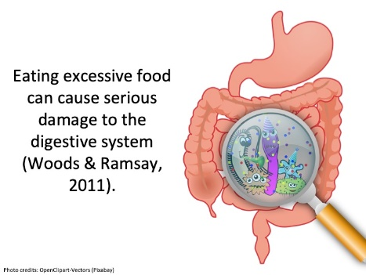 | 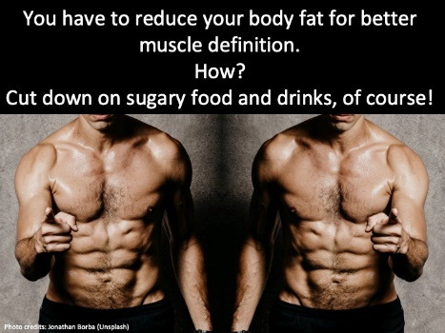 | 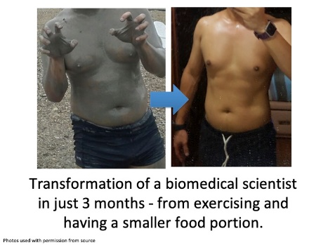
6 | 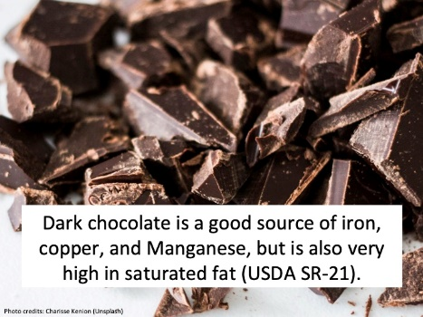 | 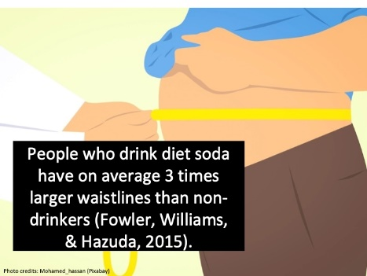 | 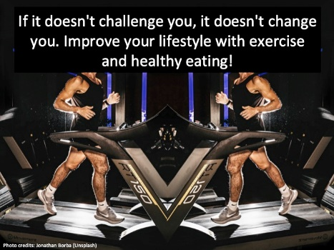 | 
7 | 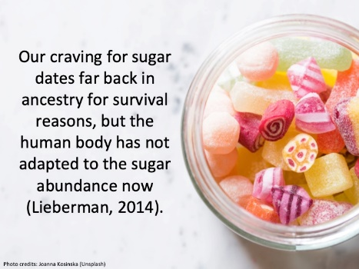 | 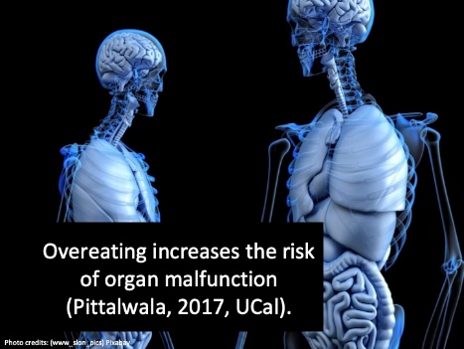 | 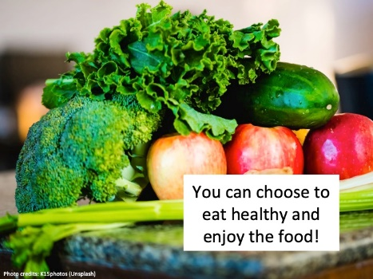 | 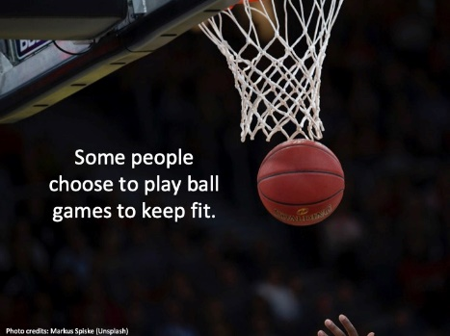
8 | 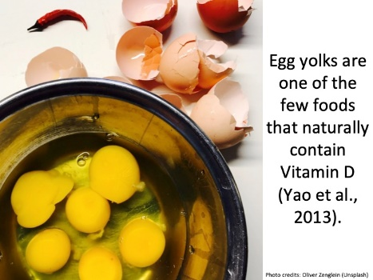 | 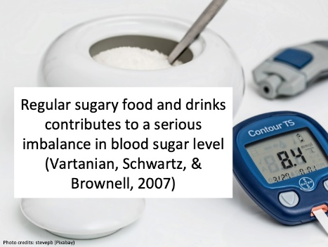 | 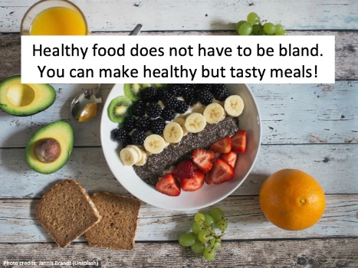 | 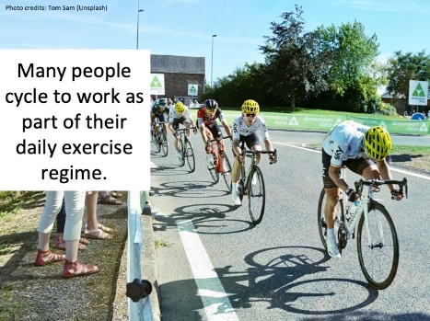
9 | 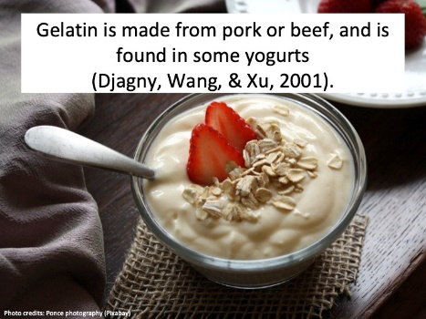 | 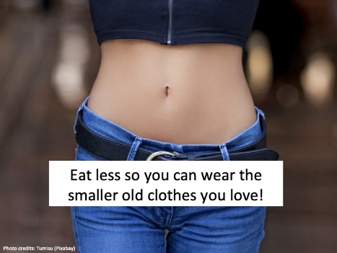 | 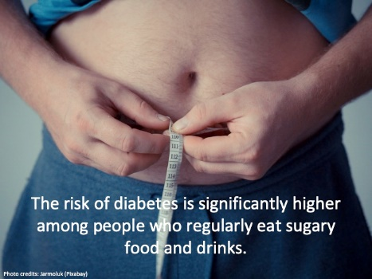 | 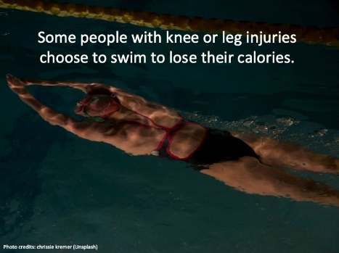
10 | 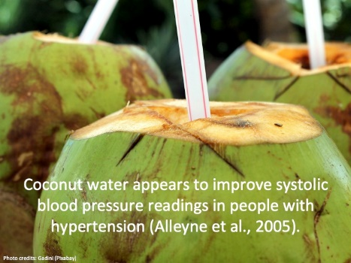 | 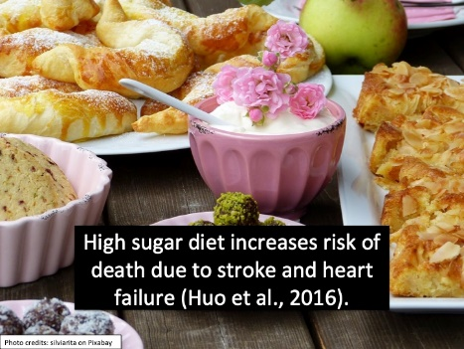 | 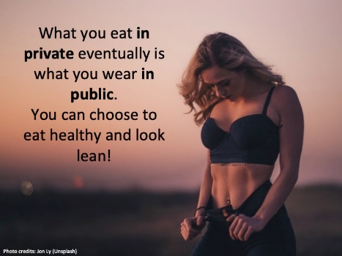 | 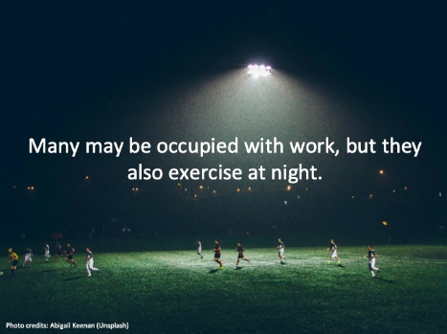
11 | 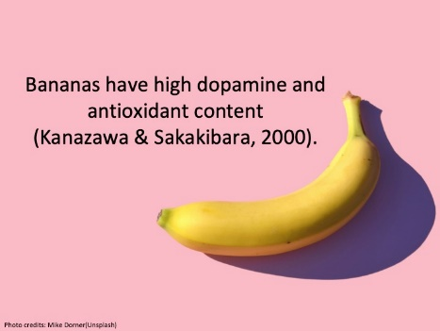 | 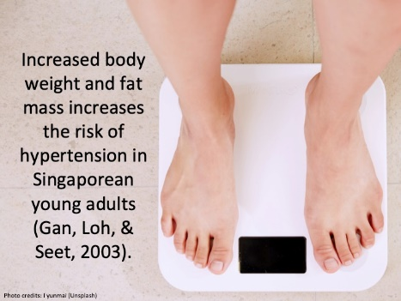 | 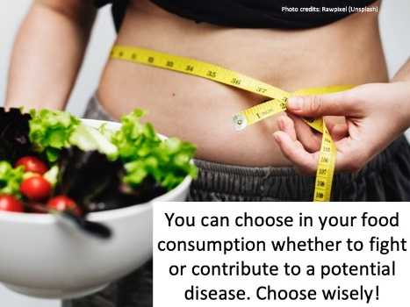 | 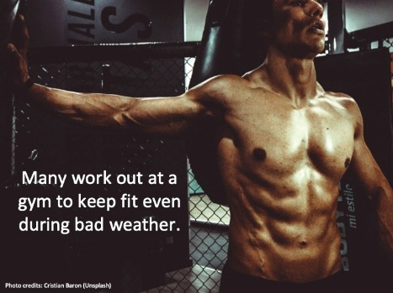
12 | 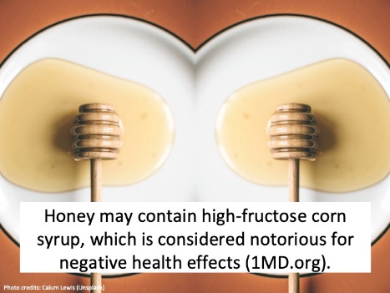 | 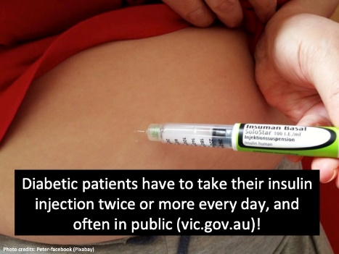 | 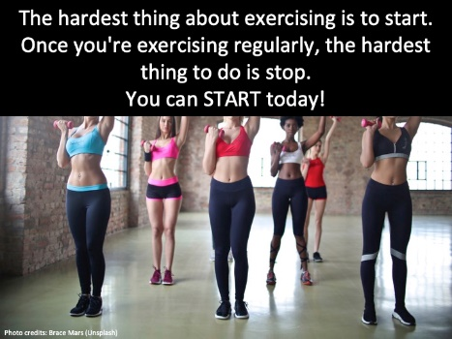 | 