RELAXED PACK
THE HATE RACE
23 February – 17 March 2024

VISUAL GUIDE: MALTHOUSE THEATRE
113 STURT STREET SOUTHBANK VIC 3006
THE HATE RACE GENERAL INFORMATION

Inspired by the best-selling, award-winning memoir by Australian writer and poet of Afro-Caribbean descent Maxine Beneba Clarke, The Hate Race is an unflinching exploration of the complexities of race in Australia, and the universal search for belonging. Making its theatrical premiere on the Malthouse stage, this powerful story stars Zahra Newman (Wake in Fright), accompanied by multidisciplinary performer and musician Kuda Mapeza. Zahra embodies all characters from the book with astonishing honesty and theatricality.

The Hate Race follows Maxine’s childhood in Sydney’s western suburbs, as she navigates the sting of otherness. From everyday street encounters to schoolyard battles, Maxine’s story exposes the realities of growing up the child of Black migrants in a predominantly white society. This inventive reimagining, filled with poetry, music and beats, invites audiences to experience Maxine’s world—exposing biases, challenging societal norms, and asking us to foster empathy and understanding as we seek an inclusive future.

The Hate Race is more than a theatrical experience—it is a call to action. This is how we change.

Dates: 23 February 2024 – 17 March 2024
Relaxed Performance: No dedicated relaxed performance, please talk to our Front of House or Box Office Team if you require assistance.

Venue: Beckett Theatre, The Malthouse, 113 Sturt Street, Southbank VIC 3006

Company Website: https://www.malthousetheatre.com.au/

Malthouse Theatre Access Webpage: https://www.malthousetheatre.com.au/your-visit/access/

The Hate Race Event Page: https://www.malthousetheatre.com.au/what-s-on/malthouse-theatre/the-hate-race/

The Hate Race – LABRISH: Community Engagement Program: https://www.malthousetheatre.com.au/discover/labrish/

PERFORMANCE STYLE

DURATION / Approx. 65 minutes (no interval)

HOW TO BOOK / CONTACT US

Information about The Malthouse venue and The Hate Race can be found on Malthouse Theatre’s website www.malthousetheatre.com.au

You can book tickets on the website or by calling the Box Office on (03) 9685 5111.

For more detailed access information, please feel free to contact our box office team on: boxoffice@malthousetheatre.com.au

We are committed to continual improvement and learning and welcome your feedback.

HOW TO GET TO THE MALTHOUSE

The Malthouse is located at 113 Sturt Street in Southbank. You can get here by tram, train, bike or car.

Tram: The closest tram stop is Stop 18 – Grant Street/Sturt Street (Route 1). You can also get to the venue from St Kilda Road. Get off at Stop 17 – Grant Street, Police Memorial/St Kilda Road. From this stop, it is a 6-minute walk to the venue via Grant Street.
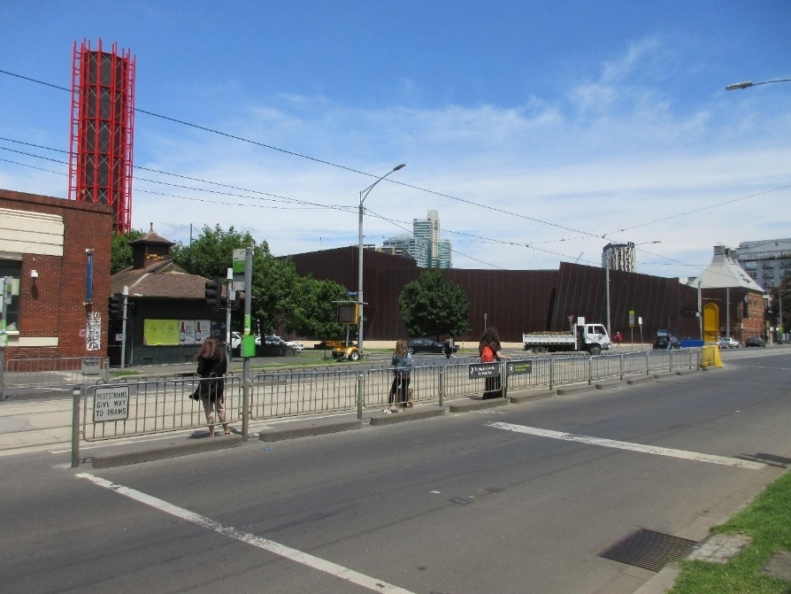
Pictured: The view of Stop 18 with Malthouse and ACCA in the distance

Train: Flinders Street station is approximately 15-minute walk away.

Bike: There are bike racks and a Melbourne Bike Share station outside The Malthouse.

Car: There is limited on-street parking on Grant Street, Sturt Street and Dodds Street. There are 2 disabled spaces outside The Malthouse entrance on Sturt Street.

The closest secure carparks are:
- Arts Centre Melbourne Car Park (enter from Sturt Street)
- The Australian Ballet Centre Car Park (2 Kavanagh Street)

VENUE IMAGES

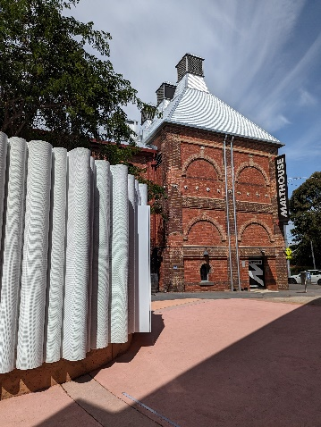
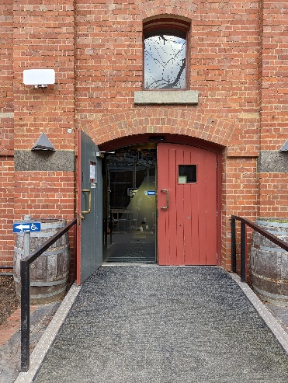
Entrance from Sturt Street side
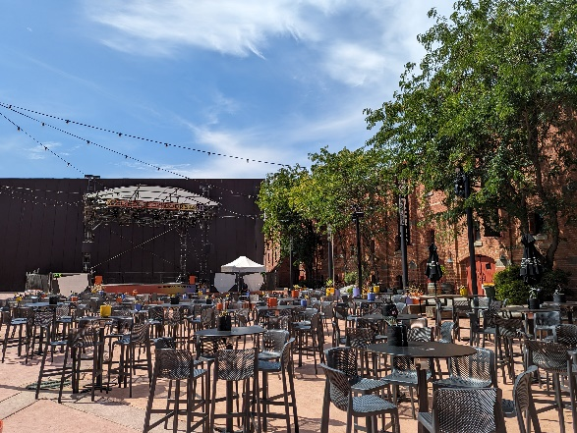

Entrance from Dodds Street side (wheelchair access)
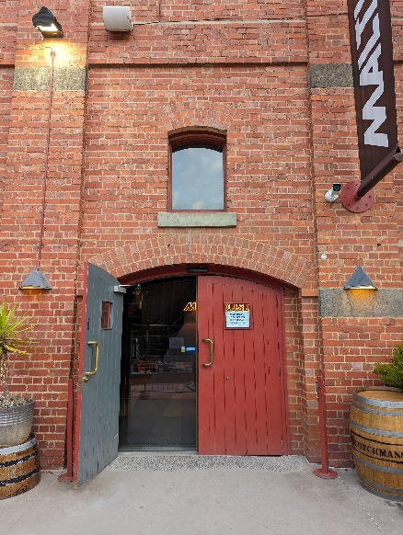
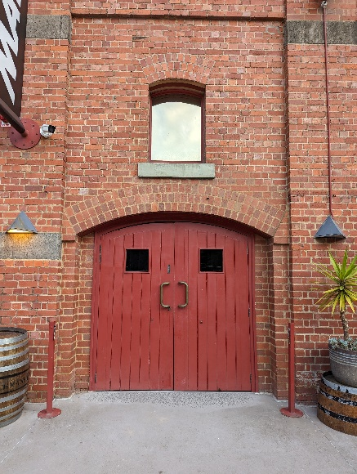
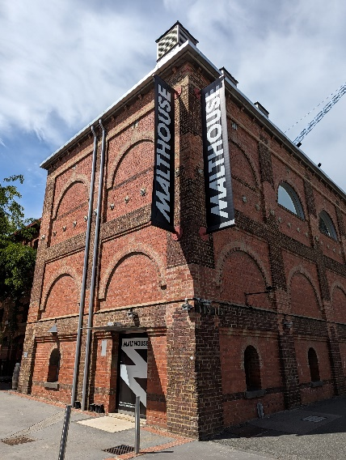

Sanitiser station in the Foyer

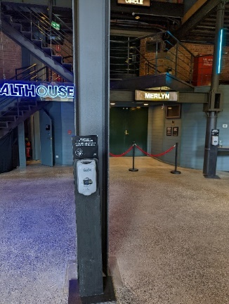
Bar and seating in the Foyer
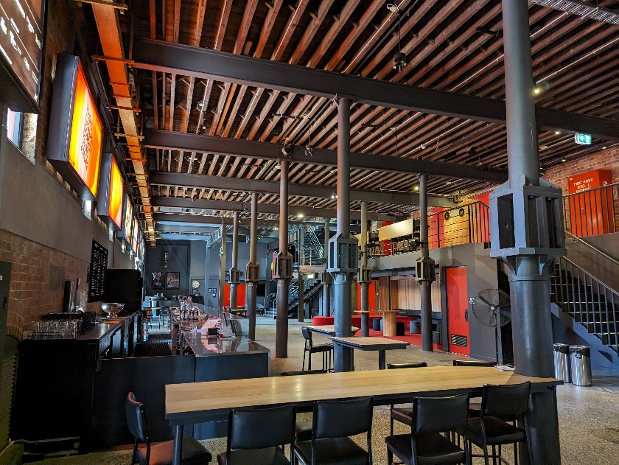

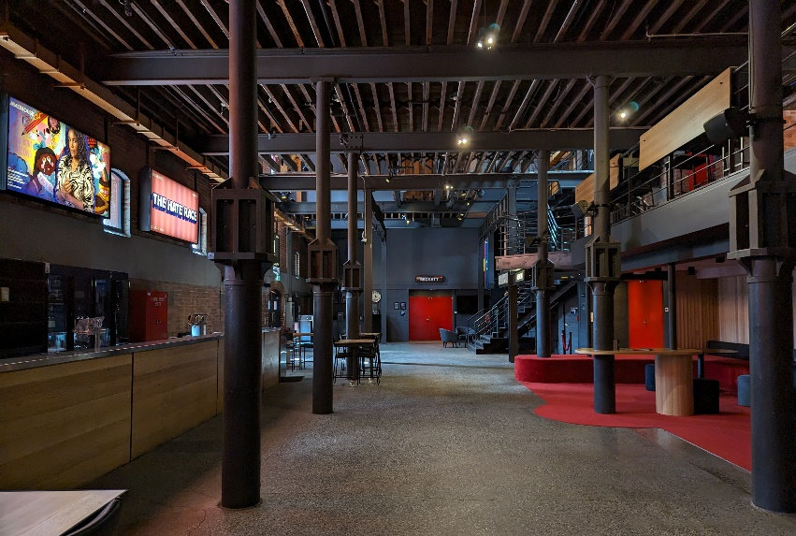

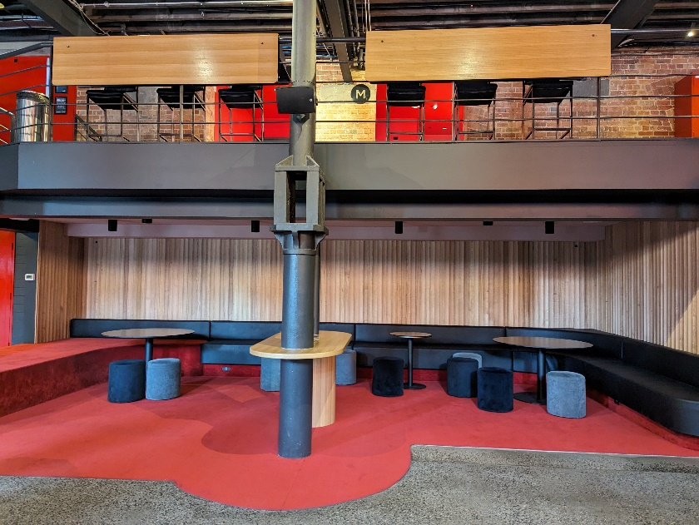
Box Office in the Foyer
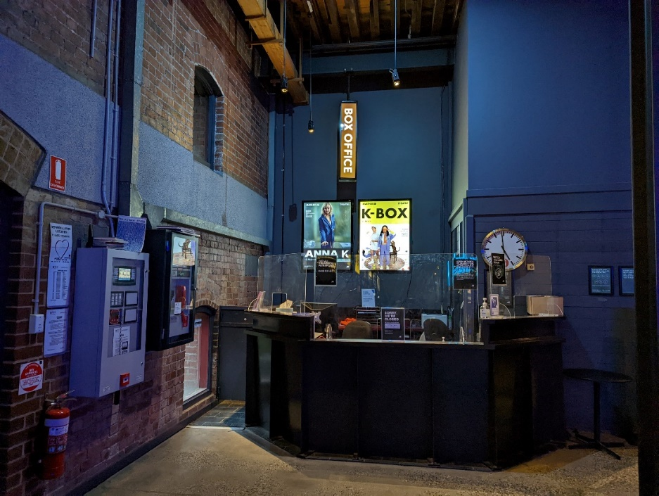

Bathroom in Foyer (Ground Level)

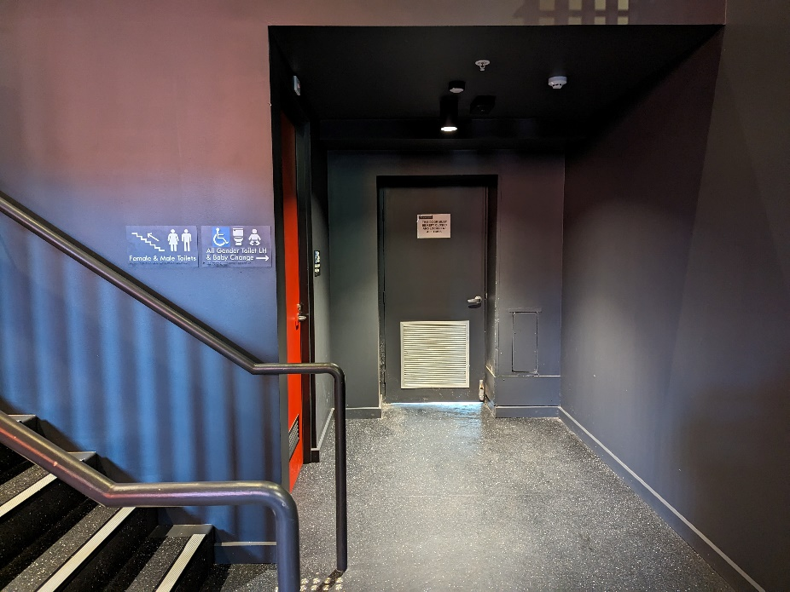

All gender toilet, Baby Change

Bathrooms on Mezzanine (up two flights of stairs)

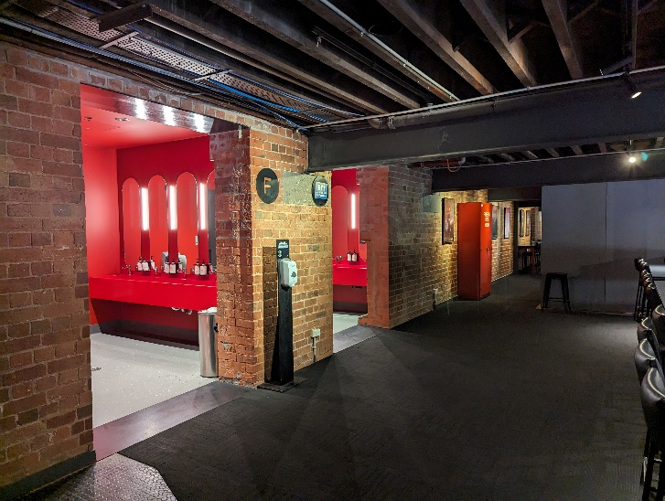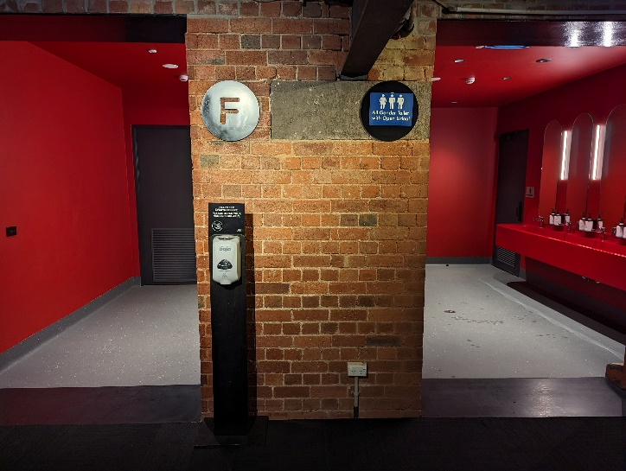

Beckett Theatre entrance
This entrance is wheelchair accessible.
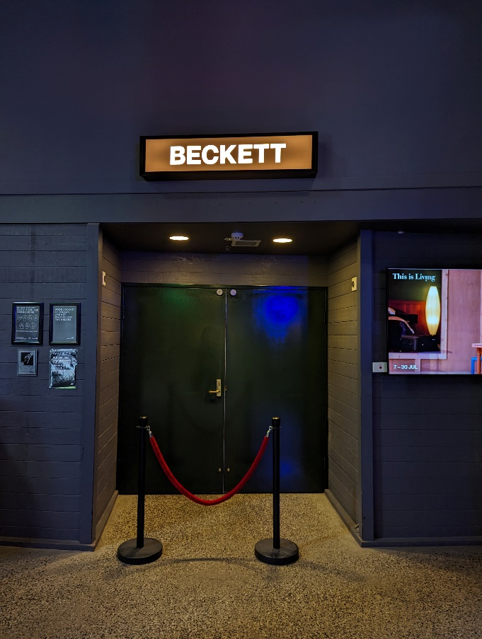

THE CAST
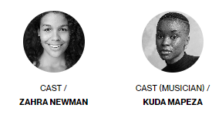

LIST OF CONTENT ADVICE / WARNINGS

FREQUENT COARSE LANGUAGE
FREQUENT USE OF RACIST LANGUAGE
Throughout the show there is frequent use of racially violent slurs. Some are explicitly said, and others are implied. If you would like more information on what words are said, please contact New Work Manager Bernadette Fam on engineroom@malthousetheatre.com.au
EXPLORATIONS OF RACE AND EXPLICIT DEPICTIONS OF RACISM (BOTH PHYSICAL AND VERBAL)
The Hate Race follows Maxine’s childhood growing up Black in the predominantly white suburbs of Western Sydney in the 1980’s and 1990s.
The emotional arc of the work follows Maxine as she faces different forms of racism in her schooling and adult life. We bear witness to Maxine’s journey as she finds her voice and creative expression despite of the hate she faces. Consequently, within the work there is frequent depiction and descriptions of racism – both physical and verbal – towards Maxine.
There is also a scene which speaks about an act of racial violence Maxine has committed towards another student.
The forms of racism explored within the show are:
- Interpersonal Racism
- Institutional Racism
- Systemic Racism
- Internalised Racism
- Cultural Appropriation
The forms of verbal violence within the show include:
- Racial slurs
- Threats to harm another individual
- Bullying
- Microaggressions
The forms of physical racial violence within the show include:
- Bullying such as the throwing of rocks and physically blocking an individual from passing
- Threats to harm another individual
If you would like more information on what instances of racism occur in the show, please contact New Work Manager Bernadette Fam on engineroom@malthousetheatre.com.au
REFERENCES TO SLAVERY
There are multiple references to slavery within the work. There is a key scene where the Transatlantic Slave Trade and Empire Windrush is explained in detail to child Maxine by her father.
DEPICTIONS OF ANXIETY
There are multiple instances where the character of Maxine experiences mild to severe anxiety, including panic attacks, due to racial attacks.
STROBING LIGHTS AND DYNAMIC SOUND

LABRISH PEACE POD

Located at Malthouse, this is a quiet space just for you. Outfitted with meditations, reflective activities, soft furnishings and sensory toys, this is your nook to be still and process whatever arises. The Peace Pod is open one hour before and after every The Hate Race performance.

Curated by our mental health partner, Pola Practice.

Pictured: The ‘Peace Pod’ a quiet space upstairs on level 3

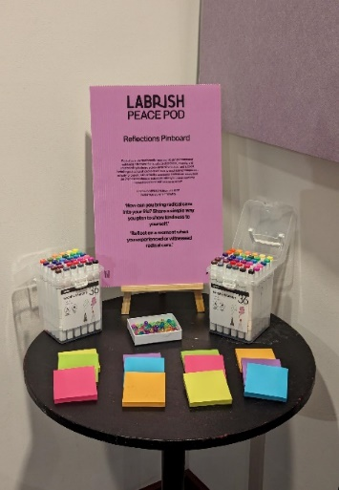
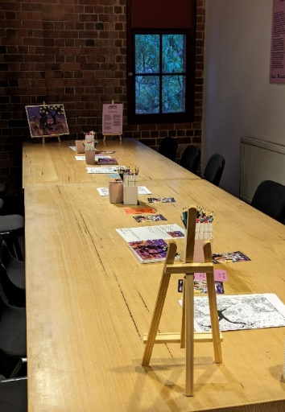
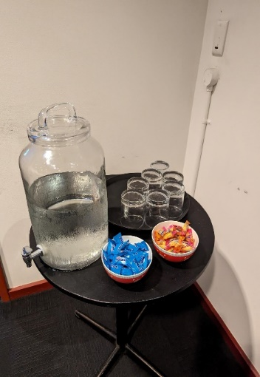
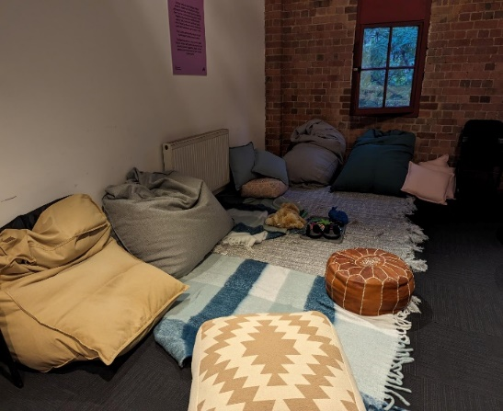
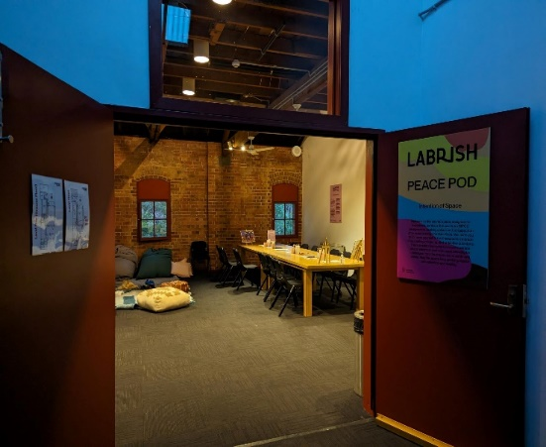
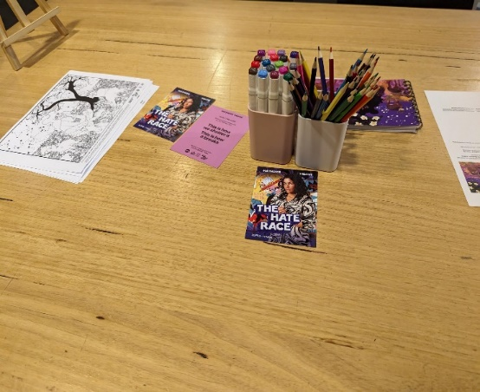
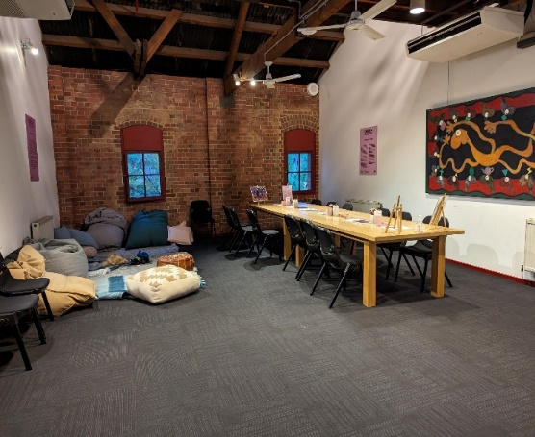

THEATRES
The Malthouse has three theatres, The Merlyn, The Beckett and the Tower Theatre.
The Hate Race is playing in the Beckett Theatre.

All theatres and spaces at the Malthouse are clearly marked. There are many staff members who will be able to assist you if you have any questions.

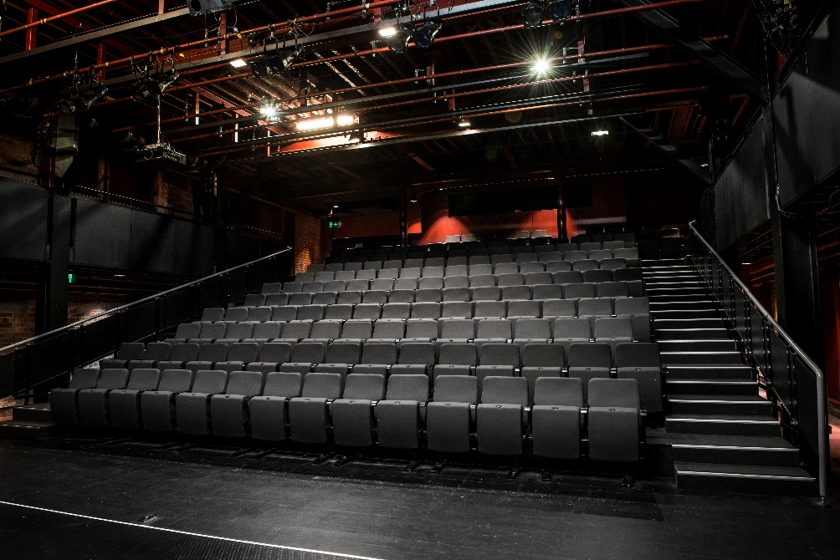

Below is a picture of inside the Beckett Theatre

The theatre seats are organized in rows, labelled with letters from A to M. Each seat also has a number on it. Your ticket will show which row and seat number you can sit in.

Pictured: theatre seats with number labels

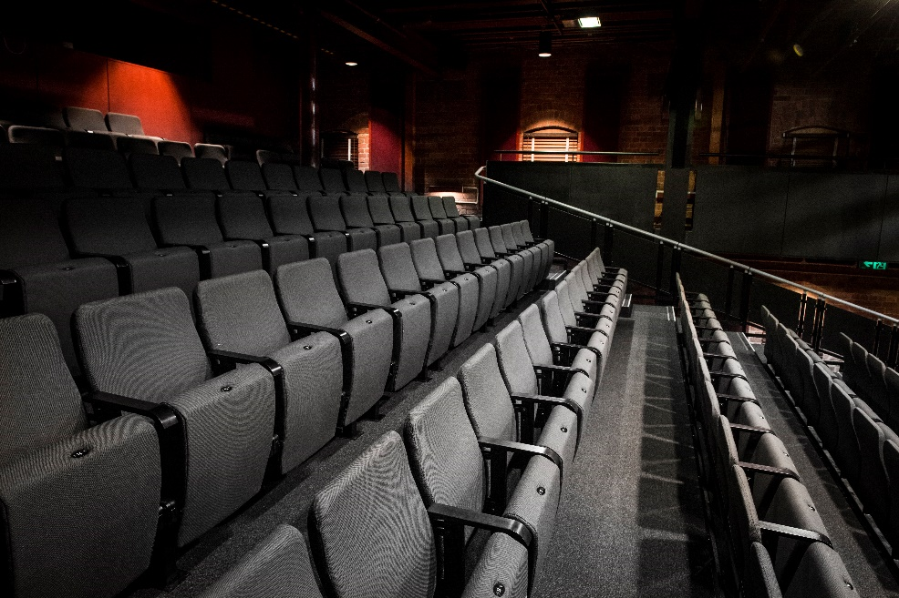

WE’RE HERE TO ASSIST
If you need help finding your seat, or with anything else, you can ask a Malthouse Theatre Usher. Ushers wear a uniform of a black shirt with a lanyard.

Pictured: Usher wearing their uniform.

