Supporting Information

Genome-guided discovery of the first myxobacterial Biarylitide Myxarylin reveals C–N biaryl crosslinking in RiPP biosynthesis

Joachim J. Hug ^{1,2,†}, Nicolas A. Frank ^{1,2,†}, Christine Walt ^{1,2}, Petra Šenica ^{1,2}, Fabian Panter ^{1,2,3} and Rolf Müller ^{1,2,3,}*

1 Helmholtz-Institute for Pharmaceutical Research Saarland (HIPS), Helmholtz Centre for Infection Research (HZI), Saarland University, Campus E8 1, 66123 Saarbrücken, Germany;
Joachim.Hug@helmholtz-hips.de (J.J.H.); Nicolas.Frank@helmholtz-hips.de (N.A.F.); Christine.Walt@helmholtz-hips.de (C.W.); Petra.Senica1@gmail.com (P.S.); Fabian.Panter@gmail.com (F.P.)
2 German Center for Infection Research (DZIF), Partner Site Hannover-Braunschweig, Germany
3 Helmholtz International Labs, Campus E8 1, 66123 Saarbrücken, Germany
* Correspondence: rolf.mueller@helmholtz-hips.de
† These authors contributed equally to this work.
Table of Contents
1 Myxobacterial culture media 3
2 Molecular cloning, construction of expression plasmids and genetic investigation 6
2.1 Genetic investigations 7
2.2 Heterologous production of Myxarylin in M. xanthus DK1622 8
3 Compound Characterization 10
3.1 Tandem MS spectra 10
3.2 Structure elucidation 11
3.2.1 NMR-based structure elucidation 11
3.2.2 NMR spectra employed in Myxarylin structure elucidation 14
3.2.3 Elucidation of the absolute stereochemistry 27
4 References 33

Myxobacterial culture media
Table S1. Recipe for VY/2 medium.
VY/2 – Medium
Amount | Ingredient | Concentration | Supplier
5 g/L | Yeast (entire cells) | - | Deutsche Hefewerke GmbH, Nürnberg, Germany
5 g/L | Soluble Starch | - | Carl Roth GmbH, Karlsruhe, Germany
1 g/L | CaCl₂• 2H₂O | - | Sigma Aldrich Chemie GmbH, Taufkirchen, Germany
1 g/L | MgSO₄ • 7H₂O | - | Grüssing GmbH, Filsum, Germany
10 mL/L | TRIS • HCl pH 8 | 1 M | Sigma Aldrich Chemie GmbH, Taufkirchen, Germany
100 µL/L | Sterile Vit. B12 solution  (added after autoclaving) | 1 mg/mL | Carl Roth GmbH, Karlsruhe, Germany
200 µL/L | Sterile FeNaEDTA solution  (added after autoclaving) | 8 mg/mL | Sigma Aldrich Chemie GmbH, Taufkirchen, Germany
Dissolved in milli-Q. Water, pH adjusted to 7.2 with 1N HCl
Table S2. Recipe for VY medium.
VY – Medium
Amount | Ingredient | Concentration | Supplier
10 g/L | Yeast (entire cells) | - | Deutsche Hefewerke GmbH, Nürnberg, Germany
5 g/L | Soluble Starch | - | Carl Roth GmbH, Karlsruhe, Germany
1 g/L | CaCl₂• 2H₂O | - | Sigma Aldrich Chemie GmbH, Taufkirchen, Germany
1 g/L | MgSO₄ • 7H₂O | - | Grüssing GmbH, Filsum, Germany
10 mL/L | TRIS • HCl pH 8 | 1 M | Sigma Aldrich Chemie GmbH, Taufkirchen, Germany
100 µL/L | Sterile Vit. B12 solution  (added after autoclaving) | 1 mg/mL | Carl Roth GmbH, Karlsruhe, Germany
200 µL/L | Sterile FeNaEDTA solution  (added after autoclaving) | 8 mg/mL | Sigma Aldrich Chemie GmbH, Taufkirchen, Germany
Dissolved in milli-Q. Water, pH adjusted to 7.2 with 1N HCl
Table S3. Recipe for CFL medium.
CFL – Medium
Amount | Ingredient | Concentration | Supplier
3 g/L | Tryptone | - | Becton, Dickinson and Company, Sparks, MD, USA
1 g/L | Soytone | - | Becton, Dickinson and Company, Sparks, MD, USA
3.5 g/L | Soluble Starch | - | Carl Roth GmbH, Karlsruhe, Germany
4 g/L | Maltose Monohydrate | - | Sigma Aldrich Chemie GmbH, Taufkirchen, Germany
2 g/L | Glucose | - | Carl Roth GmbH, Karlsruhe, Germany
0.5 g/L | CaCl₂• 2H₂O | - | Sigma Aldrich Chemie GmbH, Taufkirchen, Germany
1 g/L | MgSO₄ • 7H₂O | - | Grüssing GmbH, Filsum, Germany
10 mL/L | TRIS • HCl pH 8 | 1 M | Sigma Aldrich Chemie GmbH, Taufkirchen, Germany
100 µL/L | Sterile Vit. B12 solution  (added after autoclaving) | 1 mg/mL | Carl Roth GmbH, Karlsruhe, Germany
200 µL/L | Sterile FeNaEDTA solution  (added after autoclaving) | 8 mg/mL | Sigma Aldrich Chemie GmbH, Taufkirchen, Germany
Dissolved in milli-Q. Water, pH adjusted to 7.5 with 1N KOH
Table S4. Recipe for P medium.
P – Medium
Amount | Ingredient | Concentration | Supplier
2 g/L | Peptone (Phytone) | - | Becton, Dickinson and Company, Sparks, MD, USA
4 g/L | Probion FM582 | - | Hoechst GmbH, Frankfurt, Germany
8 g/L | Soluble Starch | - | Carl Roth GmbH, Karlsruhe, Germany
2 g/L | Glucose | - | Carl Roth GmbH, Karlsruhe, Germany
1 g/L | CaCl₂• 2H₂O | - | Sigma Aldrich Chemie GmbH, Taufkirchen, Germany
1 g/L | MgSO₄ • 7H₂O | - | Grüssing GmbH, Filsum, Germany
10 mL/L | TRIS • HCl pH 8 | 1 M | Sigma Aldrich Chemie GmbH, Taufkirchen, Germany
100 µL/L | Sterile Vit. B12 solution  (added after autoclaving) | 1 mg/mL | Carl Roth GmbH, Karlsruhe, Germany
200 µL/L | Sterile FeNaEDTA solution  (added after autoclaving) | 8 mg/mL | Sigma Aldrich Chemie GmbH, Taufkirchen, Germany
Dissolved in milli-Q. Water, pH adjusted to 7.5 with 1N KOH
Table S5. Recipe for M medium.
M – Medium
Amount | Ingredient | Concentration | Supplier
10 g/L | Soy Peptone | - | Becton, Dickinson and Company, Sparks, MD, USA
10 g/L | Maltose monohydrate | - | Becton, Dickinson and Company, Sparks, MD, USA
1 g/L | CaCl₂• 2H₂O | - | Sigma Aldrich Chemie GmbH, Taufkirchen, Germany
1 g/L | MgSO₄ • 7H₂O | - | Grüssing GmbH, Filsum, Germany
10 mL/L | TRIS • HCl pH 8 | 1 M | Sigma Aldrich Chemie GmbH, Taufkirchen, Germany
100 µL/L | Sterile Vit. B12 solution  (added after autoclaving) | 1 mg/mL | Carl Roth GmbH, Karlsruhe, Germany
200 µL/L | Sterile FeNaEDTA solution  (added after autoclaving) | 8 mg/mL | Sigma Aldrich Chemie GmbH, Taufkirchen, Germany
Dissolved in milli-Q. Water, pH adjusted to 7.5 with 1N KOH
Table S6. Recipe for YM medium.
YM – Medium
Amount | Ingredient | Concentration | Supplier
3 g/L | Yeast extract | - | Becton, Dickinson and Company, Sparks, MD, USA
3 g/L | Malt extract | - | Becton, Dickinson and Company, Sparks, MD, USA
5 g/L | Peptone (Phytone) | - | Becton, Dickinson and Company, Sparks, MD, USA
10 g/L | Glucose | - | Carl Roth GmbH, Karlsruhe, Germany
1 mL/L | K_{x}H_{y}PO₄ buffer pH 8.0 | 0.8 M | Sigma Aldrich Chemie GmbH, Taufkirchen, Germany
1 g/L | MgSO₄ • 7H₂O | - | Grüssing GmbH, Filsum, Germany
10 mL/L | TRIS • HCl pH 8 | 1 M | Sigma Aldrich Chemie GmbH, Taufkirchen, Germany
100 µL/L | Sterile Vit. B12 solution  (added after autoclaving) | 1 mg/mL | Carl Roth GmbH, Karlsruhe, Germany
200 µL/L | Sterile FeNaEDTA solution  (added after autoclaving) | 8 mg/mL | Sigma Aldrich Chemie GmbH, Taufkirchen, Germany
Dissolved in milli-Q. Water, pH adjusted to 7.5 with 1N KOH

Table S7. Recipe for CTT medium.
CTT – Medium
Amount | Ingredient | Concentration | Supplier
10 g/L | Casitone | - | Becton, Dickinson and Company, Sparks, MD, USA
10 mL/L | MgSO₄ • 7H₂O | 0.8 M | Grüssing GmbH, Filsum, Germany
1 mL/L | K_{x}H_{y}PO₄ buffer pH 8.0 | 0.1 M | Sigma Aldrich Chemie GmbH, Taufkirchen, Germany
10 mL/L | TRIS • HCl ph8 | 1 M | Sigma Aldrich Chemie GmbH, Taufkirchen, Germany
100 µL/L | Sterile Vit. B12 solution  (added after autoclaving) | 1 mg/mL | Carl Roth GmbH, Karlsruhe, Germany
200 µL/L | Sterile FeNaEDTA solution  (added after autoclaving) | 8 mg/mL | Sigma Aldrich Chemie GmbH, Taufkirchen, Germany
Dissolved in milli-Q. Water, pH adjusted to 7.6 with 1N KOH
Table S8. Recipe for AMB medium.
AMB– Medium
Amount | Ingredient | Concentration | Supplier
2.5 g/L | Casitone | - | Becton, Dickinson and Company, Sparks, MD, USA
5 g/L | Soluble starch | - | Carl Roth GmbH, Karlsruhe, Germany
10 mL/L | MgSO₄ • 7H₂O | 0.8 M | Grüssing GmbH, Filsum, Germany
1 mL/L | K_{x}H_{y}PO₄ buffer pH 8.0 | 0.1 M | Sigma Aldrich Chemie GmbH, Taufkirchen, Germany
10 mL/L | TRIS • HCl pH 8.0 | 1 M | Sigma Aldrich Chemie GmbH, Taufkirchen, Germany
100 µL/L | Sterile Vit. B12 solution  (added after autoclaving) | 1 mg/mL | Carl Roth GmbH, Karlsruhe, Germany
200 µL/L | Sterile FeNaEDTA solution  (added after autoclaving) | 8 mg/mL | Sigma Aldrich Chemie GmbH, Taufkirchen, Germany
Dissolved in milli-Q. Water, pH adjusted to 7.6 with 1N KOH

Molecular cloning, construction of expression plasmids and genetic investigation
Table S9. List of oligonucleotides used in this study.
No. | Primer name | Primer sequence 5’–3’
1 | Fw_mx8_PagI | ATATTCATGAGGCCATCGTCGAAAGAGTCG
2 | Rv_mx8_ScaI | ATATAGTACTAGGACTCCTCTGGCTGGGTG
3 | Fw_An_d48_NdeI | ATATCATATGAACTACCTGCACTGAGAGGAGCCTCCGTGCCCA
4 | Rv_An_d48_EcoRI | TATATGAATTCGAGGCGGCGTAGCCCTCA
5 | Mx8-attP-up2 | CGACGGTGCCGACAAATAC
6 | Mx8-attB-up2 | GCGCACTGGACCATCACGTC
7 | Mx8-attP-down | GGCTTGTGCCAGTCAACTGCG
8 | Mx8-attB-down | CGGATAGCTCAGCGGTAGAG
Restriction sites in bold, bytA and bytO start are underlined, RBS of bytO in yellow.
Table S10. List of oligonucleotides for sequencing used in this study.
No. | Primer name | Primer sequence 5’–3’
1 | P_{van}_Seq1 | TGTCAAGCTGCTGTTTTCGC
2 | M13-29R | CAGGAAACAGCTATGACC
3 | BiarylSeq1 | GAGGCGGCGTAGCCCTCA
4 | BiarylSeq2 | GAGGAGCCTCCGTGCCCA
Table S11. List of PCR-amplified constructs.
No. | PCR product name/characteristics | Size [bp] | template | Primers used
1 | mx8_integrase gene_PagI_ScaI | 1945 | pBen39 | primer No.1  primer No.2
2 | An_d48_bytAOZ | 2034 | gDNA from P. fallax An d48 | primer No.1  primer No.2
Table S12. List of plasmids used in this study.
No. | Plasmid name/ characteristic | Size [kb] | Function | Reference
1 | pFP_{Van}_pcyA | 6.181 | pCR 2.1 TOPO derivative; used as backbone for heterologous expression of bytAO | [1]
2 | pBen39 | 7.616 | mx8_integrase fragment mobilized on pUC-based plasmid pBen38/kanR, ampR | unpublished

Table S13. List of genetic constructs generated in this study.
No. | Plasmid name | Construction details/ characteristics
1 | pFP_{Van}_pcyA_mx8 | Construct obtained by conventional restriction ligation of plasmid pFP_{Van}_pcyA and PCR product No. 1
2 | pFP_{Van}_bytAOZ_mx8 | Construct obtained by conventional restriction ligation of construct No. 1 and PCR product No. 2

Genetic investigations
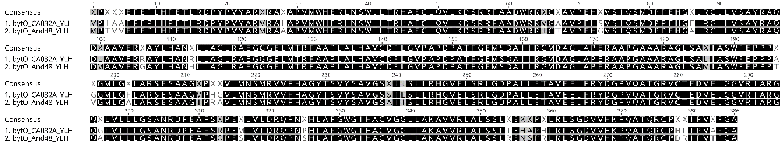
Figure S1. Amino acid alignment of myxobacterial BytO homologs from Pyxidicoccus sp. CA032A (bytO_CA032A_YLH) and Pyxidicoccus fallax An d48 (bytO_And48_YLH). Pairwise identity and identical sites: 91.5%.

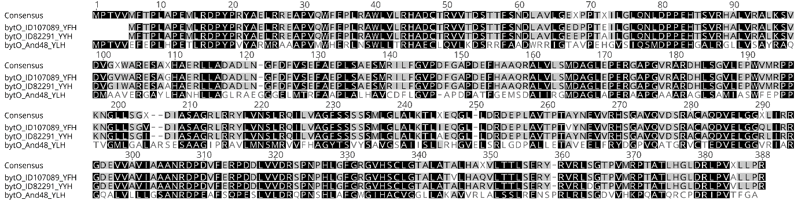
Figure S2. Amino acid alignment of BytO homologs from Planomonospora sp. ID107089 (bytO_ ID107089_YFH), Planomonospora sp. ID82291 (bytO_ID82291_YYH) and Pyxidicoccus fallax An d48 (bytO_And48_YLH). Pairwise identity: 59.5%, Identical sites: 40.7%.

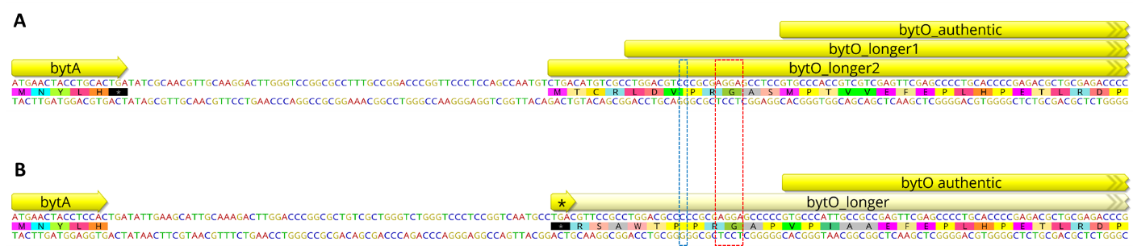
Figure S3. Nucleotide sequence and different orfs of bytO in Pyxidicoccus fallax An d48 (A) and Pyxidicoccus sp. CA032A (B) that are varying in nucleotide length. The length of a hypothetical bytO gene in Pyxidicoccus sp. CA032A is limited by the presence of a stop codon in the same translational frame. Pyxidicoccus fallax An d48 features in this genetic locus a single nucleotide deletion, which causes a frame shift (blue dashed box). Therefore two hypothetical longer orfs of bytO could be possibly expressed. Nevertheless, the most likely start of the myxobacterial bytO is in both nucleotide sequences labeled as bytO authentic for the following two reasons; firstly, a putative RBS (red dashed box) is only present in front of bytO authentic, and secondly in Pyxidicoccus sp. CA032A, only bytO authentic can be expressed, since any other longer version does not feature an appropriate start codon.

Heterologous production of Myxarylin in M. xanthus DK1622
To express the identified Myxarylin-BGC in M. xanthus DK1622, an expression vector was constructed based on the plasmid pFP_{Van}_pcyA.[1] To enable efficient genomic integration of the expression plasmid, the mx8 integrase gene originating from the bacteriophage Mx8 was PCR-amplified (Phusion™ High-Fidelity polymerase, Thermo Fisher Scientific) from pBen39 and the resulting PCR product subcloned into pFP_{Van}_pcyA via conventional restriction ligation (PagI, ScaI). The resulting plasmid pFP_{Van}_pcyA_mx8 (genetic construct 1) was subsequently used to incorporate the PCR-amplified Myxarylin-BGC (An_d48_bytAOZ, PCR product 2) from P. fallax An d48, which led to the final expression vector pFP_{Van}_bytAOZ_mx8 (genetic construct 2). The PCR-amplified operon (An_d48_bytAOZ, PCR product 2) differs from the natural sequence in that sense, it lacks the intergenic region between bytA and bytO (termed bytAO_intergenic region, Figure S3).

Figure S4. Nucleotide sequence encoding the precursor peptide BytA, the intergenic region termed bytAO, the putative ribosome binding site of bytO, and the first seven nucleotides encoding the cytochrome P450 dependent enzyme BytO.

Since the intergenic region bytAO features in silico the formation of secondary structures (Figure S5) –resembling those of known transcriptional terminators such as the tD1 terminator from M. xanthus bacteriophage Mx8 [2] – the heterologous expression construct was designed in a way to omit this 90 bp intergenic region and only includes 11 bp in which a putative ribosome binding site is incorporated (..AGGA..) (Figure S6).

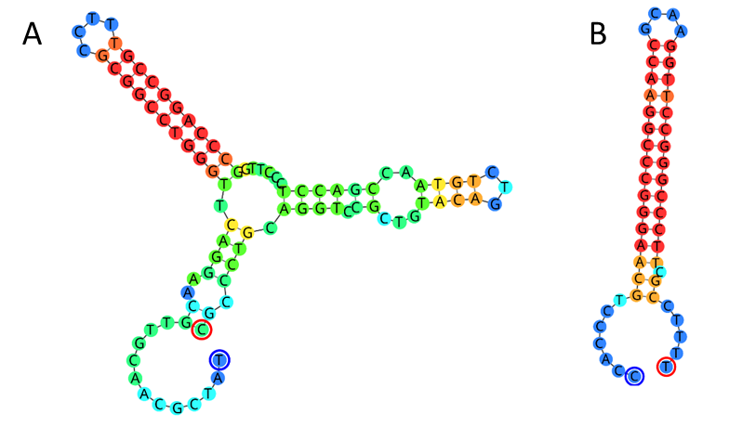
Figure S5. Predicted secondary structure of the 90 bp intergenic region bytAO (A), and the hair pin structure of the previously described 49 bp transcriptional terminator tD1 (B).

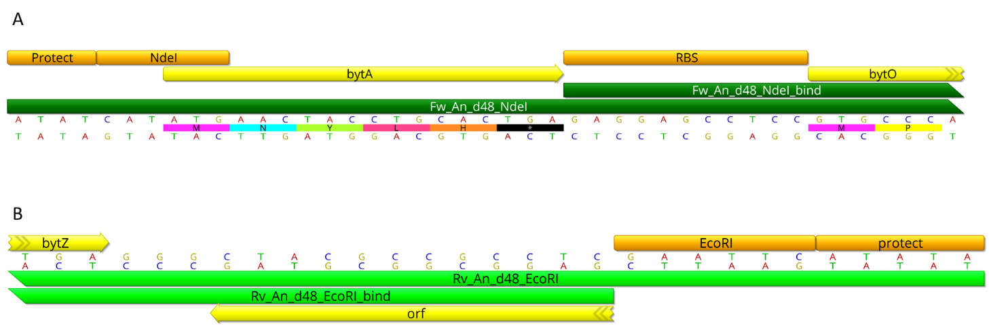
Figure S6. A) Nucleotide sequence and annotation of the primer Fw_An_d48_NdeI (Primer 3, 43 bp). Primer 3 comprises at the 5’ end extensions which include a protection site for the NdeI restricition site, the authentic bytA nucleotide sequence, the identified RBS site of bytO and the first seven nucleotides of the gene encoding BytO. Within Primer 3, 18 bp at the 3’ end is responsible for the site-specific annealing (termed Fw_An_d48_NdeI_bind). B) The associated reverse primer Rv_An_d48_EcoRI (Primer 4, 29 bp), was designed in a way that the genetic region downstream of bytZ remained unmodified in the respective PCR product. Hence, Primer 4 features at the 5’ end an extension for the EcoRI restriction site including a 5 bp protection site and 18 bp at the 3’ end for site-specific annealing (termed Rv_An_d48_EcoRI_bind).

Compound Characterization

Tandem MS spectra
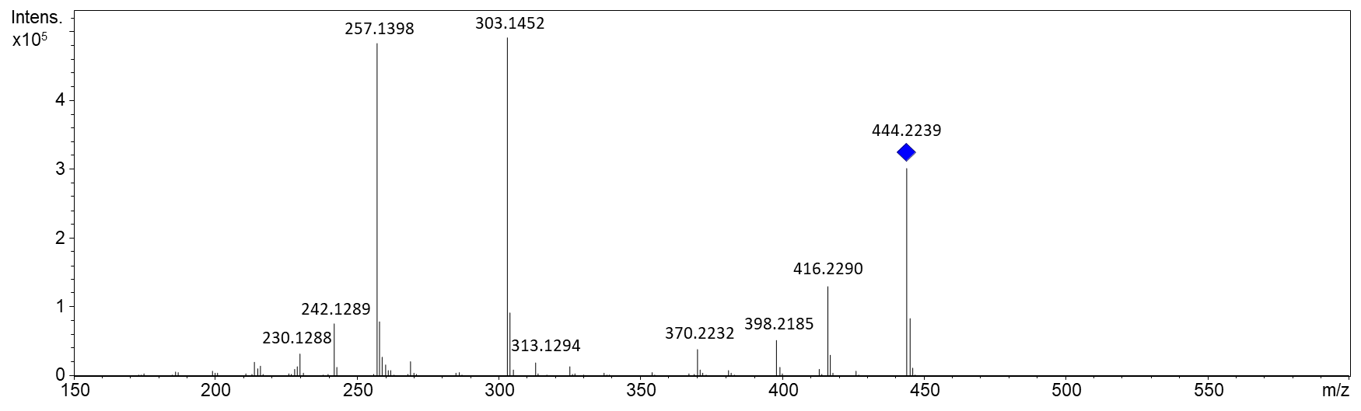
Figure S7. Tandem MS spectrum of 1 (collision energy: 35.0 eV). Leucine loss (Δm/z = 113.0841) is visible e.g. between 416.2290 m/z and 303.1452 m/z (err. 0.0003 m/z) or 370.2232 m/z and 257.1398 m/z (err. 0.0007 m/z).
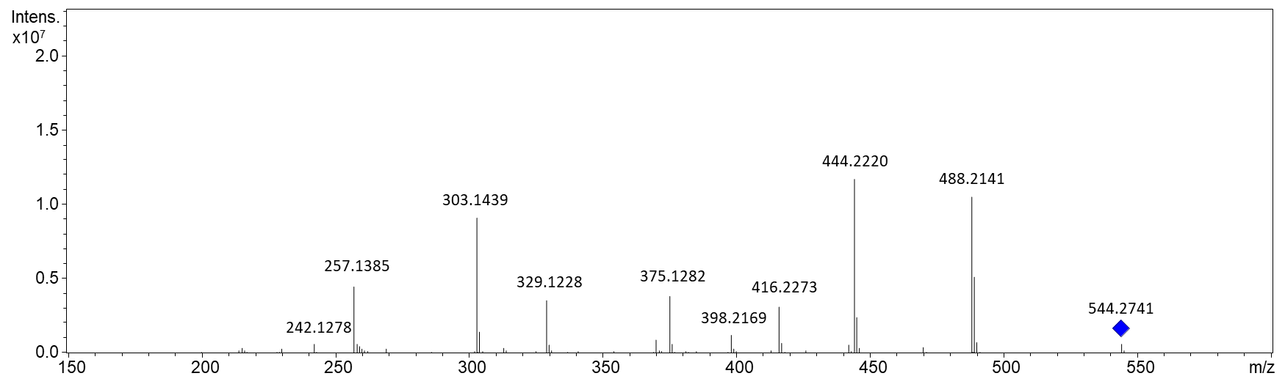
Figure S8. Tandem MS spectrum of 2 (collision energy: 35.9 eV).

Structure elucidation

NMR-based structure elucidation
Table S14. NMR spectroscopic data of 2 measured in methanol-d₄ at 700/175 MHz.
# | δ ¹³C [ppm] | δ ¹H [ppm], mult (J [Hz]) | δ ¹⁵N [ppm] | COSY | HMBC | sel NOesy | ¹H-¹⁵N HMBC
1 | 171.8 | - | - | - | - | n.m. | -
2 | 59.7 | 4.66, m | - | 3 | - | n.m. | -
3 | 34.2 | 3.55,2.56, dd (15.19, 11.77) | - | 2,3,5 | 1,2,5,9 | n.m. | -
4 | 131.1 | - | - | - | - | n.m. | -
5 | 126.1 | 6.84, m | - | - | - | n.m. | -
6 | - | - | - | - | - | n.m. | -
7 | 149.7 | - | - | - | - | n.m. | -
8 | 118.1 | 6.91, brs | - | 9 | 4,5,7,9 | 9 | -
9 | 130.2 | 7.03, d (8.13) | - | 8 | 3,5,7,8 | n.m. | -
10 | 157.6 | - | - | - | - | n.m. | -
11 | 81.9 | - | - | - | - | n.m. | -
12,13,14 | 28.8 | 1.48, s | - | - | 11,12,13,14- | n.m. | -
15 | 30.7 | 2.90, s | - | - | 2,10 | n.m. | 16
1’ | 173.7 | - | - | - | - | n.m. | -
2’ | 52.8 | 4.86, s | - | 3’ | 1,1’,3’,4’ | n.m. | -
3’ | 43.7 | 1.58, m | - | 2’,5’,6’ | 4’ | n.m. | -
4’ | 26.1 | 1.60, m | - | 5’,6’ | - | n.m. | -
5’,6’ | 23.8 | 0.94, m | - | 3’ | - | n.m. | -
1’’ | 177.8 | - | - | - | - | n.m. | -
2’’ | 55.2 | 4.61, dd (12.62, 2.78) | - | 3’’ | 1’,1’’,3’’,4’’ | n.m. | -
3’’ | 33.0 | 3.32,2.82, dd (16.47, 12.62) | - | 2’’,3’’,6’’ | 1’’,2’’,4’’,6’’ | n.m. | 18,20
4’’ | 139.3 | - | - | - | - | n.m. | -
5’’ | 138.5 | 7.94, s | - | 6’’ | 4’’,6’’ | - | 19,20
6’’ | 118.9 | 6.89, s | - | 3’’,5’’ | 4’’,5’’ | - | 19,20
16 | - | - | 84.7 | - | - | n.m. | -
17 | - | - | - | - | - | n.m. | -
18 | - | - | 123.1 | - | - | n.m. | -
19 | - | - | 174.6 | - | - | n.m. | -
20 | - | - | 247.3 | - | - | n.m. | -
n.m.: not measured

Table S15. NMR spectroscopic data of 1 measured in DMSO-d₆ at 700/175 MHz.
# | δ ¹³C [ppm] | δ ¹H [ppm], mult (J [Hz]) | COSY | HMBC
1 | 166.6 | - | - | -
2 | 61.1 | 4.08, m | 3,16 | -
3 | 33.1 | 3.16, m | 2,5,9 | 1,2,5,9
4 | - | - | - | -
5 | 127.8 | 6.81, d (2.25) | 3,9 | 3,7,9
6 | 125.3 | - | - | -
7 | 149.3 | - | - | -
8 | 117.1 | 7.08, d (8.34) | 9 | 6,7
9 | 131.8 | 7.23, dd (8.24,2.25) | 3,5,8 | 3,7,8
15 | 31.3 | 2.50, m | 16 | 2
1’ | 171.9 | - | - | -
2’ | 51.5 | 4.71, td (9.06,5.4) | 3’,17 | -
3’ | 42.1 | 1.54,1.48, m | 2’,4’ | 1’,2’,4’,5’,6’
4’ | 24.1 | 1.67, m | 5’,6’ | 3’,5’,6’
5’ | 22.7 | 0.93, d (6.63) | 4’ | 3’,4’,6’
6’ | 21.6 | 0.90 d (6.63) |  | 4’,5’
1’’ | 171.1 | - | - | -
2’’ | 50.6 | 4.58, ddd (12.25, 9.52, 2.78) | 3’’,18 | -
3’’ | 27.0 | 3.35,2.87, dd (15.19, 12.41) | 2’’,6’’ | 1’’,2’’,4’’,6’’
4’’ | 130.6 | - | - | -
5’’ | 135.6 | 9.35, s | 6’’ | 4’’,6’’
6’’ | 120.4 | 7.16, s | 3’’,5’’ | 4’’,5’’
16 | - | 8.79, brs | 2 | -
17 | - | 9.21, d (8.56) | 2’ | 1
18 | - | 8.86, d (9.52) | 2’’ | 1’

Figure S9. Chemical structure and atom numbering of 2. COSY correlations are represented as bold lines, HMBC correlations are marked with arrows

Figure S10. Chemical structure and atom numbering of 1. COSY correlations are represented as bold lines, HMBC correlations are marked with arrows

NMR spectra employed in Myxarylin structure elucidation

Figure S11. ¹H spectrum of 2 measured in methanol-d₄ at 700 MHz.
Figure S12. ¹³C spectrum of 2 measured in methanol-d₄ at 175 MHz.
Figure S13. HSQC spectrum of 2 measured in methanol-d₄ at 700 (¹H) and 175 (¹³C) MHz.
Figure S14. COSY spectrum of 2 measured in methanol-d₄ at 700 MHz.
Figure S15. HMBC spectrum of 2 measured in methanol-d₄ at 700 (¹H) and 175 (¹³C) MHz.
Figure S16. ¹H-¹⁵N HMBC spectrum of 2 measured in methanol-d₄ at 700 (¹H) and 175 (¹⁵N) MHz.
Figure S17. Spectrum of 2 exciting at δ(¹H) = 6.91 ppm with a distance of 20.32 Hz in methanol-d₄ at 700 MHz.
Figure S18. Selective 1D NOESY spectrum of 2 exciting at δ(¹H) = 7.94 ppm with a distance of 17.20 Hz in methanol-d₄ at 700 MHz.

Figure 19. ¹H spectrum of 1 measured in DMSO-d₆ at 700 MHz.
Figure 20. ¹³C spectrum of 1 measured in DMSO-d₆ at 175 MHz.
Figure 21. HSQC spectrum of 1 measured in DSMO-d₆ at 700 (¹H) and 175 (¹³C) MHz.
Figure 22. COSY spectrum of 1 measured in DMSO-d₆ at 700 MHz.
Figure 23. HMBC spectrum of 1 measured in DMSO-d₆ at 700 (¹H) and 175 (¹³C) MHz.

Elucidation of the absolute stereochemistry
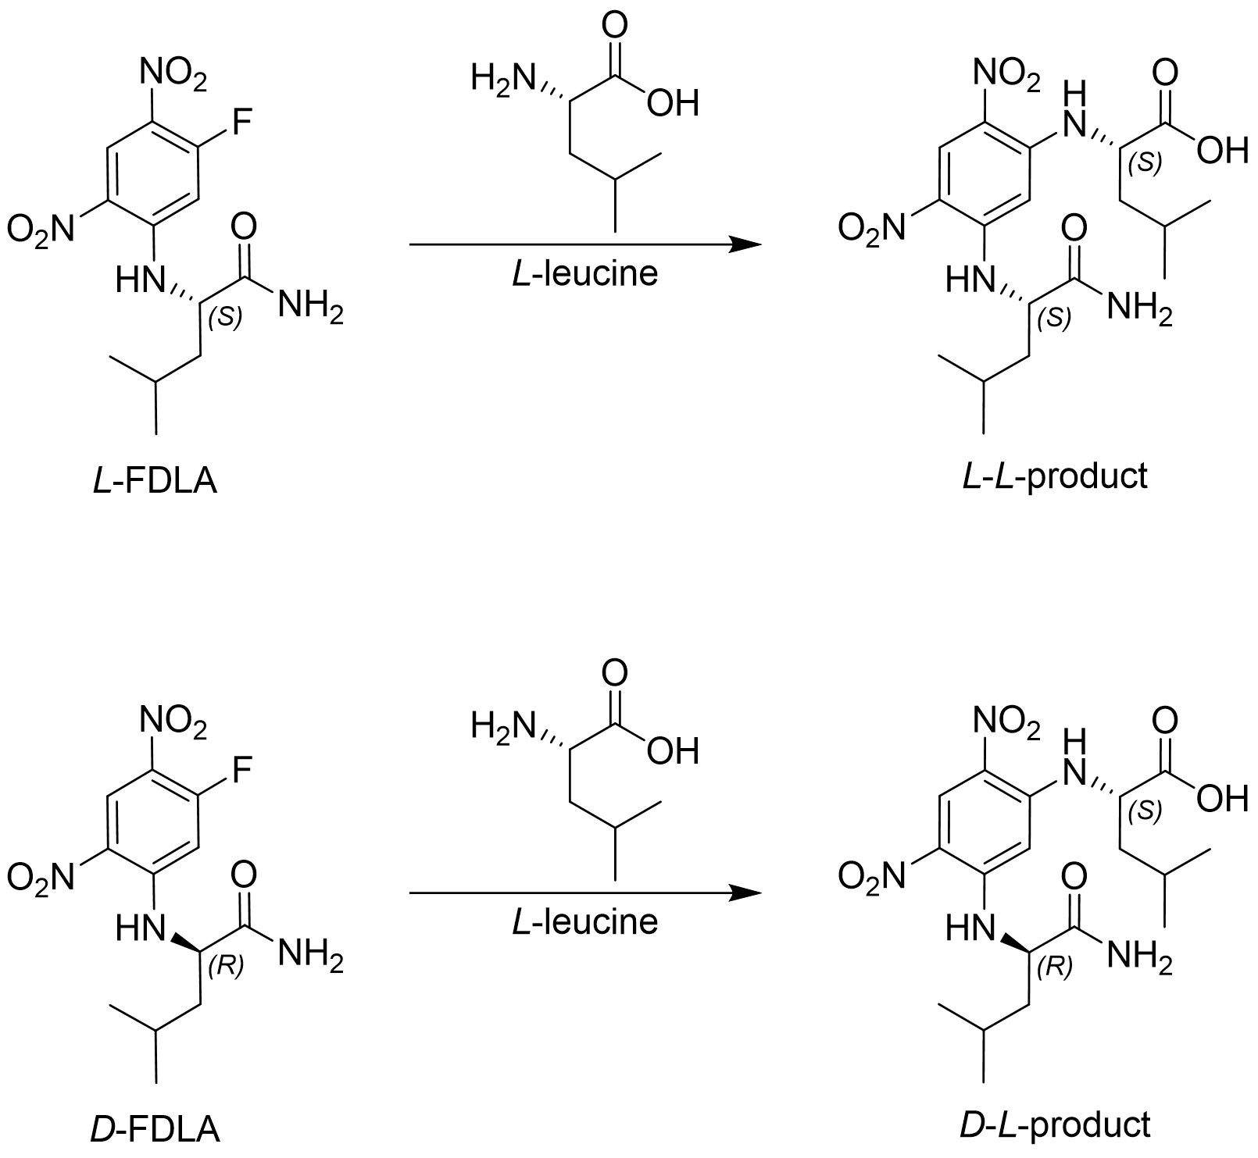
Figure S24. Marfey’s derivatization reaction of l-leucine standard with l- respective d-(1-fluoro-2,4-dinitrophenyl-5-leucine amide) (FDLA).
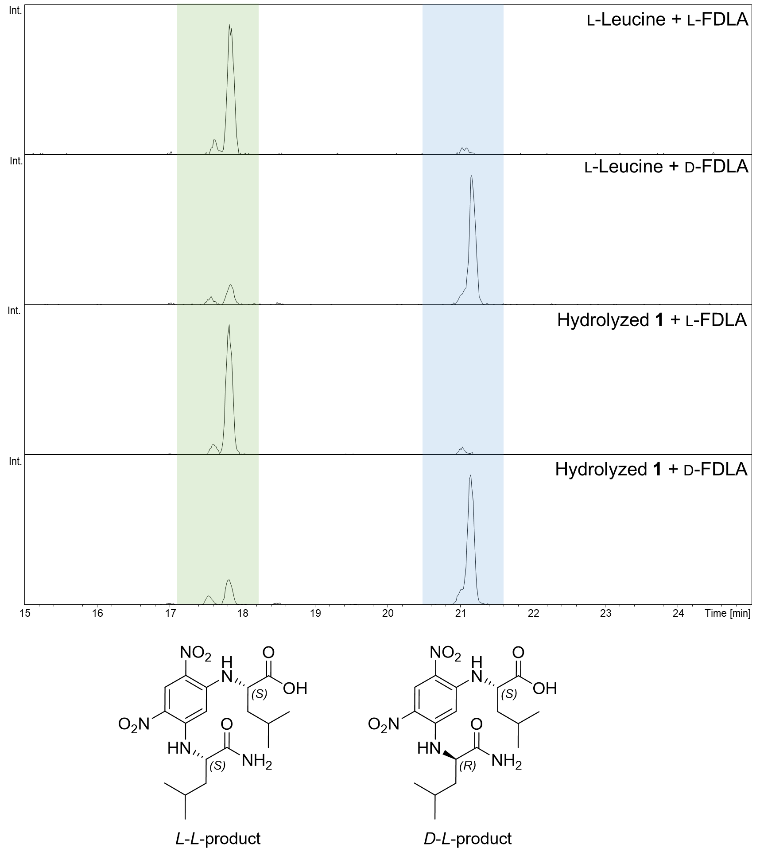
Figure S25. HPLC-MS extracted ion chromatograms (EICs) of 426.19833 m/z with a width of 0.005 m/z from Marfey’s derivatization reaction with commercial l-leucine standard and hydrolyzed 1. Highlighted in green: l-l-product peaks; highlighted in blue: d-l-product peaks.
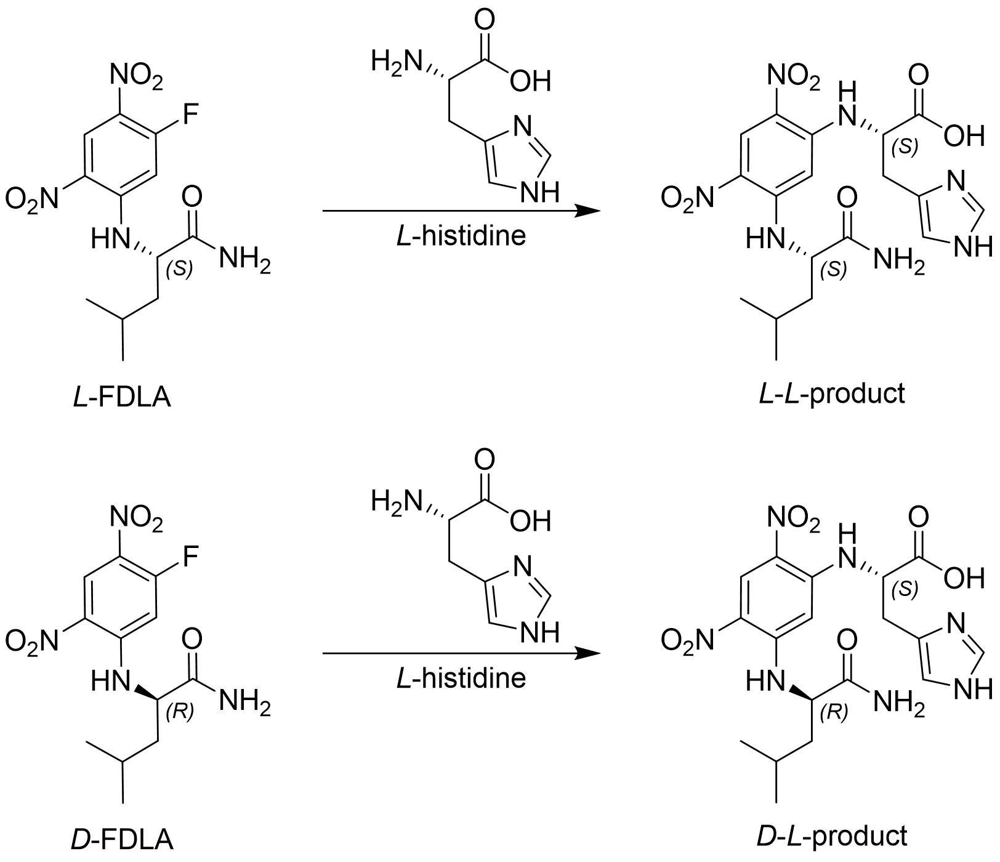
Figure S26. Marfey’s derivatization reaction of l-histidine standard with l- respective d-(1-fluoro-2,4-dinitrophenyl-5-leucine amide) (FDLA).
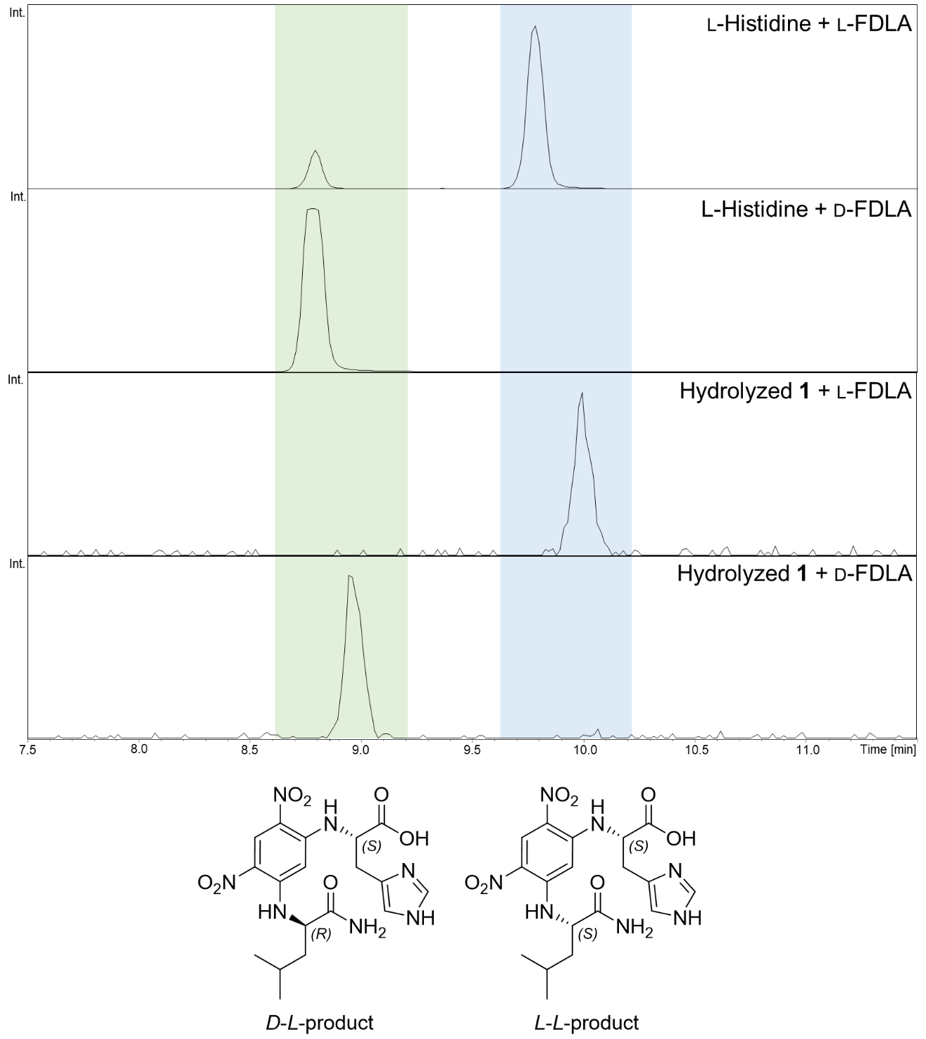 Figure S27. HPLC-MS extracted ion chromatograms (EICs) of 450.17317 m/z with a width of 0.005 m/z from Marfey’s derivatization reaction with commercial l-histidine standard and hydrolyzed 1. Highlighted in green: d-l-product peaks; highlighted in blue: l-l-product peaks.
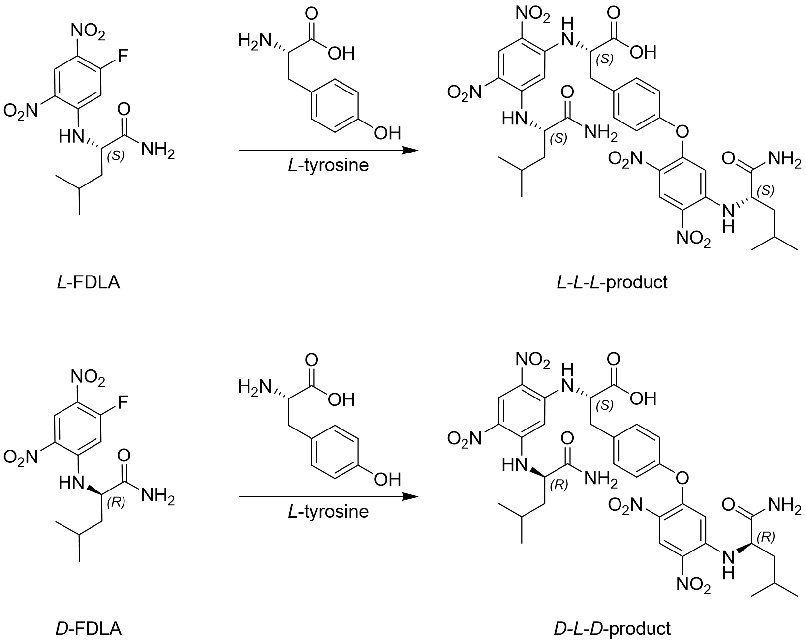
Figure S28. Marfey’s derivatization reaction of l-tyrosine standard with l- respective d-(1-fluoro-2,4-dinitrophenyl-5-leucine amide) (FDLA). In this case, we mainly observed the double derivatized product as shown above.
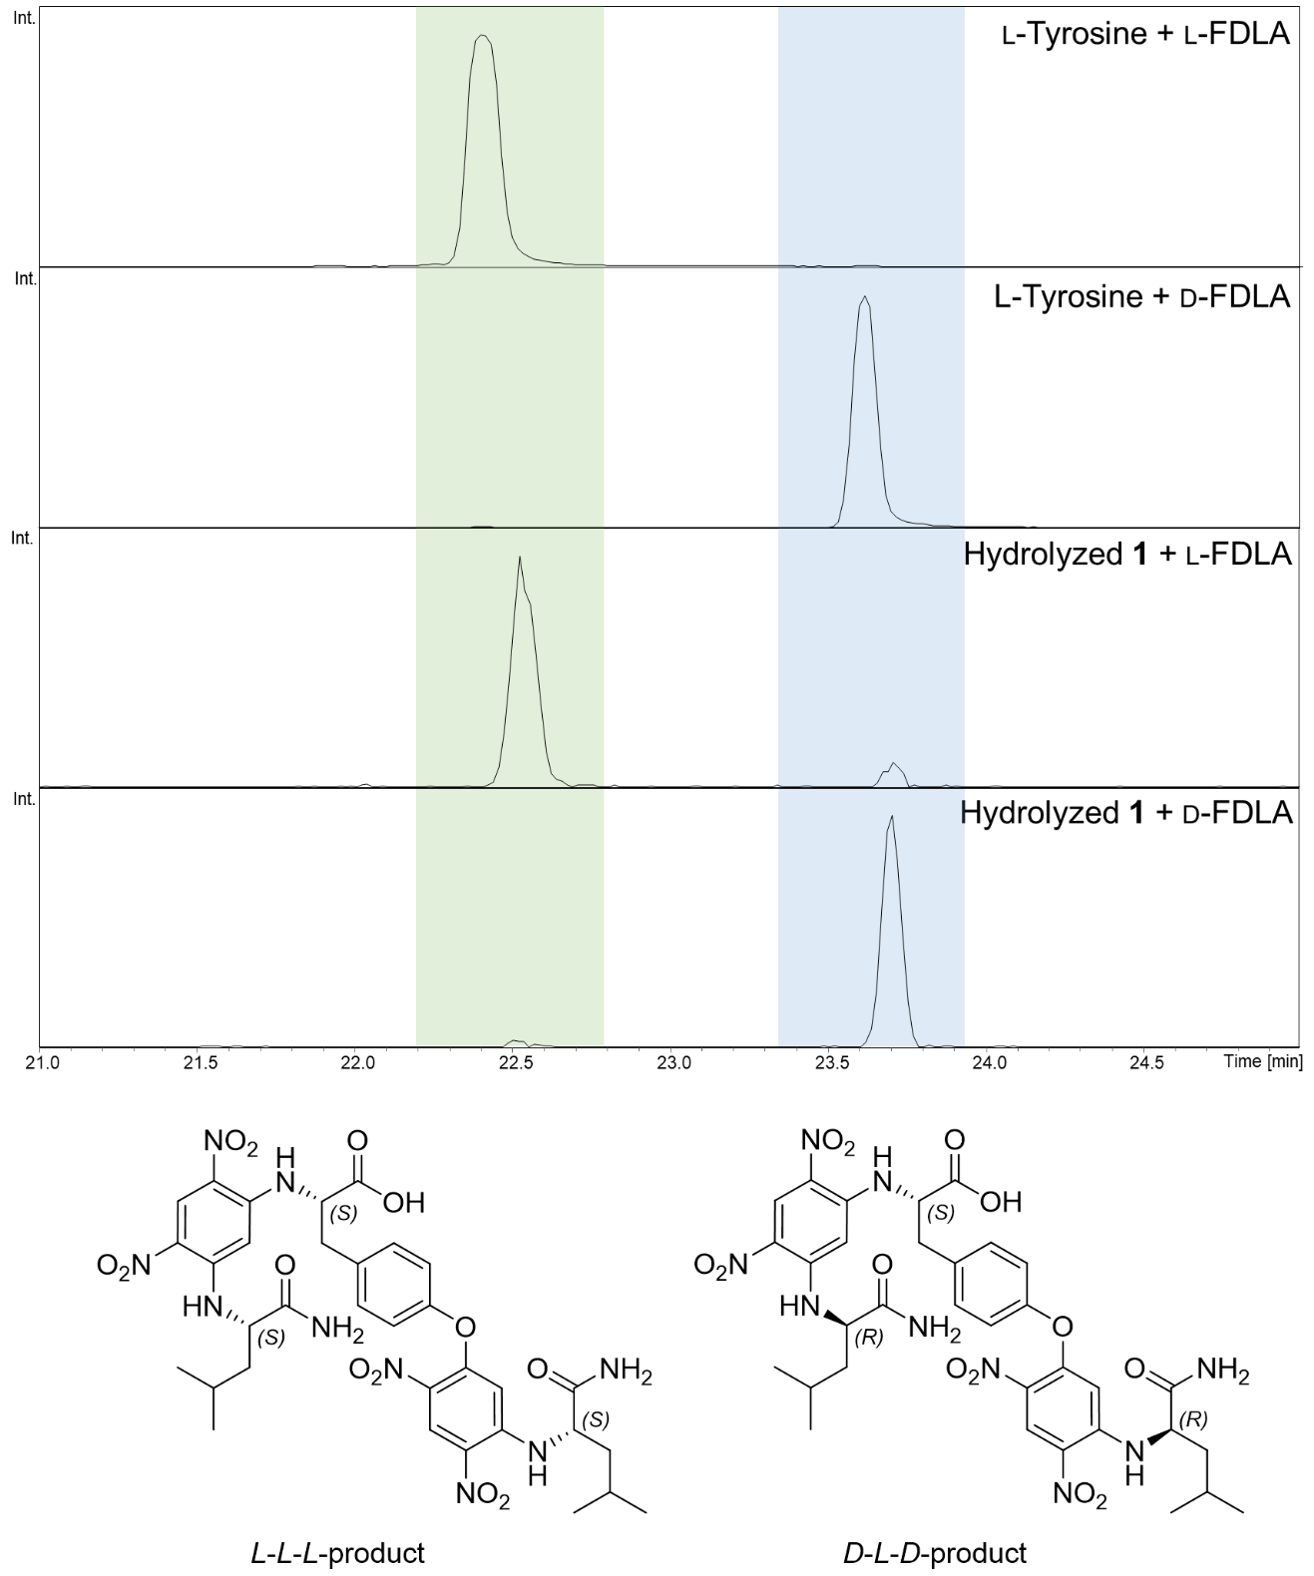
Figure S29. HPLC-MS extracted ion chromatograms (EICs) of 770.27401 m/z with a width of 0.005 m/z from Marfey’s derivatization reaction with commercial l-tyrosine standard and hydrolyzed 1. Highlighted in green: l-l-l-product peaks; highlighted in blue: d-l-d-product peaks.

References
1. Panter, F.; Krug, D.; Baumann, S.; Müller, R. Self-resistance guided genome mining uncovers new topoisomerase inhibitors from myxobacteria. Chem. Sci. 2018, 9, 4898–4908, doi:10.1039/C8SC01325J.
2. Magrini, V.; Creighton, C.; Youderian, P. Site-specific recombination of temperate Myxococcus xanthus phage Mx8: genetic elements required for integration. J. Bacteriol. 1999, 181, 4050–4061, doi:10.1128/jb.181.13.4050-4061.1999.

