Supplemental Material
Table S1 Profiles of volatiles in cherry tomatoes (2021). Values are mean ± SD of three independent experiments. ND: not detected; SW: surface water; HNW: hydrogen nanobubble water; SW+F: surface water plus fertilizers; HNW+F: hydrogen nanobubble water plus fertilizers.
Code | Family | Compound | Concentration (mg kg⁻¹)
 |  |  | SW | HNW | SW+F | HNW+F
1 | Aldehydes | Hexanal | 0.278±0.052 | 0.463±0.050 | 0.179±0.031 | 0.447±0.036
2 | (average proportion: 77.1%) | (E)-2-Hexenal | 0.431±0.049 | 0.444±0.000 | 0.362±0.014 | 0.294±0.094
3 |  | 2-Methyl-4-pentenal | 0.122±0.009 | 0.031±0.044 | 0.121±0.007 | 0.017±0.024
4 |  | Methional | 0.002±0.003 | 0.004±0.006 | 0.007±0.001 | 0.003±0.005
5 |  | Benzeneacetaldehyde | 0.035±0.001 | 0.008±0.011 | 0.043±0.001 | 0.034±0.008
6 |  | Decanal | 0.004±0.001 | 0.002±0.003 | 0.005±0.001 | 0.006±0.000
7 |  | (E,E)-2,4-Hexadienal | 0.012±0.001 | 0.022±0.019 | 0.015±0.002 | 0.006±0.001
8 |  | (Z)-2-Heptenal | 0.007±0.001 | 0.002±0.003 | 0.003±0.004 | 0.016±0.007
9 |  | (E)-4-Oxohex-2-enal | 0.022±0.007 | 0.024±0.012 | 0.034±0.001 | 0.012±0.016
10 |  | Nonanal, 3-(methylthio)- | 0.002±0.003 | ND | ND | 0.002±0.003
11 |  | Nonanal | ND | 0.014±0.019 | ND | 0.047±0.029
12 |  | 5-Methyl-hexanal | ND | ND | 0.002±0.003 | ND
13 |  | (E)-2-Octenal | ND | ND | ND | 0.008±0.011
14 |  | (E)-2-Nonenal | 0.002±0.003 | ND | ND | ND
15 | Alcohols | trans-1,2-Cyclopentanediol | 0.048±0.004 | 0.060±0.006 | 0.034±0.013 | 0.020±0.002
16 | (average proportion: 12.3%) | 2-Ethyl-1-hexanol | 0.010±0.000 | 0.004±0.006 | 0.007±0.001 | 0.004±0.006
17 |  | Phenylethyl alcohol | 0.075±0.002 | 0.075±0.001 | 0.089±0.005 | 0.069±0.011
18 |  | 2,4,6-Trimethyl-1,6-heptadien-4-ol | 0.023±0.000 | 0.009±0.012 | 0.006±0.009 | 0.007±0.010
19 |  | Benzene-1,2-diol, 4-(2-guanidinothiazol-4-yl)- | 0.005±0.000 | 0.003±0.004 | 0.004±0.000 | ND
20 |  | 3-Hepten-1-ol | 0.001±0.002 | 0.008±0.004 | ND | ND
21 |  | cis-1,3-Cyclopentanediol | 0.004±0.006 | ND | ND | ND
22 |  | cis-2-Methylcyclohexanol | 0.004±0.001 | ND | ND | ND
23 |  | 5-Methyl-5-hexen-2-ol | 0.002±0.003 | ND | ND | ND
24 |  | E,E-2,6-Dimethyl-3,5,7-octatriene-2-ol | 0.001±0.002 | ND | ND | 0.003±0.001
25 | Esters | Carbamic acid, (2-methylphenyl)methyl ester | 0.019±0.003 | 0.009±0.002 | 0.020±0.002 | 0.026±0.005
26 | (average proportion: 1.9%) | Decanoic acid, ethyl ester | 0.004±0.000 | ND | 0.002±0.004 | 0.005±0.000
27 |  | Isobutyl acrylate | ND | 0.002±0.003 | ND | 0.001±0.002
28 |  | Oxalic acid, isohexyl neopentyl ester | ND | ND | ND | 0.001±0.001
29 | Phenols (average proportion: 2.1%) | 2,4-Bis(1,1-dimethylethyl)-phenol | 0.020±0.002 | 0.022±0.006 | 0.030±0.011 | 0.022±0.001
30 | Others (average proportion: 6.6%) | L-Isoleucine | 0.012±0.016 | 0.042±0.031 | ND | ND
31 |  | 1,6-Anhydro-3,4-dideoxy-.beta.-D-manno-hexapyranose | 0.013±0.018 | ND | ND | 0.012±0.006
32 |  | Benzene, 1-(1-hydroxyheptyl)-3-[1-(tetrahydropyran-2-yloxy)heptyl]- | ND | 0.006±0.008 | 0.005±0.007 | ND
33 |  | Oxetane, 2-methyl-4-propyl- | 0.006±0.000 | 0.003±0.004 | 0.002±0.003 | 0.002±0.003
34 |  | Benzyl nitrile | 0.014±0.000 | 0.004±0.005 | 0.011±0.000 | 0.022±0.011
35 |  | Octyl-oxirane | 0.005±0.000 | ND | ND | 0.004±0.005
36 |  | Propanoic acid, 3-hydroxy-, hydrazide | ND | ND | 0.009±0.012 | 0.002±0.003
37 |  | 4-(2,2,6-Trimethyl-7-oxabicyclo[4.1.0]hept-1-yl)-3-buten-2-one | 0.003±0.004 | ND | ND | 0.003±0.001
38 |  | Bis(3-methylbutyl) fluorene-2,7-disulfonate | 0.004±0.000 | ND | 0.004±0.000 | 0.004±0.005
39 |  | Hydroxylamine, O-decyl- | 0.006±0.001 | ND | 0.005±0.001 | 0.003±0.004
40 |  | Decane, 6-ethyl-2-methyl- | ND | ND | ND | 0.001±0.001
41 |  | trans-β-Ionone | ND | ND | ND | 0.003±0.000
42 |  | 1H-Pyrrole, 2,5-dihydro-1-nitroso- | 0.007±0.010 | ND | 0.036±0.011 | ND
43 |  | 2-Isobutylthiazole | ND | ND | ND | 0.022±0.022
44 |  | Thieno[2,3-c]furan-3-carbonitrile, 2-amino-4,6-dihydro-4,4,6,6-tetramethyl- | ND | ND | 0.003±0.005 | ND
45 |  | 1,2-Epoxyundecane | ND | ND | 0.008±0.000 | ND
46 |  | Valeric acid hydrazide | ND | ND | 0.004±0.000 | ND
47 |  | Methyl 2-methoxypropenoate | 0.005±0.007 | ND | ND | ND
48 |  | 4-Hydroxybutyric acid hydrazide | ND | ND | 0.001±0.002 | ND
49 |  | Hydrazinecarboxamide | ND | ND | ND | 0.007±0.010
Table S2 Primers of qPCR used in this study
Gene | Forward primer (5’-3’) | Reverse primer (5’-3’)
SlACT (NM_001330119.1) | CGGTGACCACTTTCCGATCT | TCCTCACCGTCAGCCATTTT
18S rRNA (XM_004241429.4) | GGGCATTCGTATTTCATAGTCAGA | GTTCTTGATTAATGAAAACATCCT
SlPSY1 (NM_001347838.1) | TGGCCCAAACGCATCATATA | CACCATCGAGCATGTCAAATG
SlPDS (NM_001247166.2) | TGCCAAACCACCACAAATTTCA | CCAATTTGAGGCATTTTACTCGGA
LeAMT2 (NM_001247324.2) | TTGTACCGCCGCTCTGACAACTTT | CATGGCTCAACAACTGCACAACCT
LePT2 (NM_001247114.1) | CATTGGACACTGGAGGCTAACC | ATAAGAACCCATACGCTCCCA
LePT5 (XM_004240903.4) | GGCGAATGAAGATGCCTGAAAC | TACCAATTAAGTGATGTCCGTG
SlHKT1,1(NM_001308344.1) | TGTTTTGTGCTTTGGAGTGGA | GGGGGTGAAAGAGTGGAGAT

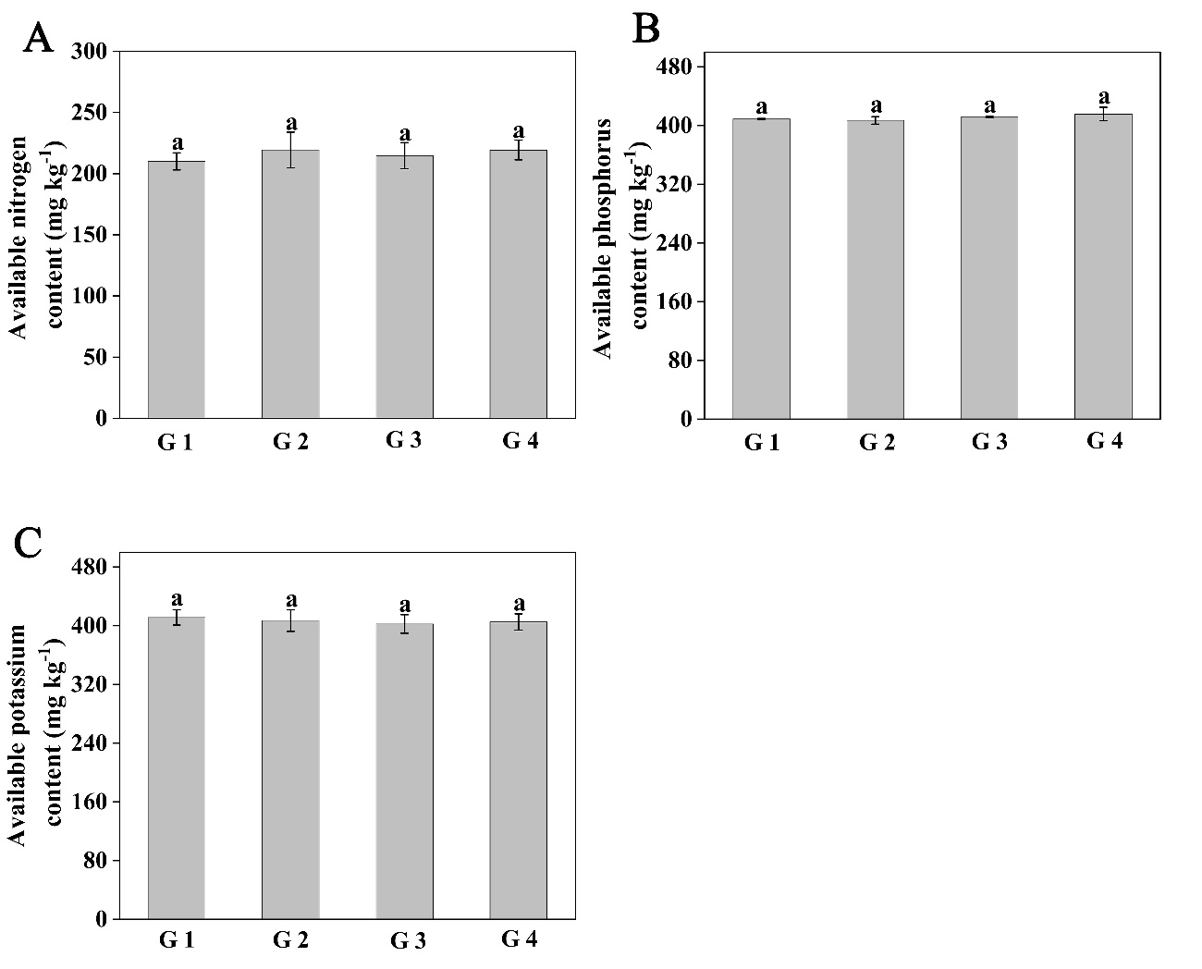
Figure S1. The contents of available nitrogen (A), available phosphorus (B), available potassium (C) in soil of four greenhouses before fertilizing (Shanghai, 2021). G 1: greenhouse 1; G 2: greenhouse 2; G 3: greenhouse 3; G 4: greenhouse 4.

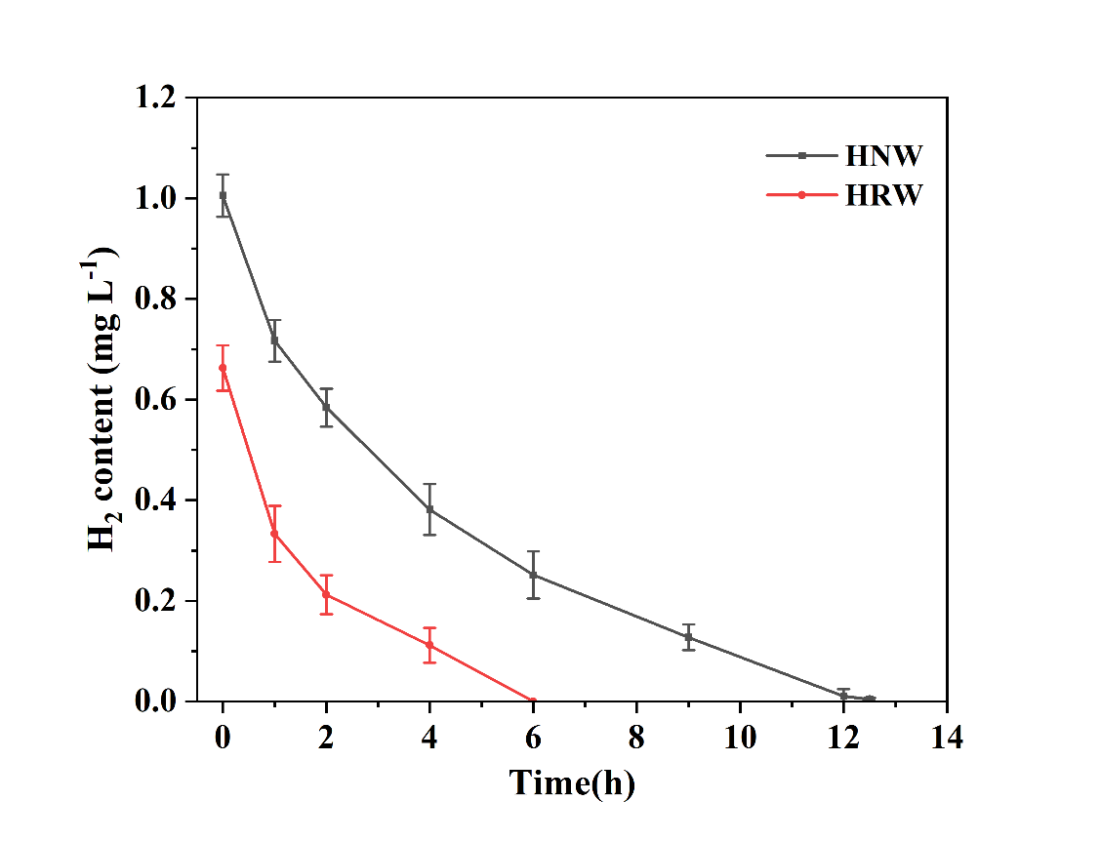
Figure S2. Changes in H₂ content of fresh HRW and HNW. HRW: hydrogen-rich water; HNW: hydrogen nanobubble water.

Figure S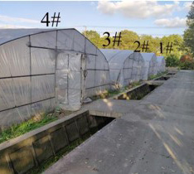3. The design and location information of the four greenhouses (Shanghai, 2021). 1#: Irrigation with surface water (SW) and normal fertilization; 2#: Irrigation with SW and free of fertilization; 3#: Irrigation with hydrogen nanobubble water (HNW) and normal fertilization; 4#: Irrigation with HNW and free of fertilization.

