ONLINE SUPPLEMENTAL MATERIAL

Spheroid-type amyloid deposition: comprehensive analysis using immunohistochemistry, proteomic analysis, and a literature review

Shojiro Ichimata¹, Yukiko Hata¹, Tsuneaki Yoshinaga², Nagaaki Katoh², Fuyuki Kametani³, Masahide Yazaki⁴, Yoshiki Sekijima², and Naoki Nishida¹

1 Department of Legal Medicine, Faculty of Medicine, University of Toyama, Toyama, Japan
2 Department of Medicine (Neurology and Rheumatology), Shinshu University School of Medicine, Matsumoto, Japan
3 Department of Brain and Neurosciences, Tokyo Metropolitan Institute of Medical Science, Tokyo, Japan
4 Institute for Biomedical Sciences, Shinshu University, Matsumoto, Japan

List of Supplemental Materials
Supplemental Table: 1
Supplementary Figure: 4
Supplementary Table S1. Details of the antibodies used in this study

Antibody | Source | Clone | Dilution | Antigen retrieval
Igλ | Abcam | polyclonal | 1:1600 | 98% FA (1 min)
β2-microglobulin | GeneTex | polyclonal | 1:3000 | 98% FA (1 min)
Lysozyme C | Santa Cruz Biotechnology | E-5 | 1:150 | 98% FA (1 min)
PSP-A | Abcam | 6F10 | 1:4000 | 98% FA (1 min)
PSP-B | Santa Cruz Biotechnology | F-2 | 1:4000 | 98% FA (1 min)
Lactoferrin | Santa Cruz Biotechnology | B97 | 1:150 | 98% FA (1 min)
Olfactomedin 4 | Abcam | polyclonal | 1:50 | Heat (20 min, pH6)
p62 | Biomol | polyclonal | 1:3000 | Heat (20 min, pH6)

Abbreviations: FA, formic acid; PSP-A, pulmonary surfactant protein A; PSP-B, pulmonary surfactant protein B
Immunostaining was performed using the Leica Bond-IV automation and Leica Refine detection kits (Leica Biosystems, Bannockburn, IL, USA) according to the manufacturer’s instructions. All sections were counterstained with hematoxylin.

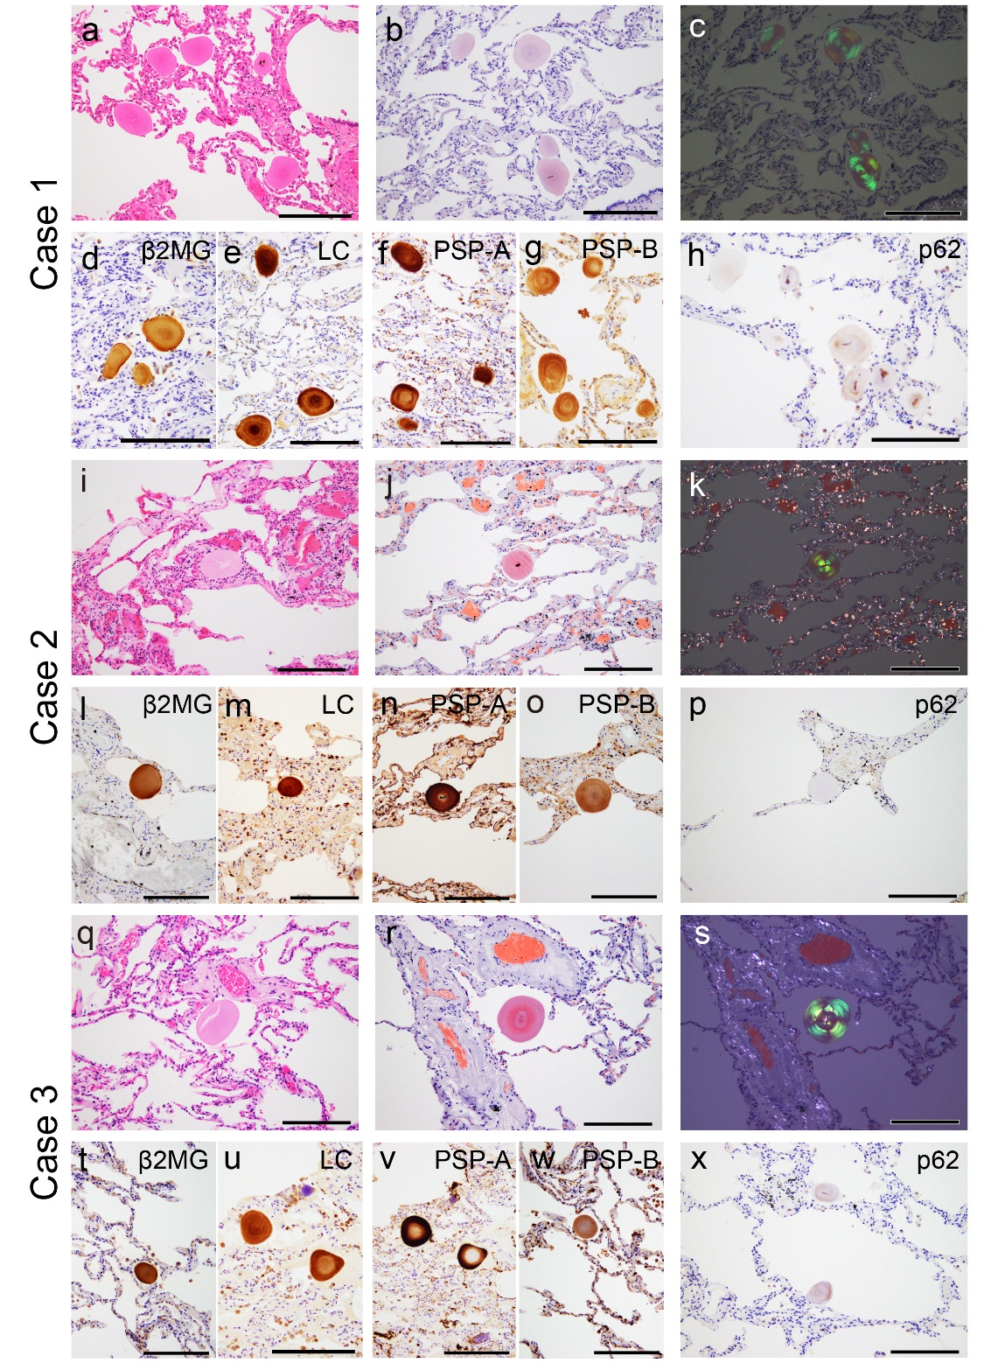
Supplementary Figure S1. Representative microphotographs of the pulmonary corpora amylacea (CA) in all three cases.

(a–h) Pulmonary CA Case 1; (i–p) Case 2; (q–x) Case 3. (a, i, q) Hematoxylin and eosin (H&E) staining; phenol Congo red (pCR) staining under bright field (b, j, r) and polarized light (c, k, s); Immunohistochemistry for β2-microglobulin (β2MG) (d, l, t); lysozyme C (LC) (e, m, u); pulmonary surfactant protein A (PSP-A) (f, n, v); PSP-B (g, o, w); and p62 (h, p, x). In all cases, CAs were round and eosinophilic deposits showed concentric laminations by H&E staining. In addition, all CAs exhibited congophilic and clear apple-green birefringence under polarized light. Furthermore, all CAs showed immunoreactivity for β2MG, LC, PAP-A, and PSP-B. In contrast, immunoreactivity for p62 was weak and focal in Cases 1 and 3, whereas it was almost negative in Case 2. Scale bar = 200 μm (a–x).

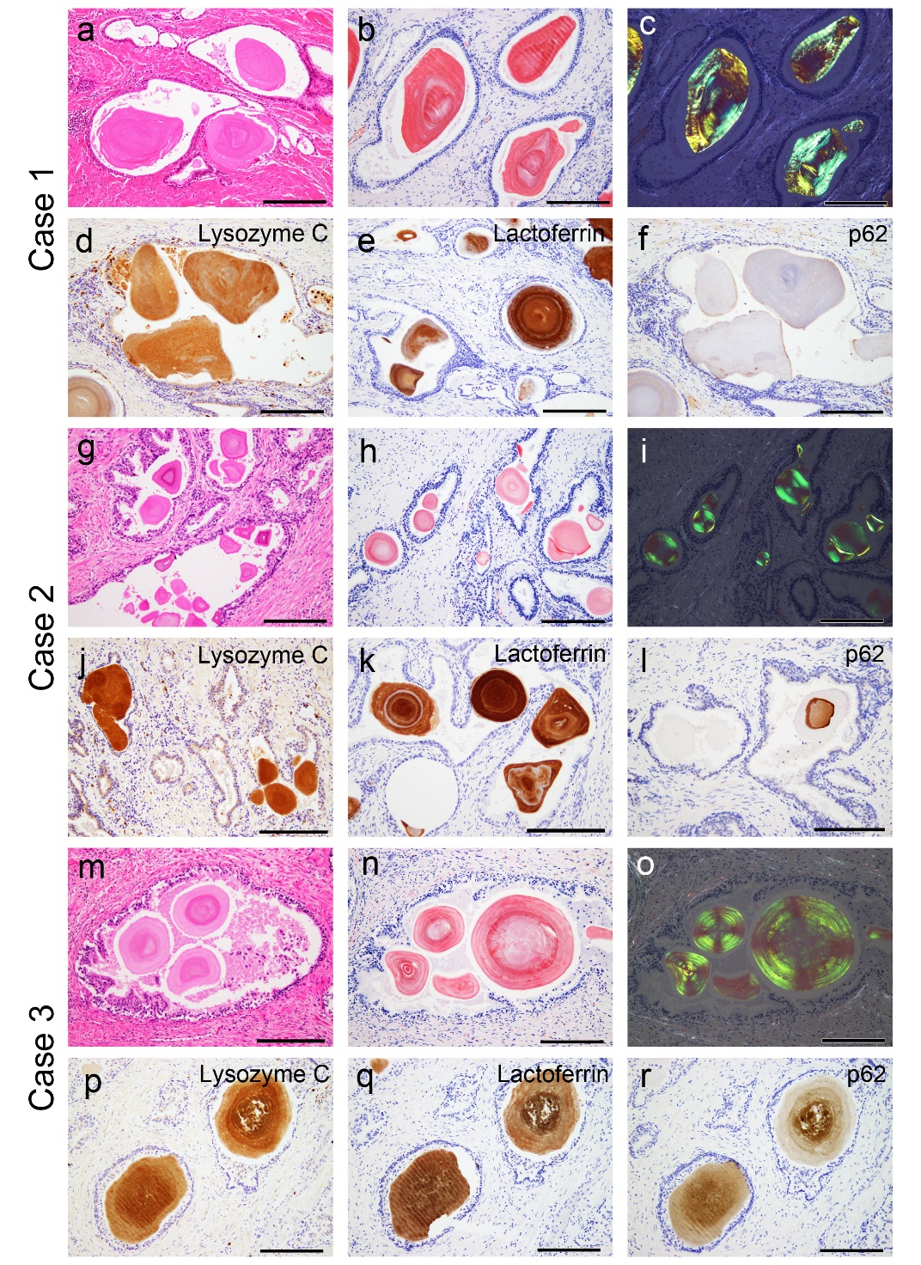
Supplementary Figure S2. Representative microphotographs of prostatic CA in all three patients.
(a–f) Prostatic CA Case 1; (g–l) Case 2; and (m–r) Case 3. (a, g, m) H&E staining; pCR staining under bright field (b, h, n) and polarized light (c, i, o); Immunohistochemistry for lysozyme C (d, j, p); lactoferrin (e, k, q); and p62 (f, l, r). For all cases, the CAs were round and eosinophilic deposits showed concentric laminations by H&E staining. In addition, all CAs exhibited congophilic and clear apple-green birefringence under polarized light. Furthermore, all CAs showed immunoreactivity for lysozyme C and lactoferrin. Immunoreactivity for p62 was moderate in Case 3, but weak and focal in Cases 1 and 2. Scale bar = 200 μm (a–r).

Supplementary Figure S3. Proteomic analysis results for PSP-A and PSP-B in pulmonary CA lesions in Case 1.

(a) PSP-A and (b) PSP-B. Detected peptides with peptide scores of 30 or higher in the MASCOT analysis are shown in red.

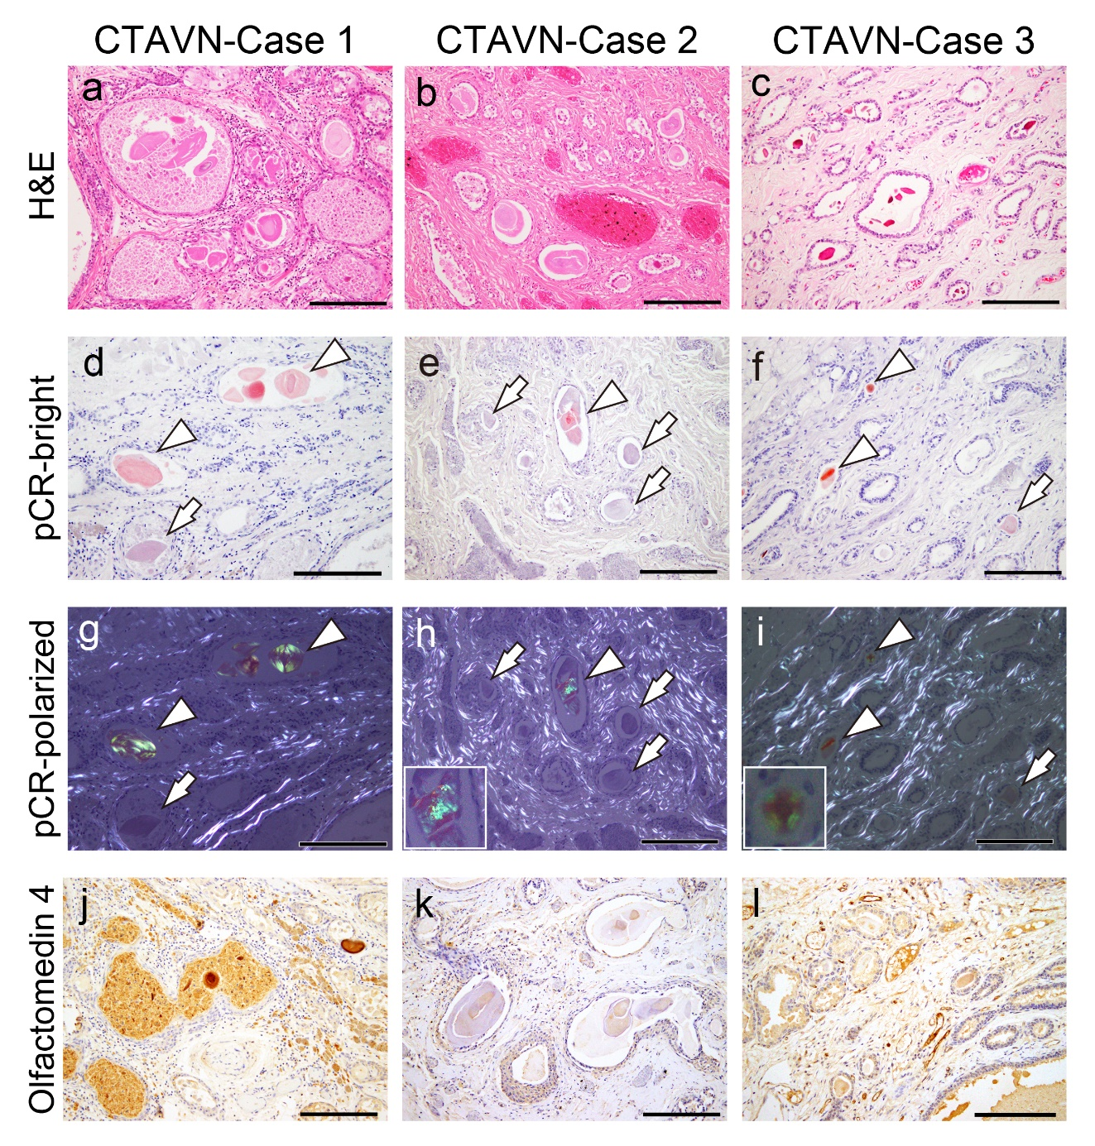
Supplementary Figure S4. Representative microphotographs of cystic tumors of the atrioventricular node (CTAVN)-associated CA in all three cases.
(a, d, g, j) Prostatic CA Case 1; (b, e, h, k) Case 2; (c, f, i, l) Case 3. (a–c) H&E staining; pCR staining under bright field (d–f) and polarized light (g–i); (j–l) Immunohistochemistry for olfactomedin 4. For all cases, the CAs were round and eosinophilic deposits showed concentric laminations by H&E staining. For pCR staining, the CAs showed very weak (arrow) to moderate congophilia (arrowhead) (d–f), and those exhibiting moderate congophilia showed apple-green birefringence under polarized light (arrowhead) (g–i). Immunoreactivity of the CAs to olfactomedin 4 was strong in Case 1 (j), negative to weakly positive in Case 2 (k), and weakly positive in Case 3 (l). Scale bar = 200 μm (c–e)

