Supporting information
Preparation of heterojunctions based on Cs₃Bi₂Br₉ nanocrystals and g-C₃N₄ nanosheets for photocatalytic hydrogen evolution

María Medina-Llamas^{a,b,*}, Andrea Speltiniª, Antonella Profumoª, Francesca Panzarea,^{c} Antonella Milella,^{c} Francesco Fracassi, ^{c,d} Andrea Listorti^{c} and Lorenzo Malavasi^{a*}
ª Unidad Académica Preparatoria, Plantel II, Universidad Autónoma de Zacatecas, Zacatecas, 98068, México.
^{b} Department of Chemistry, University of Pavia, Via 12 Taramelli 12, 27100 Pavia, Italy.
^{c} Department of Chemistry, University of Bari “Aldo Moro” via Orabona 4, Bari 70126, Italy.
^{d} National Research Council, Institute of Nanotechnology (CNR-NANOTEC), Department of Chemistry, 70125 Bari, Italy.

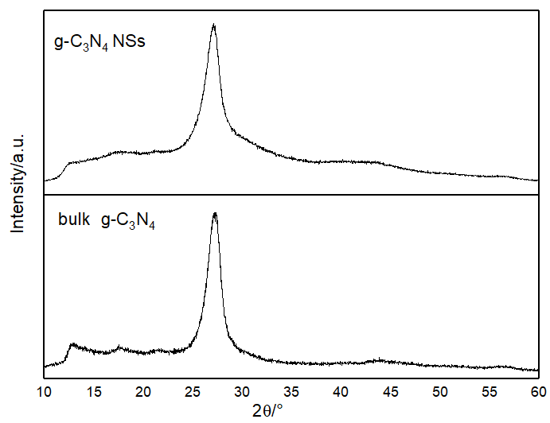
Figure S1. XRD pattern of the bulk g-C₃N₄ and the g-C₃N₄ nanosheets.
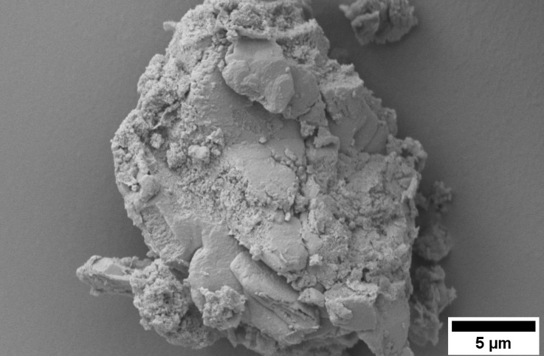
Figure S2. SEM micrograph of the bulk g-C₃N_{4.}
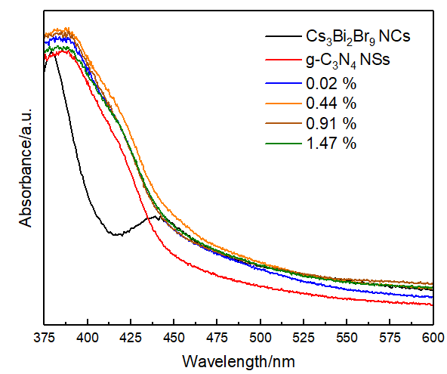
Figure S3. Absorbance spectra versus wavelength of the g-C₃N₄ NSs, the Cs₃Bi₂Br₉ NCs and the Cs₃Bi₂Br₉/g-C₃N₄ NSs composites produced at different percentages of perovskite loading (% wt.)
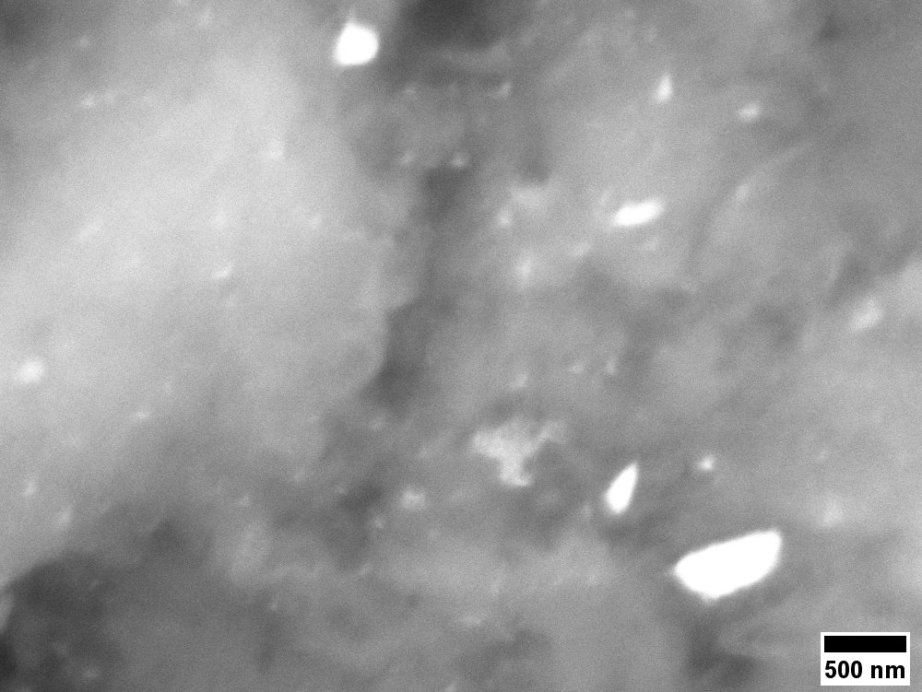
Figure S4. BSE-HRSEM micrograph of the 0.44 % wt. Cs₃Bi₂Br₉ NCs/g-C₃N₄ NS.

