Self-supporting smart air filters based on PZT/PVDF electrospun nanofiber composite membrane
Weidong He^{1,2,3}, Yinghe Guo^{1,2,3}, Fuze Jiang^{2,3}, Yi-Bo Zhao^{2,3}, Jean Schmitt^{2,3}, Yang Yue^{2,3}, Jingxian Liu^{1,*}, Junji Cao⁴, Jing Wang^{2,3,*}
¹Filter Test Center, Northeastern University, Shenyang, Liaoning 110819, China
²Institute of Environmental Engineering, ETH Zürich, Zürich, CH-8093, Switzerland
³Lab of advanced analytical technologies, Empa, Dübendorf, CH-8600, Switzerland
⁴Institute of Atmospheric Physics, Chinese Academy of Sciences, Beijing 100029, China
*Corresponding authors: 82003@126.com (J. Liu), jing.wang@ifu.baug.ethz.ch (J. Wang)

Figure. S1 Setups for SSSAF evaluation; a) particle filtration test, piezoelectric property test, and pressure drop sensing test; b) VOCs sensing test; c) energy harvesting circuit.
Figure. S2 SEM images of the bacteria on fibers before and after electric discharge treatment.

Figure. S3 The spraying system for bacteria solution dispersion.

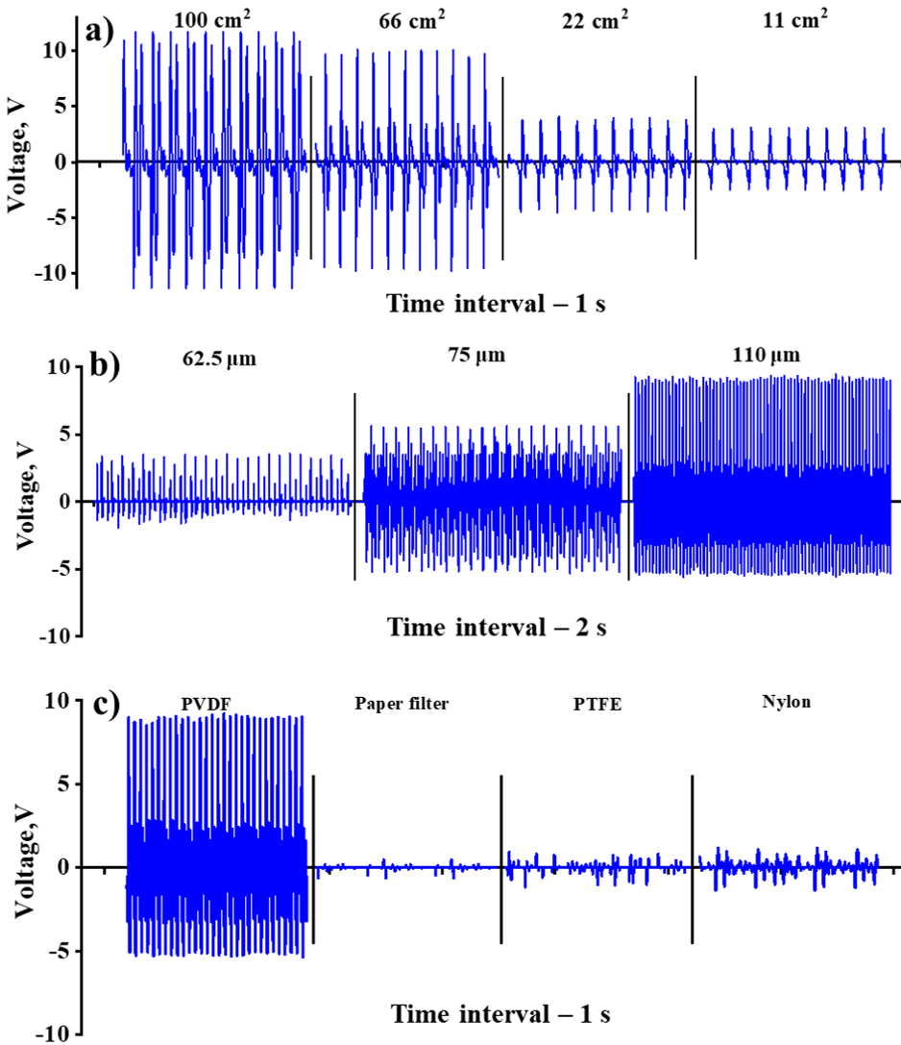
Figure. S4 a) The output voltage signal of SSSAF equipped with PZT/PVDF membranes of different area. b) The output voltage signal of SSSAF equipped with PZT/PVDF membranes of different thickness. c) The output voltage signal of PVDF membrane, paper filter, PTFE membrane and nylon membrane.

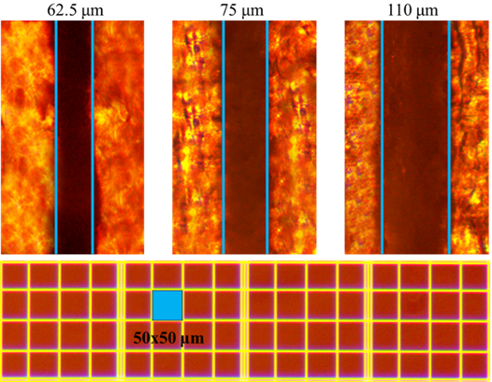
Figure. S5 Thickness of PZT/PVDF membranes which were used to equip SSSAF. The film was immersed in epoxy resin, cured and sliced, and the thickness of the film was measured via an optical microscope.
Figure S6. The output voltages of the other two SSSAFs under different pressure drops.

Figure. S7 Three voltage signals for energy harvesting measurement, all signals were generated by SSSAF based nanogenerator
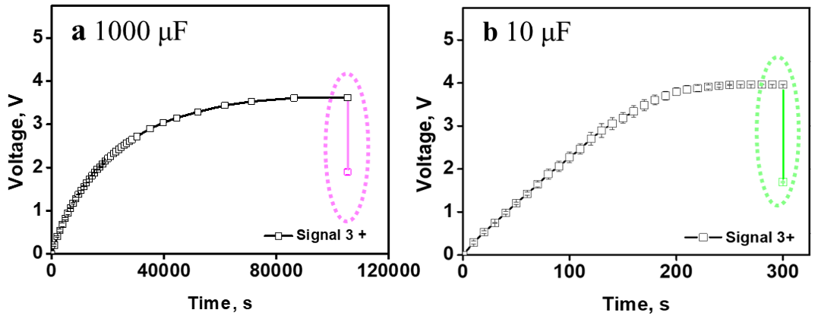
Figure. S8 Charge curves of capacitors with different capacity.

Figure. S9 Petri dishes for E. Coli-formed colonies counting after 3 and 5 hours electrical discharge treatment.

Figure. S10 Electrical discharge curve of capacitor which used for inhibiting bacteria, a) curve of electrical current, b) curve of voltage.

Table S1. The relative differences of the top 100 peak voltage generated by SSSAF 2 and SSSAF 3 at different pressure drops compared to SSSAF 1.
Pressure drop, Pa | SSSAF 1 | SSSAF 2 | Relative error | SSSAF 3 | Relative error
0 | 4.48 | 4.26 | 4.91% | 4.36 | 2.68%
100 | 3.83 | 3.79 | 1.04% | 3.68 | 3.92%
200 | 2.78 | 2.72 | 2.16% | 2.75 | 1.08%
300 | 2.54 | 2.50 | 1.57% | 2.52 | 0.79%
400 | 1.98 | 1.95 | 1.57% | 1.97 | 0.79%
500 | 1.06 | 1.02 | 3.94% | 1.04 | 1.57%

Table. S2. The resistances of gold particle layers with a thickness of 40 nm and different areas.
Area (mm²) | Resistance (Ω） |  |  |  |  | Average | Standard Deviation
 | S1 | S2 | S3 | S4 | S5
1 | 2.8 | 3.2 | 2.6 | 2.7 | 3.1 | 2.88 | 0.26
2 | 4.5 | 4.3 | 4.9 | 4 | 3.8 | 4.3 | 0.43
3 | 8.3 | 8.4 | 6.9 | 11.2 | 8.4 | 8.64 | 1.57
4 | 10.6 | 9.2 | 9.3 | 11.9 | 10.8 | 10.36 | 1.13
5 | 14 | 9.6 | 11.6 | 8.5 | 13.7 | 11.48 | 2.43

