SUPPLEMENTARY INFORMATION
Figure S1: ¹H NMR (500 MHz, CDCl₃) spectrum of voacamine A
Figure S2: ¹³ C NMR (125 MHz, CDCl₃) spectrum of voacamine A
Figure S3: ¹H-¹H COSY spectrum of voacamine A
Figure S4: ¹H-¹H NOESY spectrum of voacamine A
Figure S5: ¹H-¹H HSQC spectrum of voacamine A
Figure S6: ¹H-¹H HSQC and ¹H-¹³C HMBC spectra of voacamine A
Figure S7: ¹H-¹⁵N-HSQC and ¹H-¹⁵N-HMBC spectra of voacamine A
Figure S8: ¹H NMR (500 MHz, CDCl₃) spectrum of voacangine
Figure S9: ¹³ C NMR (125 MHz, CDCl₃) spectrum of voacangine
Figure S10: ¹H NMR (500 MHz, CDCl₃) spectrum of voacristine
Figure S11: ¹³ C NMR (125 MHz, CDCl₃) spectrum of voacristine
Figure S12: ¹H NMR (500 MHz, CDCl₃) spectrum of coronaridine
Figure S13: ¹³ C NMR (125 MHz, CDCl₃) spectrum of coronaridine
Figure S14: ¹H NMR (500 MHz, CDCl₃) spectrum of tabernanthine
Figure S15: ¹³ C NMR (125 MHz, DMSO-d₆)) spectrum of tabernanthine
Figure S16: ¹H NMR (500 MHz, MeOD) spectrum of iboxygaine
Figure S17: ¹³ C NMR (125 MHz, CDCl₃) spectrum of iboxygaine
Figure S18: ¹H NMR (500 MHz, DMSO-d₆) spectrum of voacamine
Figure S19: ¹³ C NMR (125 MHz, DMSO-d₆) spectrum of voacamine
Figure S20: ¹H NMR (500 MHz, CDCl₃) spectrum of voacorine
Figure S21: ¹³ C NMR (125 MHz, CDCl₃) spectrum of voacorine
Figure S22: ¹H NMR (500 MHz, CDCl₃) spectrum of conoduramine
Figure S23: ¹³ C NMR (125 MHz, CDCl₃) spectrum of conoduramine
Figure S24: Percentage sequence identity and similarity values to our target
Figure S25: Ramachandran plot (φ/ψ) distribution of the backbone conformation

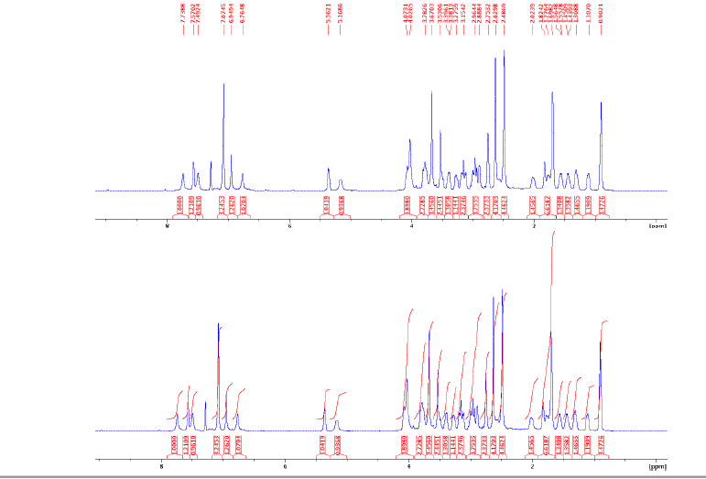

Figure S1: ¹H NMR (500 MHz, CDCl₃) spectrum of voacamine A

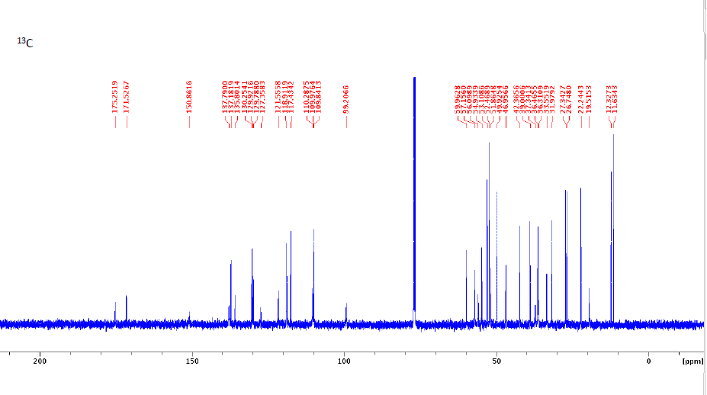

Figure S2: ¹³ C NMR (125 MHz, CDCl₃) spectrum of voacamine A

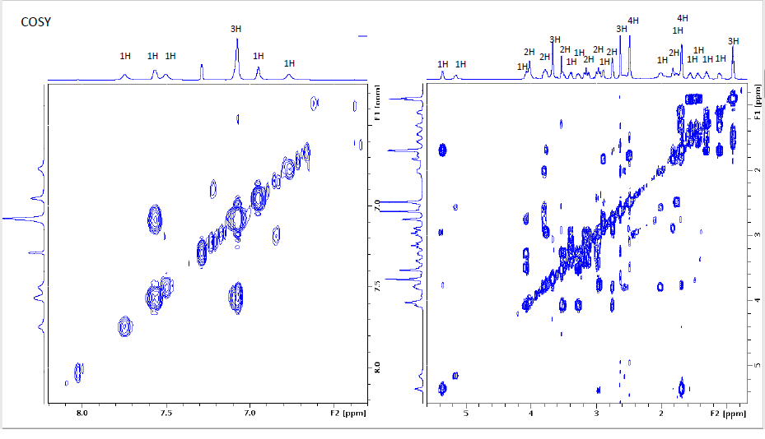

Figure S3: ¹H-¹H COSY spectrum of voacamine A

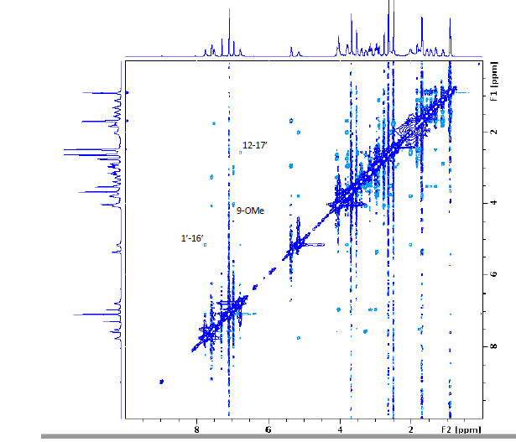

Figure S4: ¹H-¹H NOESY spectrum of voacamine A

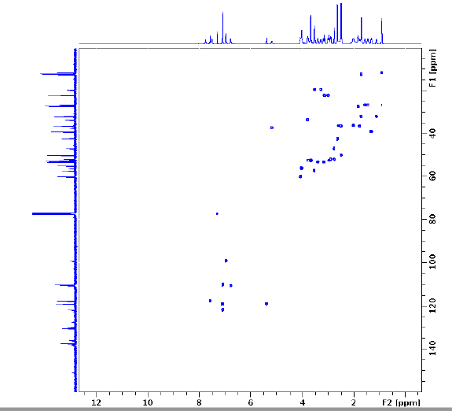

Figure S5: ¹H-¹H HSQC spectrum of voacamine A

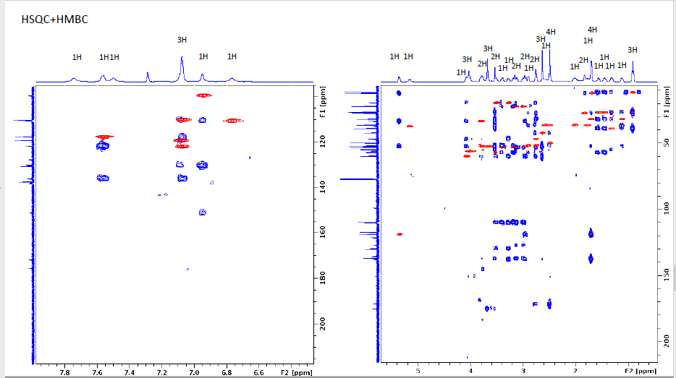

Figure S6: ¹H-¹H HSQC and ¹H-¹³C HMBC spectra of voacamine A

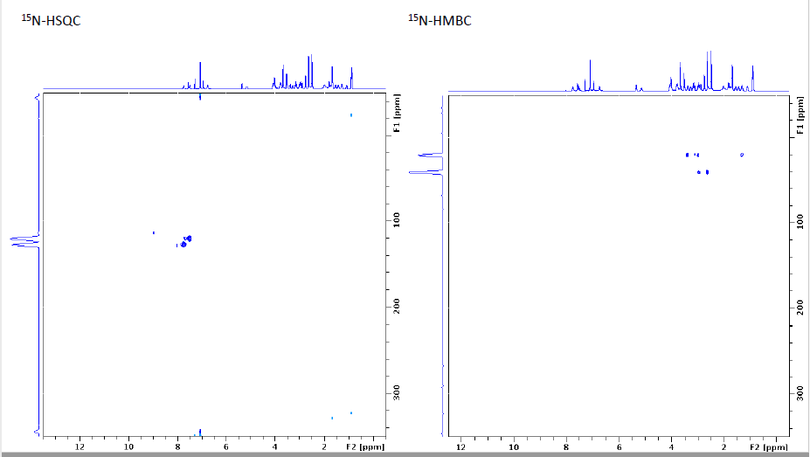

Figure S7: ¹H-¹⁵N-HSQC and ¹H-¹⁵N-HMBC spectra of voacamine A

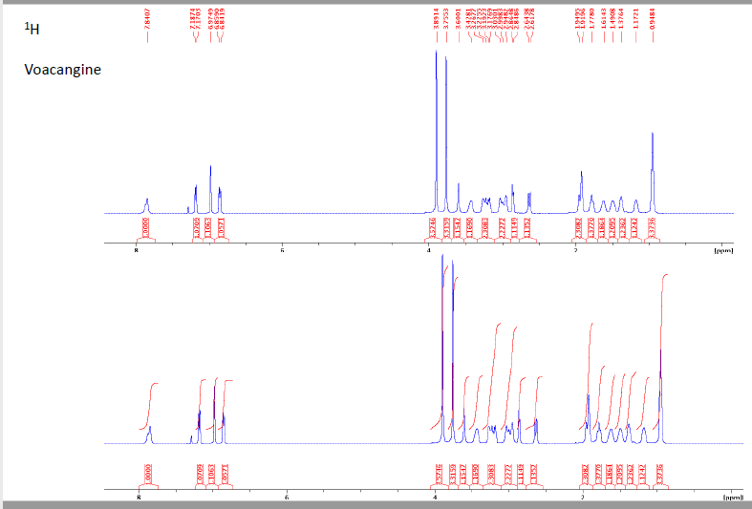

Figure S8: ¹H NMR (500 MHz, CDCl₃) spectrum of voacangine

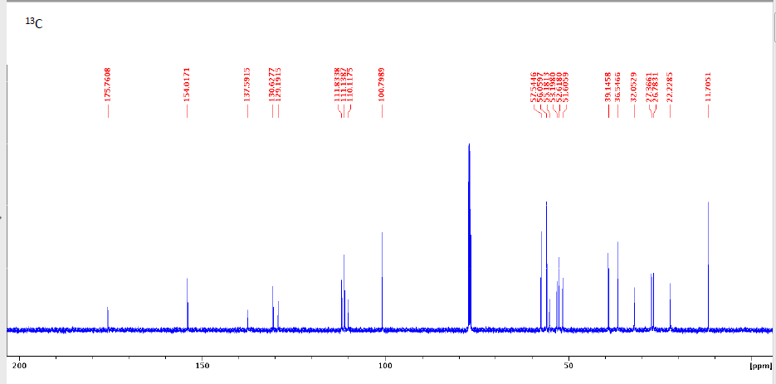

Figure S9: ¹³ C NMR (125 MHz, CDCl₃) spectrum of voacangine

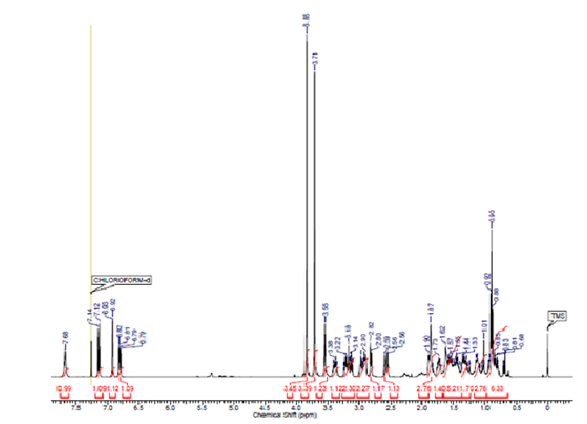

Figure S10: ¹H NMR (500 MHz, CDCl₃) spectrum of voacristine

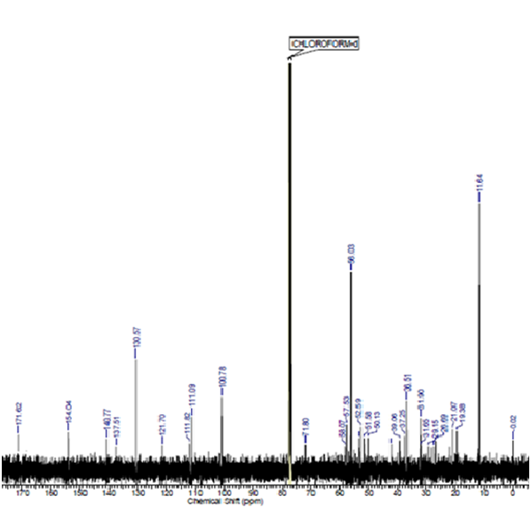
Figure S11: ¹³ C NMR (125 MHz, CDCl₃) spectrum of voacristine

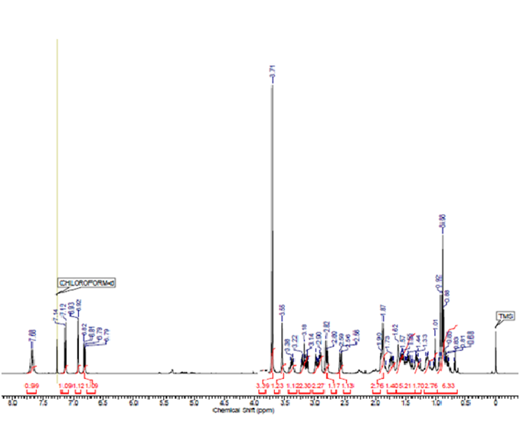
Figure S12: ¹H NMR (500 MHz, CDCl₃) spectrum of coronaridine

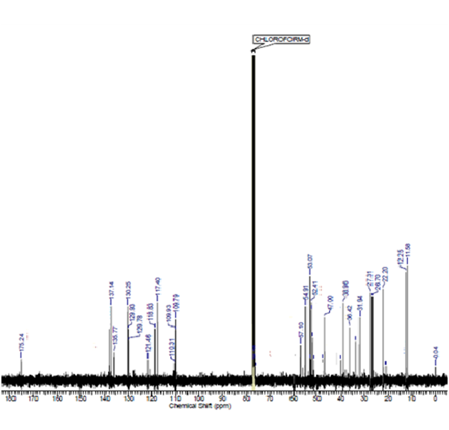
Figure S13: ¹³ C NMR (125 MHz, CDCl₃) spectrum of coronaridine

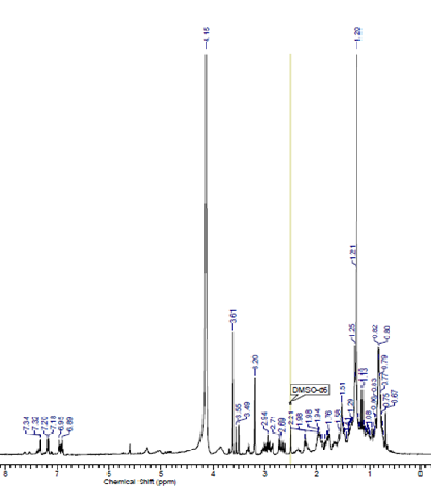
Figure S14: ¹H NMR (500 MHz, DMSO-d₆) spectrum of tabernanthine

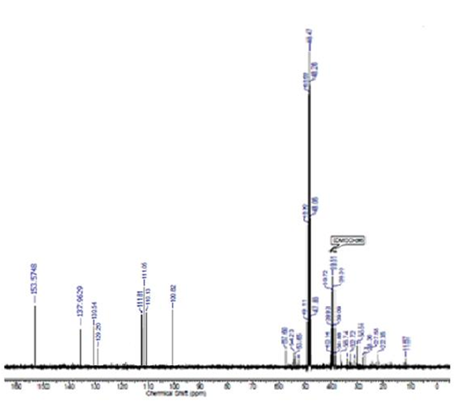
Figure S15: ¹³ C NMR (125 MHz, MeOD) spectrum of tabernanthine

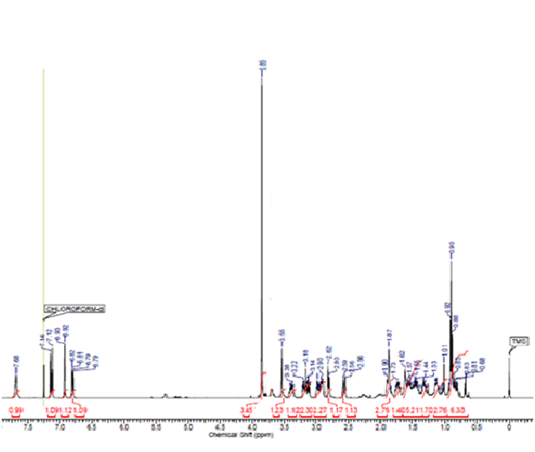

Figure S16: ¹H NMR (500 MHz, CDCl₃) spectrum of iboxygaine

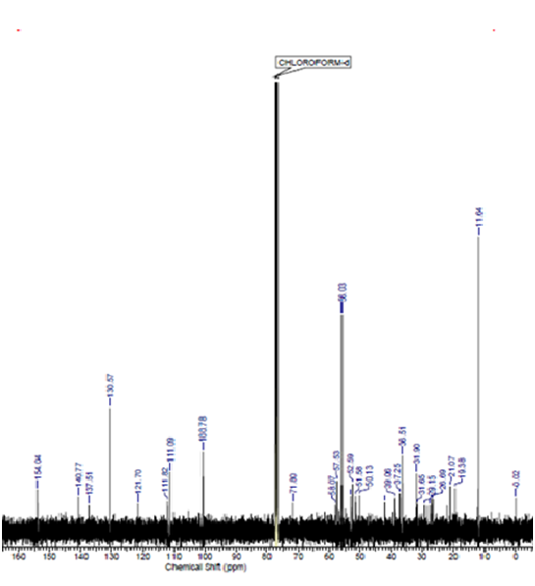
Figure S17: ¹³ C NMR (125 MHz, CDCl₃) spectrum of iboxygaine

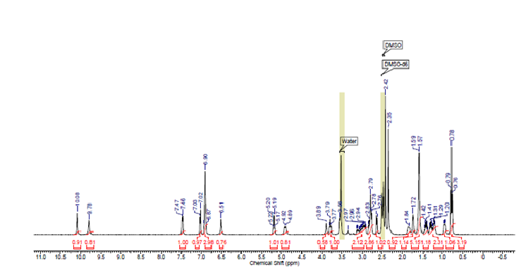
Figure S18: ¹H NMR (500 MHz, DMSO-d₆) spectrum of voacamine

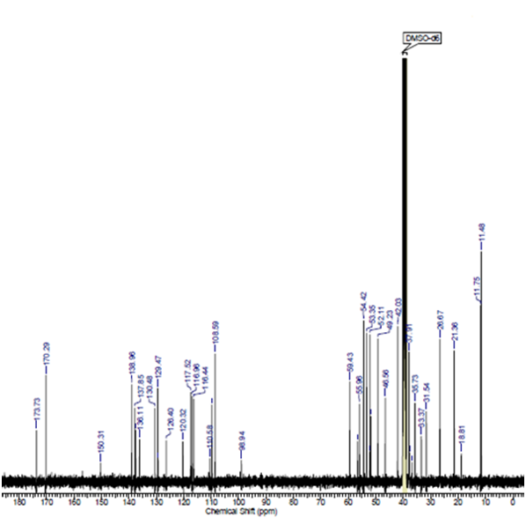
Figure S19: ¹³ C NMR (125 MHz, DMSO-d₆) spectrum of voacamine

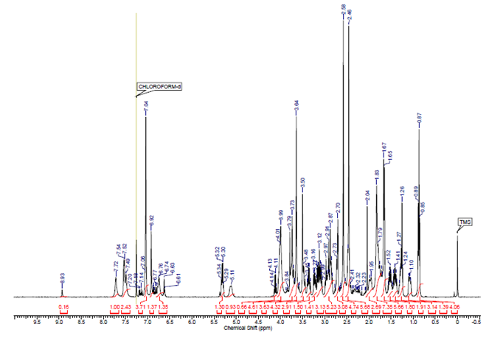
Figure S20: ¹H NMR (500 MHz, CDCl₃) spectrum of voacorine

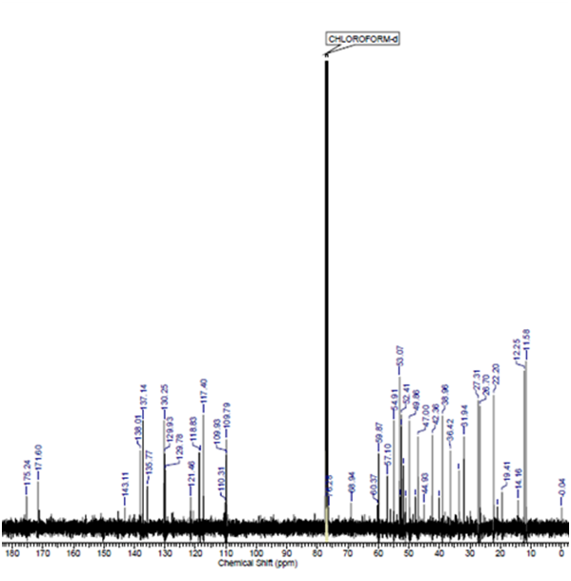

Figure S21: ¹³ C NMR (125 MHz, CDCl₃) spectrum of voacorine

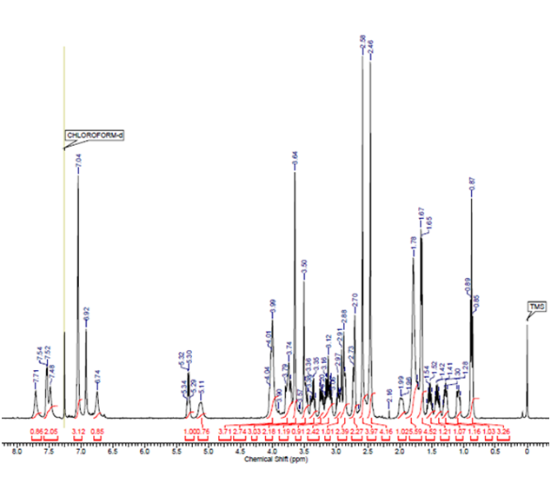
Figure S22: ¹H NMR (500 MHz, CDCl₃) spectrum of conoduramine

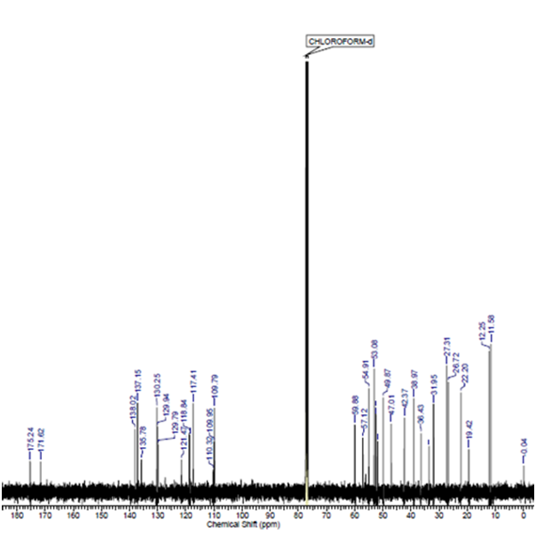
Figure S23: ¹³ C NMR (125 MHz, CDCl₃) spectrum of conoduramine

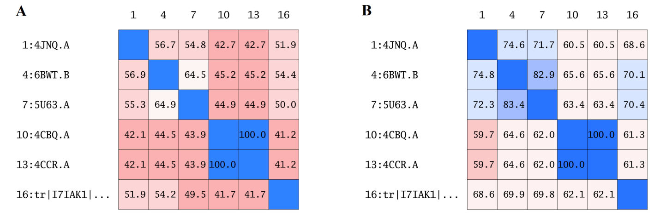
Figure S24: Percentage sequence identity and similarity values to our target

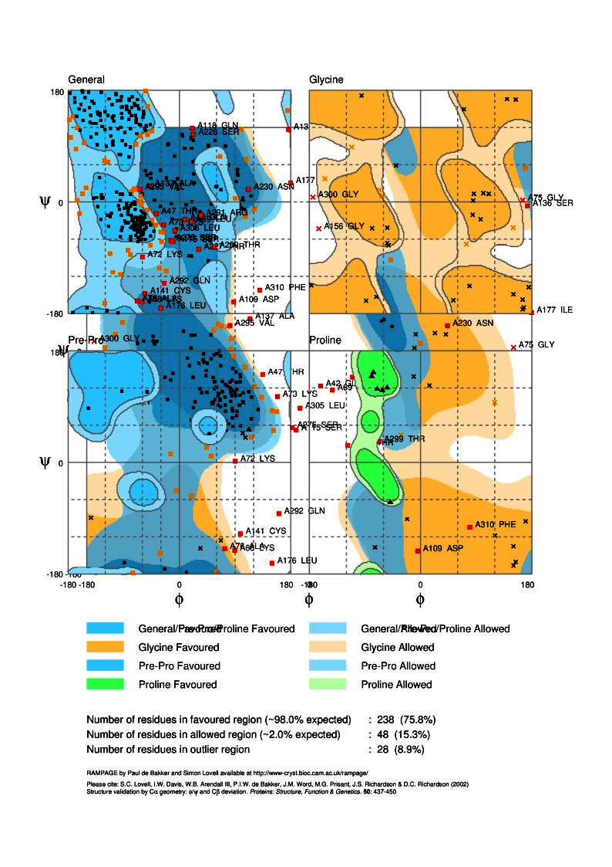
Figure S25: Ramachandran plot (φ/ψ) distribution of the backbone conformation

