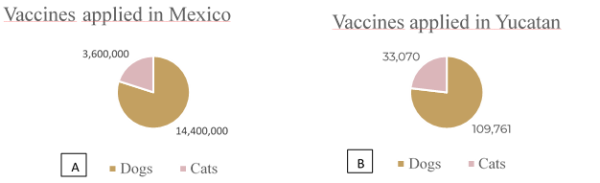
Figure S1. Vaccines applied in Mexico. Panel A. Shows the vaccines that were used in the vaccination campaigns that were carried out in the country. Panel B. Shows the number of vaccines applied in Yucatan. Despite the efforts, vaccines applied to cats represent only 6.9% of the total population of cats in the state of Yucatan in the year 2022.

