Supporting material: Overview of grasslands in Europe
Table S1: Utilized agricultural area and area of permanent and temporary grasslands in EU-28 Member States, Norway and Switzerland in 2013 (EUROSTAT 2015)
Country | UAA | Permanent grassland and meadows |  | Temporary grasses
 | 1000 ha | 1000 ha | % of UUA | 1000 ha | % of UUA
Austria | 2,727 | 1,296 | 48% | 60 | 2%
Belgium | 1,308 | 487 | 37% | 69 | 5%
Bulgaria | 4,651 | 1,271 | 27% | 1 | 0%
Croatia | 1,571 | 618 | 39% | 15 | 1%
Cyprus | 109 | 2 | 2% | 0 | 0%
Czech Republic | 3,491 | 960 | 27% | 35 | 1%
Denmark | 2,619 | 195 | 7% | 320 | 12%
Estonia | 958 | 325 | 34% | 124 | 13%
Finland | 2,258 | 31 | 1% | 640 | 28%
France | 27,739 | 8,242 | 30% | 3,140 | 11%
Germany | 16,700 | 4,621 | 28% | 360 | 2%
Greece | 4,857 | 2,102 | 43% | 111 | 2%
Hungary | 4,657 | 703 | 15% | 15 | 0%
Ireland | 4,959 | 3,916 | 79% | 652 | 13%
Italy | 12,099 | 3,316 | 27% | 1,025 | 8%
Latvia | 1,878 | 654 | 35% | 353 | 19%
Lithuania | 2,861 | 560 | 20% | 563 | 20%
Luxembourg | 131 | 67 | 51% | 12 | 9%
Malta | 11 | - | 0% | - | 0%
Netherlands | 1,848 | 773 | 42% | 210 | 11%
Poland | 14,410 | 3,206 | 22% | 216 | 2%
Portugal | 3,642 | 1,817 | 50% | 35 | 1%
Romania | 13,056 | 4,398 | 34% | 106 | 1%
Slovakia | 1,902 | 518 | 27% | 76 | 4%
Slovenia | 486 | 285 | 59% | 22 | 5%
Spain | 23,300 | 7,962 | 34% | 264 | 1%
Sweden | 3,029 | 443 | 15% | 1,131 | 37%
United Kingdom | 17,096 | 10,792 | 63% | 1,396 | 8%
EU-28 | 174,351 | 59,561 | 34% | 10,951 | 6%
Norway | 987 | 176 | 18% | 476 | 48%
Switzerland¹ | 1,048 | 620 | 59% | 131 | 13%
¹ Data from 2010

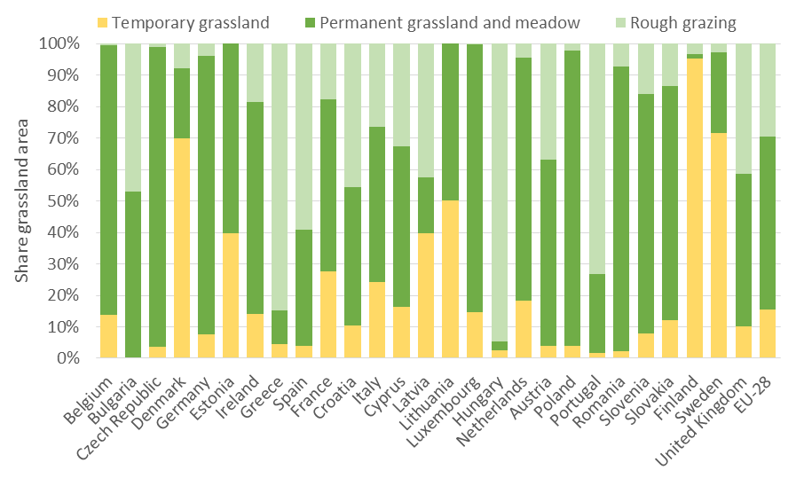
Figure S1. Distribution of grasslands by type

