Supplementary Material
Atomic-Scale Structural and Magnetic Coupling Properties of Twin Boundaries in LiFe₅O₈ film
Kun Liu *, Jiankang Li and Songyou Zhang
School of Electronics and Information Engineering, Suzhou Vocational University, Suzhou 215104, China; ljk@jssvc.edu.cn (J.L.); 92207@jssvc.edu.cn (S.Z.)
* Correspondence: 92107@jssvc.edu.cn
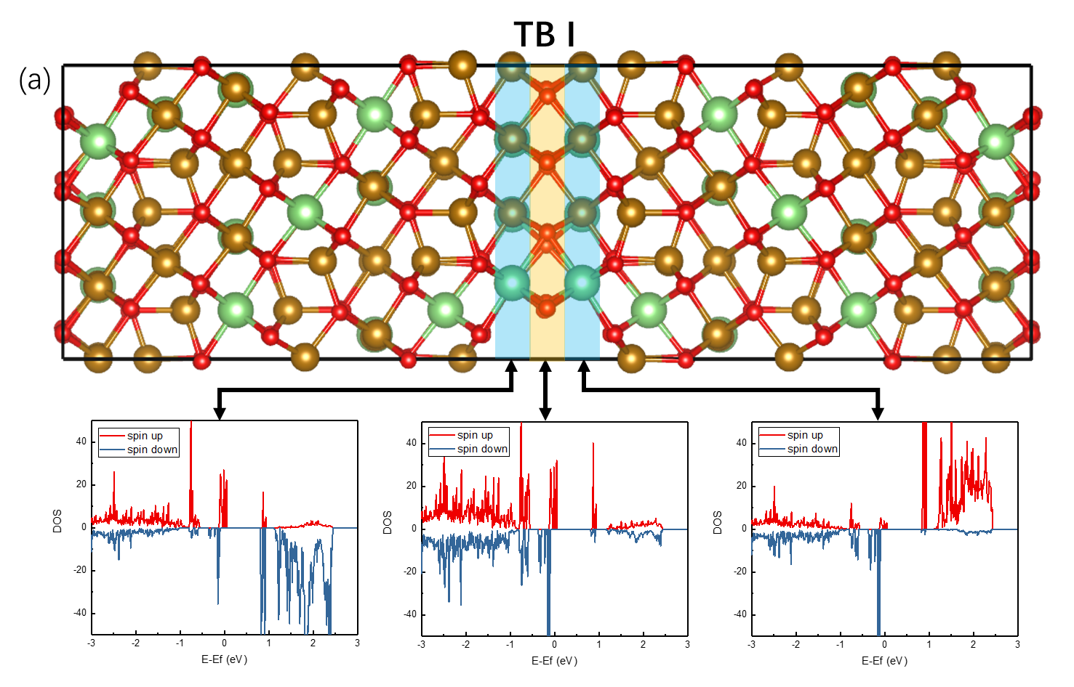
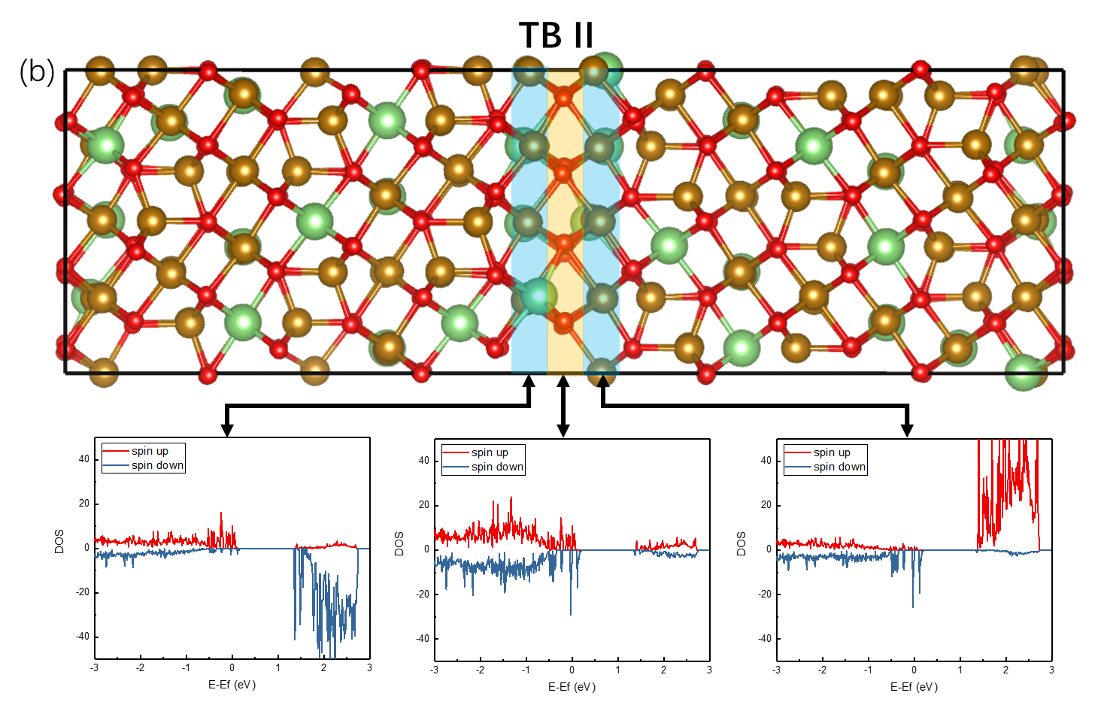
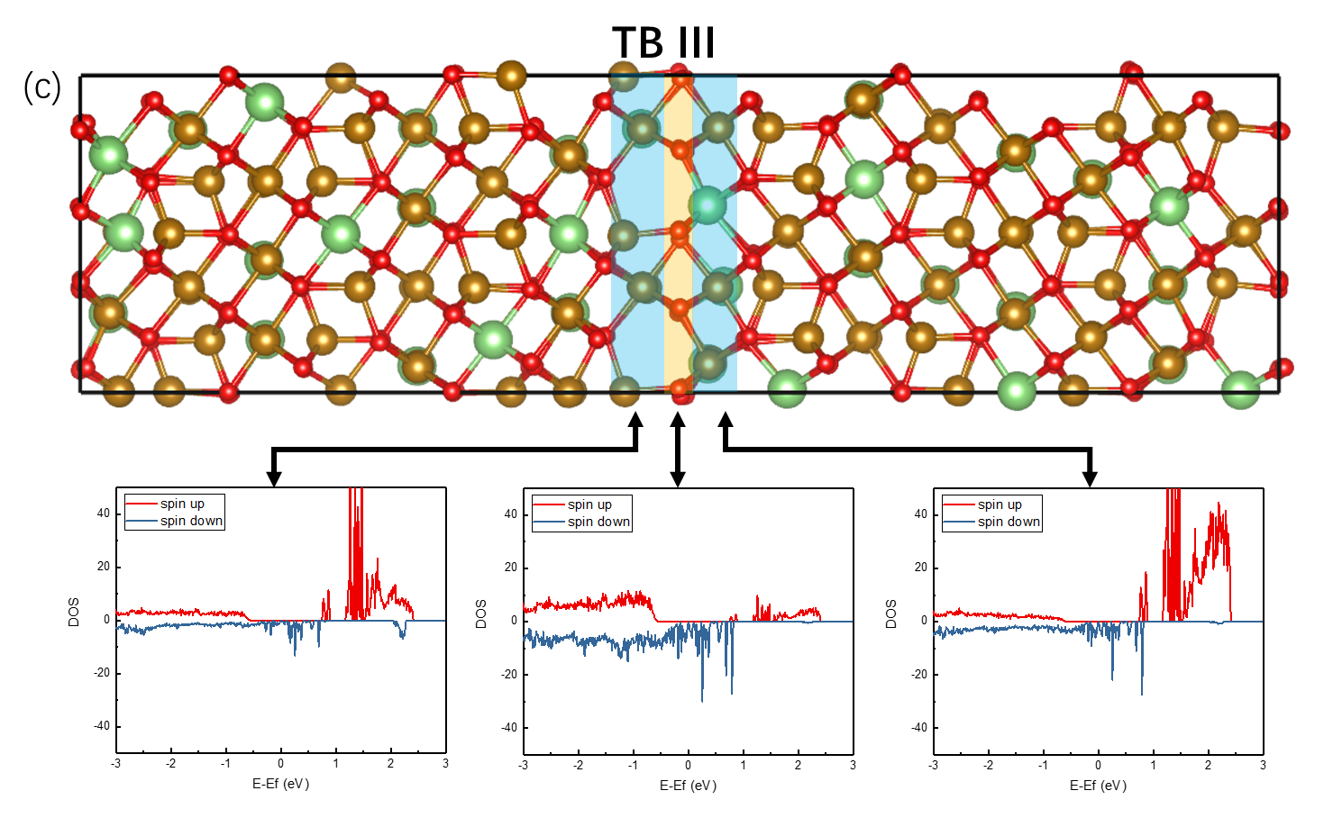
Figure S1. Spin-polarized DOS directly at the TBs. The spin polarization gradually inverts the direction across the core regions of TB I and TB II in (a) and (b), verifying their AFM coupling. The direction of spin polarization maintains unchanged across the core region of TB III in (c), indicating a FM coupling nature.

