Long term monitoring of indoor CO levels in disproportionately impacted communities in the North Denver metropolitan area

Sumit Sankhyan¹, Aniya K. Hollo¹, Dulce Gonzalez-Beltran¹, Nicholas Clements¹, Shelly L. Miller^{1,2*}

¹Paul M. Rady Department of Mechanical Engineering, University of Colorado Boulder, 1111 Engineering Drive, Boulder, CO 80309, USA
²Environmental Engineering Program, University of Colorado Boulder, 4001 Discovery Drive, Boulder, CO 80302, USA

*Corresponding email: Shelly.Miller@colorado.edu

Table of Contents

Table S1. Number of times the CO concentration level was above 9 ppm for a given house during all three cohorts. Identifiers corresponding to homes that had a gas appliance are shown in bold.

Figure S1. Monthly averages for outdoor CO data reported by the CDPHE I-25 monitoring station (AQS ID: 08-031-0027) located next to the Interstate-25 freeway. All four neighborhoods are within a 9 km radius of this monitoring station.

Figure S2. Spatial plot showing the location of all homes that were monitored for indoor CO levels during the Summer 2022 Cohort. Green dots represent homes without any occurrence of CO peak above 9 ppm. Orange, dark red and purple dots represent #times CO exceeded between 1-10 times, 11-50 times, and >50 times respectively. The location points are jittered by up to around 100 m for privacy reasons. Map source: OpenStreetMap

Figure S3. Spatial plot showing the location of all homes that were monitored for indoor CO levels during the Fall 2022 Cohort. Green dots represent homes without any occurrence of CO peak above 9 ppm. Orange, dark red and purple dots represent #times CO exceeded between 1-10 times, 11-50 times, and >50 times respectively. The location points are jittered by up to around 100 m for privacy reasons. Map source: OpenStreetMap

Figure S4. Spatial plot showing the location of all homes that were monitored for indoor CO levels during the Winter 2023 Cohort. Green dots represent homes without any occurrence of CO peak above 9 ppm. Orange, dark red, and purple dots represent #times CO exceeded between 1-10 times, 11-50 times, and >50 times respectively. The location points are jittered by up to around 100 m for privacy reasons. Map source: OpenStreetMap

Figure S5. CO concentration time series for all the homes recruited in each cohort. Panels a, b and c represent Summer 2022, Fall 2022 and Winter 2023 cohorts respectively.

Figure S6. Monthly temperature data for March 2023 reported by the nearest National Oceanic and Atmospheric Administration weather station (Denver-Central Park, CO).

Table S1. Number of times the CO concentration level was above 9 ppm for a given house during all three cohorts. Identifiers corresponding to homes that had a gas appliance are shown in bold.

Summer Cohort 2022 |  | Fall Cohort 2022 |  | Winter Cohort 2023
Identifier | #exceeded | Identifier | #exceeded | Identifier | #exceeded
2036* | 143 | 2077 | 622 | 2098 | 772
3007* | 82 | 2111 | 113 | 3065 | 95
4006 | 72 | 4020* | 94 | 2155* | 56
1035* | 57 | 2126 | 74 | 2082* | 38
2098 | 41 | 2019 | 43 | 2033* | 23
2033* | 22 | 1022 | 32 | 2169 | 21
3019 | 18 | 2036* | 30 | 2111 | 18
2054 | 11 | 3019 | 21 | 1022 | 12
1032* | 10 | 4015 | 13 | 2162* | 7
2042* | 5 | 1041 | 9 | 2126 | 6
2019 | 4 | 2018 | 4 | 1041 | 5
1022 | 3 | 3058 | 4 | 2128* | 4
2020* | 1 | 2002 | 3 | 3069* | 3
2031 | 1 | 2064* | 3 | 2049 | 3
2037 | 1 | 2004 | 2 | 3058 | 3
2021 | 1 | 3053* | 2 | 2063* | 3
2049 | 1 | 3022 | 1 | 2018 | 3
2071* | 1 | 2049 | 1 | 3027* | 2
1036* | 0 | 1048* | 1 | 2071* | 2
1056 | 0 | 2035* | 1 | 2173* | 2
2058* | 0 | 2082* | 1 | 4023* | 2
2064* | 0 | 2063* | 1 | 2019 | 2
1048* | 0 | 2071* | 1 | 1056 | 2
2035* | 0 | 2124 | 1 | 3071* | 2
2002 | 0 | 3007* | 1 | 3022 | 2
2063* | 0 | 3059* | 1 | 2166 | 2
2078* | 0 | 1027* | 1 | 2170* | 2
3028 | 0 | 3060* | 1 | 3020 | 2
2006* | 0 | 2033* | 1 | 2054 | 2
3022 | 0 | 2054 | 1 | 3007* | 2
1027* | 0 | 3017 | 1 | 1063* | 2
2087 | 0 | 3048 | 0 | 1027* | 1
2023* | 0 | 1018* | 0 | 3053* | 1
2047 | 0 | 2116 | 0 | 2116 | 1
1004* | 0 | 3028 | 0 | 2097 | 1
1018* | 0 | 2037 | 0 | 1026* | 1
2097 | 0 | 4008 | 0 | 2002 | 1
2018 | 0 | 4012 | 0 | 3060* | 1
1041 | 0 | 2097 | 0 | 2035* | 1
1030* | 0 | 3020 | 0 | 3019 | 1
1026* | 0 | 3027* | 0 | 2012* | 1
2034* | 0 | 3011* | 0 | 3011* | 1
3060* | 0 | 2021 | 0 | 3048 | 1
1001* | 0 | 2085 | 0 | 3017 | 1
1002* | 0 | 3045* | 0 | 2150* | 0
1017* | 0 | 1056 | 0 | 3005 | 0
3010 | 0 | 1036* | 0 | 2064* | 0
1029 | 0 | 3005 | 0 | 2037 | 0
3005 | 0 | 3018 | 0 | 2004 | 0
2004 | 0 | 2042* | 0 | 2124 | 0
2053* | 0 |  |  | 1018* | 0
 |  |  |  | 2080* | 0
 |  |  |  | 2156 | 0
 |  |  |  | 3059* | 0
*Information not available regarding the type of stove and heating systems used in homes.

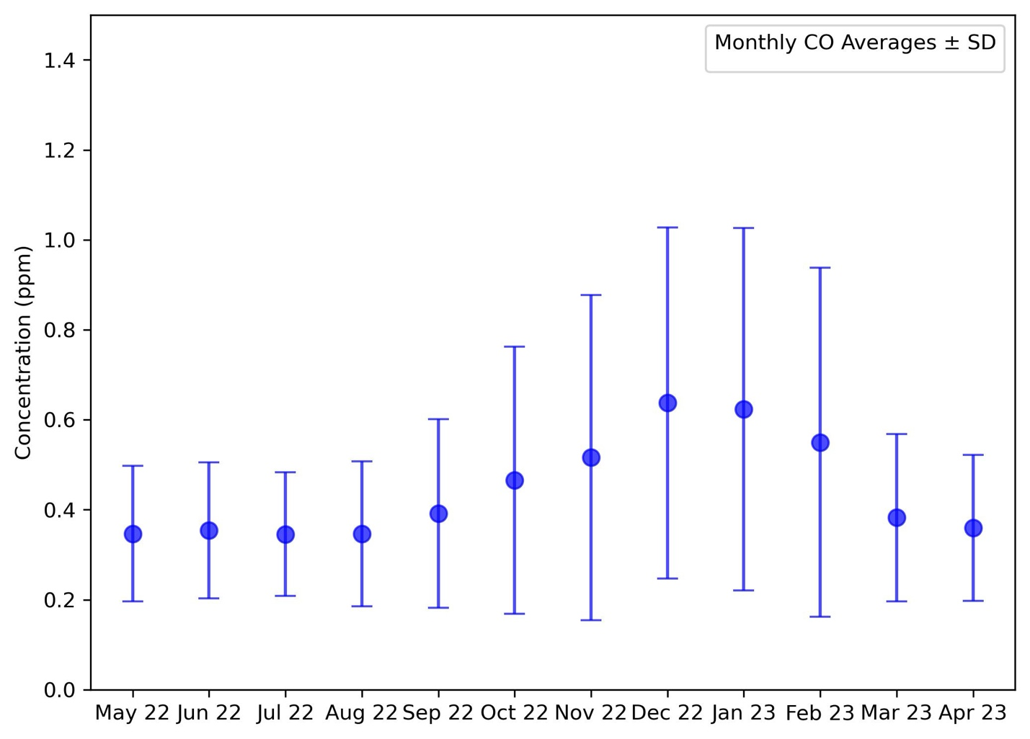
Figure S1. Monthly averages for outdoor CO data reported by the CDPHE I-25 monitoring station (AQS ID: 08-031-0027) located next to the Interstate-25 freeway. All four neighborhoods are within a 9 km radius of this monitoring station.

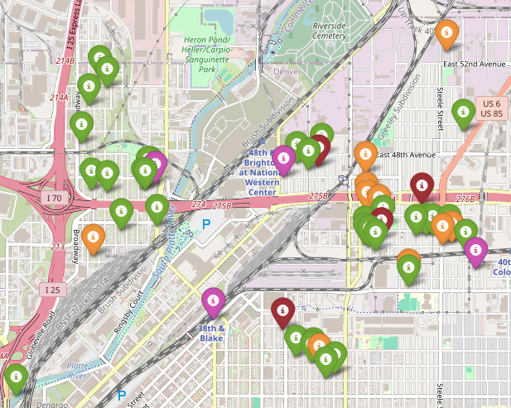
Figure S2. Spatial plot showing the location of all homes that were monitored for indoor CO levels during the Summer 2022 Cohort. Green dots represent homes without any occurrence of CO peak above 9 ppm. Orange, dark red and purple dots represent #times CO exceeded between 1-10 times, 11-50 times, and >50 times respectively. The location points are jittered by up to around 100 m for privacy reasons. Map source: OpenStreetMap

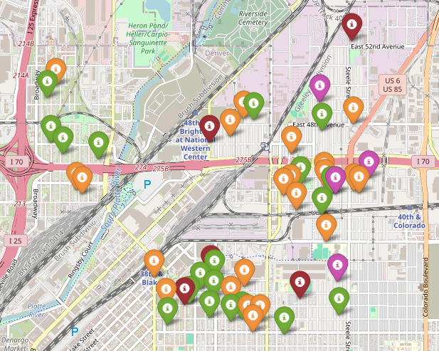
Figure S3. Spatial plot showing the location of all homes that were monitored for indoor CO levels during the Fall 2022 Cohort. Green dots represent homes without any occurrence of CO peak above 9 ppm. Orange, dark red and purple dots represent #times CO exceeded between 1-10 times, 11-50 times, and >50 times respectively. The location points are jittered by up to around 100 m for privacy reasons. Map source: OpenStreetMap

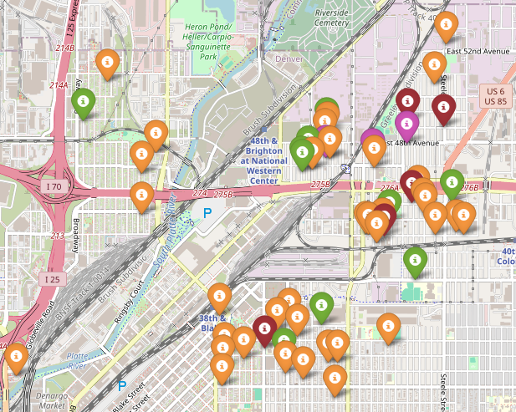
Figure S4. Spatial plot showing the location of all homes that were monitored for indoor CO levels during the Winter 2023 Cohort. Green dots represent homes without any occurrence of CO peak above 9 ppm. Orange, dark red, and purple dots represent #times CO exceeded between 1-10 times, 11-50 times, and >50 times respectively. The location points are jittered by up to around 100 m for privacy reasons. Map source: OpenStreetMap

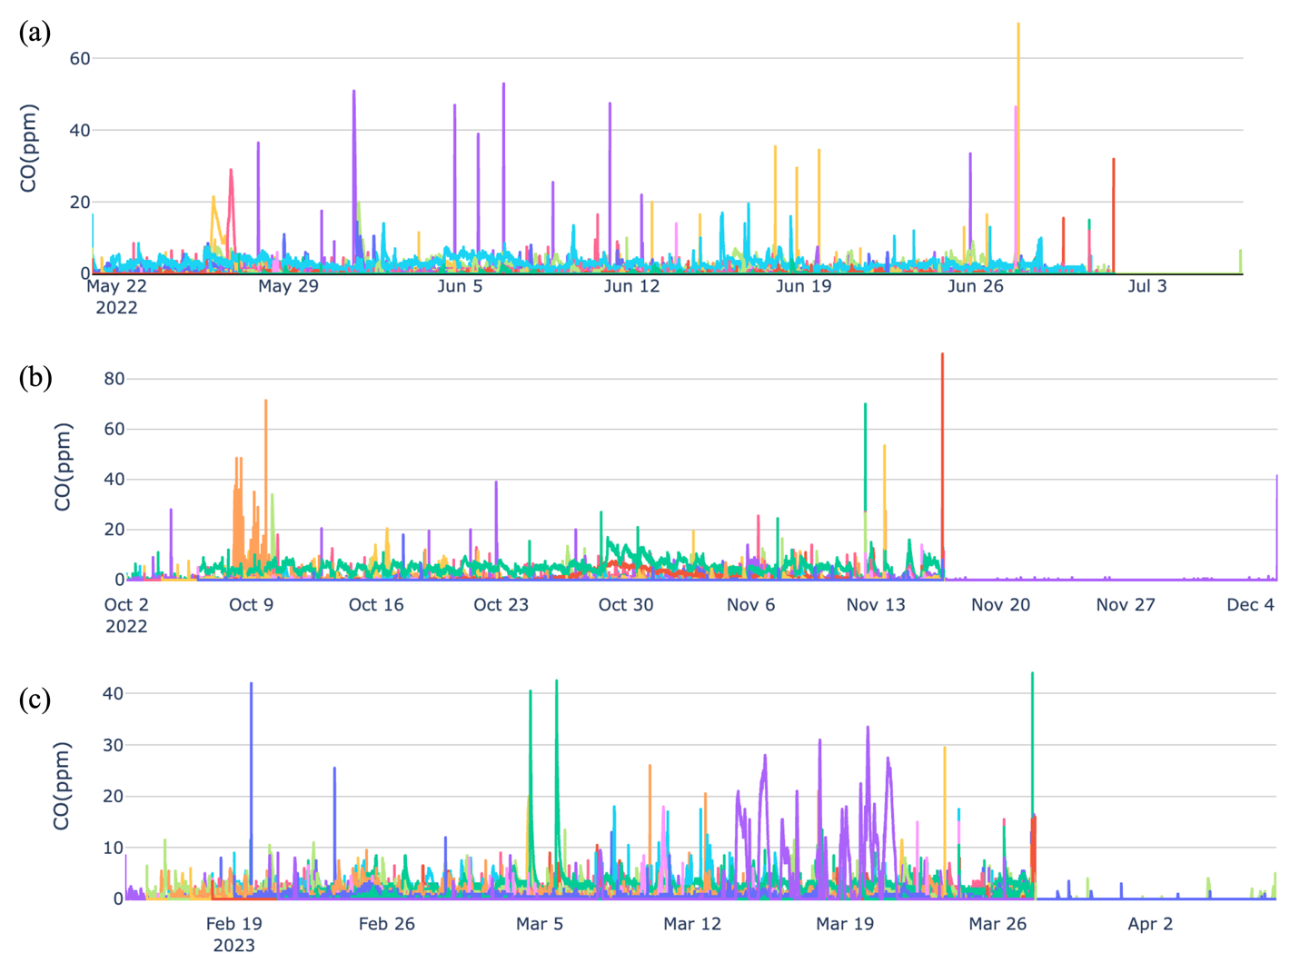
Figure S5. CO concentration time series for all the homes recruited in each cohort. Panels a, b and c represent Summer 2022, Fall 2022 and Winter 2023 cohorts respectively.

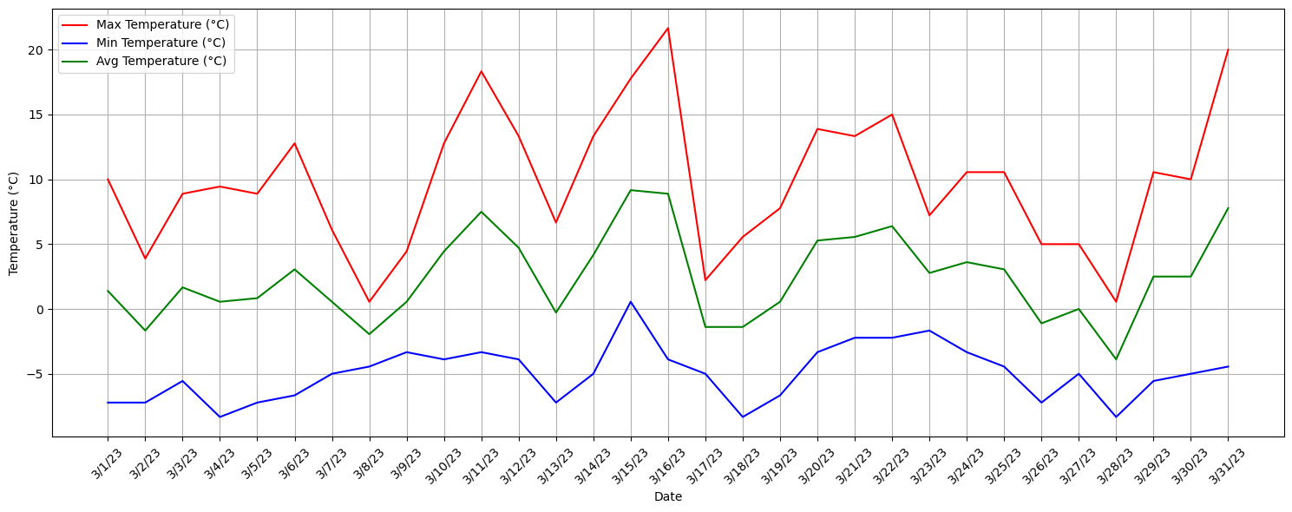
Figure S6. Monthly temperature data for March 2023 reported by the nearest National Oceanic and Atmospheric Administration weather station (Denver-Central Park, CO).

