Supporting Information
New insights into the structure of hydroxylated and alkylated glycols: a comparative X-ray diffraction, Raman and molecular dynamics study of ethane-1,2-diol, 2-methoxyethan-1-ol and 1,2-dimethoxy ethane
Lorenzo Gontrani ^{1,2,} *, Pietro Tagliatesta ², Antonio Agresti ³, Sara Pescetelli ³ and Marilena Carbone ^{2,}*
¹ Dept. of Chemistry, University of Rome La Sapienza, P. le A. Moro, 00185 Roma, Italy
² Dept. of Chemical Science and Technologies, University of Rome, Tor Vergata, Via della Ricerca Scientifica-1, 00133 Roma, Italy
³ Dept. of Electronic Engineering, University of Rome Tor Vergata, Via del Politecnico 1, 00133 Roma, Italy
* Correspondence: marilena.carbone@uniroma2.it; lorenzo.gontrani@uniroma2.it.

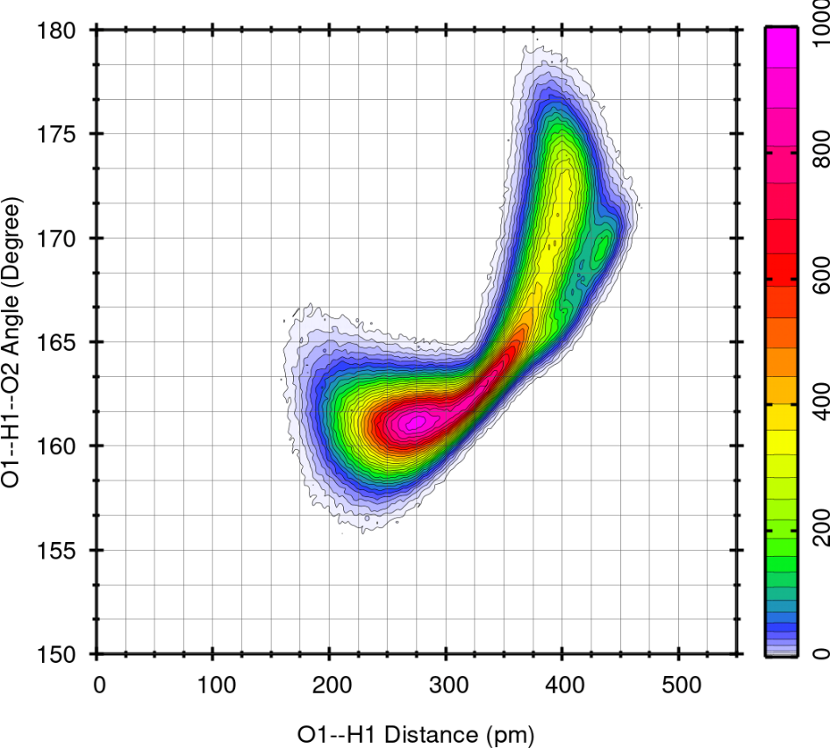
Figure S1 ME: Combined radial and angular distribution function for intramolecular H- bond
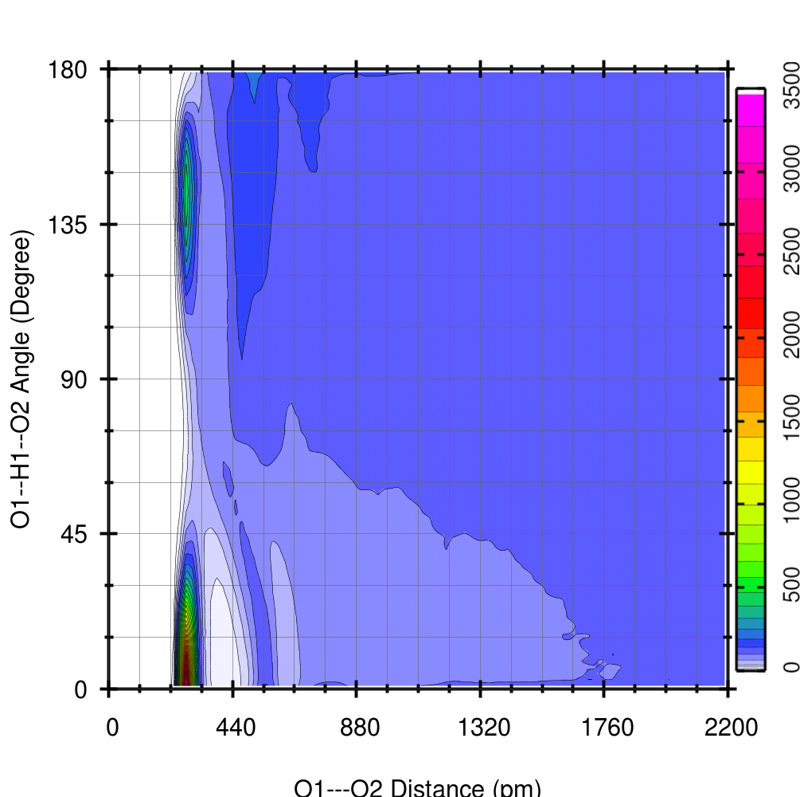

Figure S2 EG: Combined radial and angular distribution function for intermolecular H-bond

