Supplementary Materials

Bubble wrap-like carbon-coated rattle-type silica@silicon nanoparticles by surface-protected etching as hybrid anodes for lithium-ion batteries

Angelica Martino ¹, Jiyun Jeon ², Hyun-Ho Park ¹, Hochun Lee ², and
Chang-Seop Lee ^{1,}*

¹Department of Chemistry, Keimyung University, Daegu 42601, Korea
²Department of Energy Science and Engineering, DGIST, Daegu 42988, Korea

*Corresponding author: Chang-Seop Lee
Department of Chemistry, Keimyung University, Daegu 42601, Korea
Phone No: +82-53-580-5192; Fax No: +82-53-580-5056
E-mail: surfkm@kmu.ac.kr

Figure S1. FE-SEM image of (a) pure Si nanoparticles. (b) FT-IR result comparing pure Si nanoparticles and Si-OH after piranha solution pre-treatment.

Figure S2. (a) Formation of siloxane networks from piranha-treated Si-OH using APTES. (b) Hydrolysis and (c) condensation reaction mechanism of TEOS showing formation of siloxane bridges.

Figure S3. XRD patterns of (a) Si and (b) TEOS-derived SiO₂@Si and APTES/TEOS-derived SiO₂@Si.

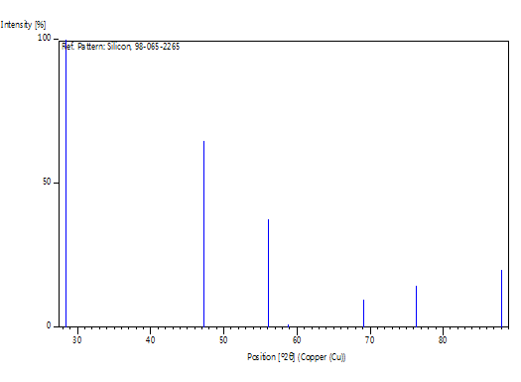
Figure S4. XRD reference peaks for face-centered cubic Si crystal (Reference code 98-065-2265)
Peak list

No. | h | k | l | d [Å] | 2Theta[deg] | I [%]
1 | 1 | 1 | 1 | 3.13559 | 28.442 | 100.0
2 | 0 | 2 | 2 | 1.92015 | 47.302 | 65.0
3 | 1 | 1 | 3 | 1.63751 | 56.122 | 37.8
4 | 2 | 2 | 2 | 1.56779 | 58.856 | 0.0
5 | 0 | 0 | 4 | 1.35775 | 69.129 | 9.8
6 | 1 | 3 | 3 | 1.24596 | 76.375 | 14.4
7 | 2 | 2 | 4 | 1.10860 | 88.029 | 19.9
Figure S5. TEM images showing carbon crosslinking from PEI and PDA carbon coating efficiency in (a, b) composite samples prepared via traditional SiO₂ sol-gel synthesis reaction and carbon coating at room temperature and (c, d) composite samples prepared via hydrothermal treatment at 140 ºC for 24 h.

Figure S6. Illustration of the two possible reaction mechanisms showing the formation of PDA-PEI carbon crosslinks.

Figure S7. Raman peak fitting of core shell PDA@SiO₂@Si composite sample.

Figure S8. Raman peak fitting of yolk shell PDA-PEI@SiO₂@Si composite sample.
Figure S9. Raman peak fitting of yolk shell PDA-PEI@PVP-SiO₂@Si composite sample.

Figure S10. Raman peak fitting of core shell PDA-PEI@SiO₂@Si composite sample.
Figure S11. CV scans of core shell PDA-PEI@TEOS-SiO₂@Si composite fabricated via RT using TEOS as precursor solution.
Figure S12. Galvanostic charge and discharge profiles of core shell PDA@SiO₂@Si (a), core shell PDA-PEI@SiO₂@Si (b), core shell PDA-PEI@PVP-SiO₂@Si (c), and yolk shell PDA-PEI@SiO₂@Si (d) composite samples.
Table S1. The I_{D}/I_{G} values of the samples calculated by the ratio of the D band peak area to the G band peak area using Gaussian-Lorentzian curve fitting model.
Sample | D band |  |  | G band |  |  | I_{D}/I_{G}
 | A | I | FWHM | A | I | FWHM
Core shell PDA@SiO₂@Si | 15244.277 | 1347.0 | 51.480 | 10940.822 | 1597.0 | 95.0 | 0.84
Yolk shell PDA-PEI@SiO₂@Si | 29685.0 | 1350.0 | 420.0 | 11177.740 | 1585.0 | 120.0 | 0.85
Yolk shell PDA-PEI@PVP-SiO₂@Si | 25087.054 | 1361.0 | 190.0 | 11283.708 | 1586.0 | 100.0 | 0.86
Core shell PDA-PEI@SiO₂@Si | 17354.846 | 1348.0 | 180.0 | 9529.654 | 1581.0 | 100.0 | 0.85

