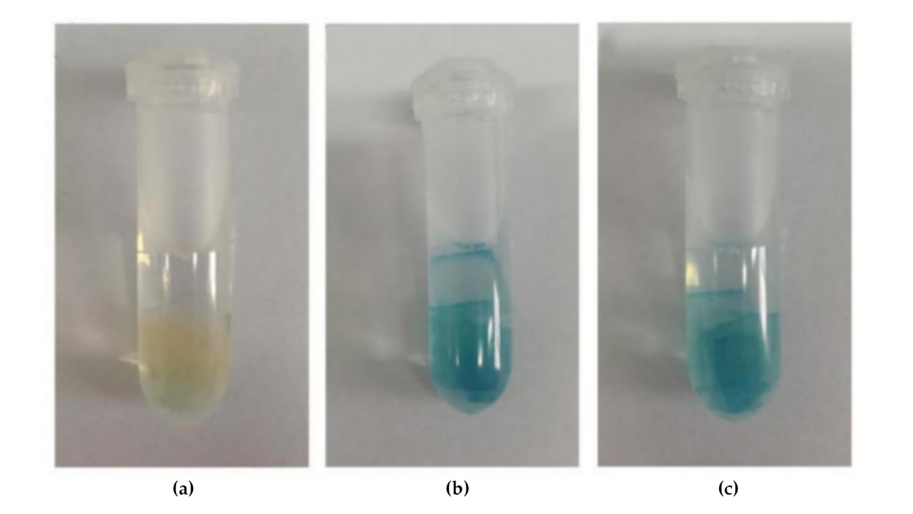
Table S1. Primers for Quantitative Real-Time PCR.
Primer | Peach Gene ID | Forward primer（5'-3'） | Reverse primer（5'-3'）
PpPG | ppa006857m | ATTGGCATCCCTAAACAG | CAAGCAACGCCTTCTATC
PpPE | ppa021753m | ACCCAGATGGATGGACAC | CGAAGCGAACAGGAACCC
Ppβ-GAL | ppa001412m | ACCAACATTGACAAACTCT | GGAGCATCATACGACTTG
PpTIR1 | ppa003344m | CTTTGTATAATTGAGCCCCGAACT | CCAATATACTCAAACGCACGATCA
PpIAA1 | ppa011843m | GATCACACAGATGCCCCTCC | GCTCCATCGACGCTTACTTTCA
PpIAA3 | ppa011755m | AGCTGCCAAAAGATGTGACCAA | CACATAAATCCCACAACCCTCC
PpIAA5 | ppa011935m | AAAGCGAAACGAAGAACCAAG | GCTCCATCCATGCTAACCTTGAC
PpIAA9  PpIAA27  PpARF2’  PpARF4  PpARF5  PpARF7  PpARF10  PpARF12 | ppa006744m  ppa007893m  ppa022314m  ppa001557m  ppa000946m  ppa000708m  ppa002082m  ppa002617m | GTATGCCACAATAGCTCGGAA  TCTTCCTCTGCCCTCTCCACA GCTCCGTGTTGGTGTTAGAC  CGGTGATGTGCTCTAATGCTACT  GAAGGGCTGCTAAATGACCCAAGA  AATTGAGCCTGTTGTAACTCC  CCAATCGGACGCTAACAAT  ACCTTTTGTGGCTTCTATACCTG | GAAGCCCAAGTCTAAGGTCTGT  AGAGACCCCAATTCCAAGTCC  GGCTTGTTCTTGGCTTGTAGTA  GCTACTCTCCTGCGGCTTATG  ATACAGCGAACACAACCAACGA  TGCCAAAGTCATCTCCAAGCCAA  GTGCCTGAACTTCCATATCTC  ATGGTTTTCACTTCTTTTGCCTT
PpTEF-2 | ppa001368m | GTTGCCTTGGTCGGTCTTGA | ATTGAACAGCAACACGCACAA
Figure S1. GUS staining to verify the success of PpTIR1 overexpression gene in an isolated peach fruit block. (a) Untreated peach fruit block (negative control); (b) peach fruit block of transient transformation in a pCAMBIA3301-121peach fruit block (positive control); (c) peach fruit block of transient transformation in a pCAMBIA3301-121-PpTIR1 peach fruit block.

