Supplementary Material
Network Biology Analyses and Dynamic Modeling of Gene Regulatory Networks Under Drought Stress Reveal Major Transcriptional Regulators in Arabidopsis
Nilesh Kumar ^{1,†}, Bharat K. Mishra ^{1,†}, Jinbao Liu ^{1,†}, Binoop Mohan ¹, Karolina M. Pajerowska-Mukhtar ^{1,‡} and
M. Shahid Mukhtar ^{1,2,3,‡,*}
¹Department of Biology, 464 Campbell Hall, 1300 University Boulevard, University of Alabama at Birmingham, Alabama 35294, USA
²Nutrition Obesity Research Center, 1675 University Boulevard, University of Alabama at Birmingham, Birmingham, AL 35294, USA
³Department of Surgery, 1808 7th Ave S, University of Alabama at Birmingham, Birmingham, AL 35294, USA
†These authors contributed equally to this work and share first authorship
‡These authors contributed equally to this work and share senior authorship
* Correspondence: smukhtar@uab.edu;
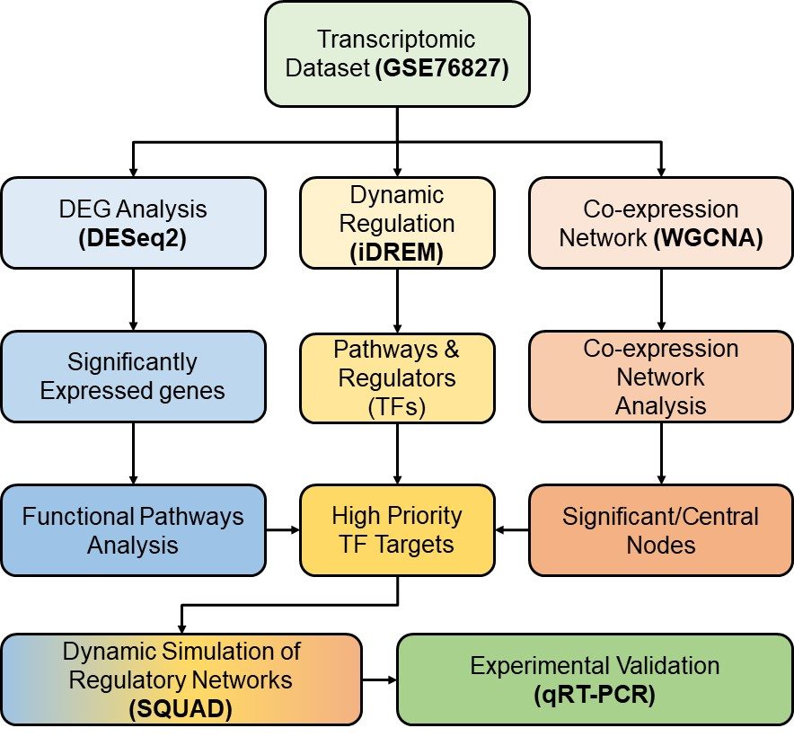
Figure 1. The pipeline describing the discovery of novel master regulators in drought.
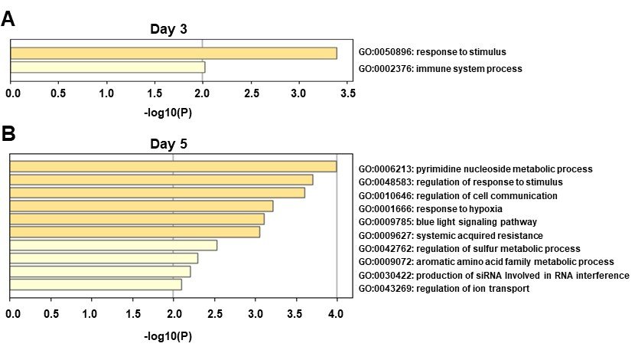
Figure S2. The gene ontology enrichment analysis of Arabidopsis unique DEGs on each (Day 3 and Day 5) after drought stress (p-value ≤0.05).
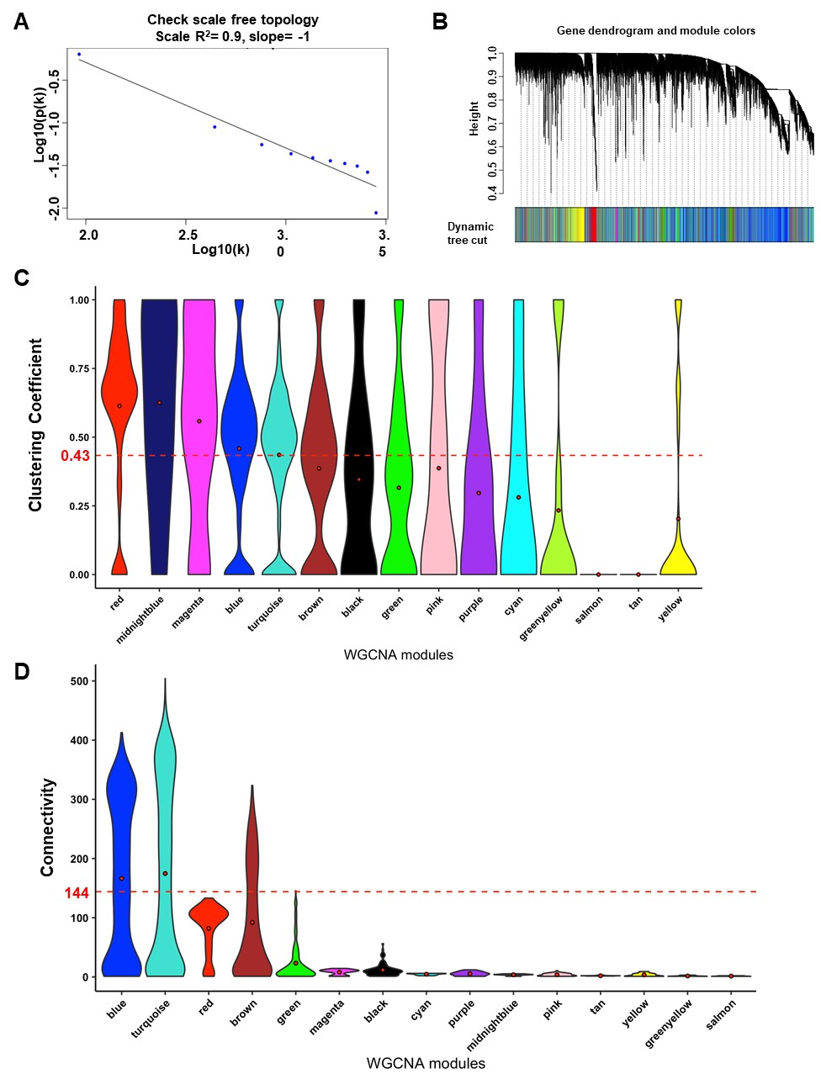
Figure S3. (A, B) The weighted gene co-expression network analysis (WGCNA) parameters for Arabidopsis drought transcriptome analysis and module identification. (C, D) The violin plot of clustering coefficient and connectivity to identify the most significant modules of ADGCN based on the cutoff of an average value of 0.43 and 144 for clustering coefficient and connectivity, respectively.
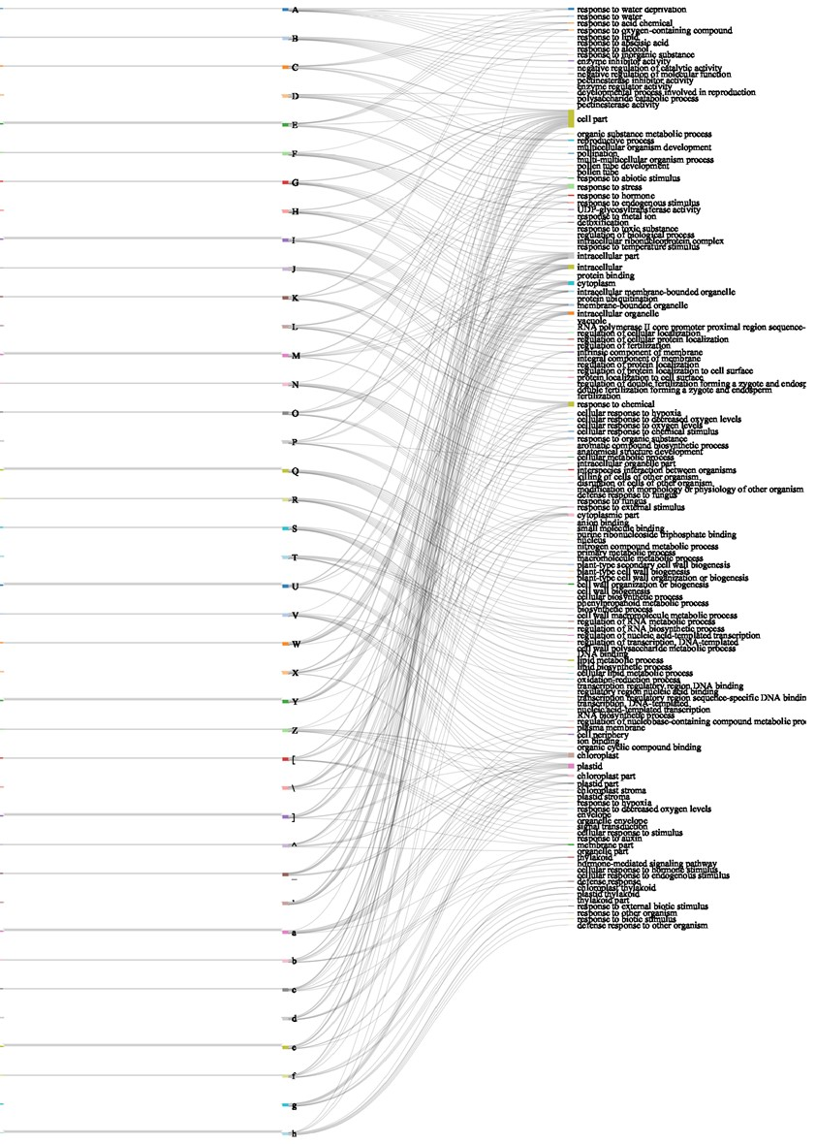
Figure S4. The iDREM analysis identified significantly enriched pathways and several TFs associated with the regulation of gene profiles in those pathways.
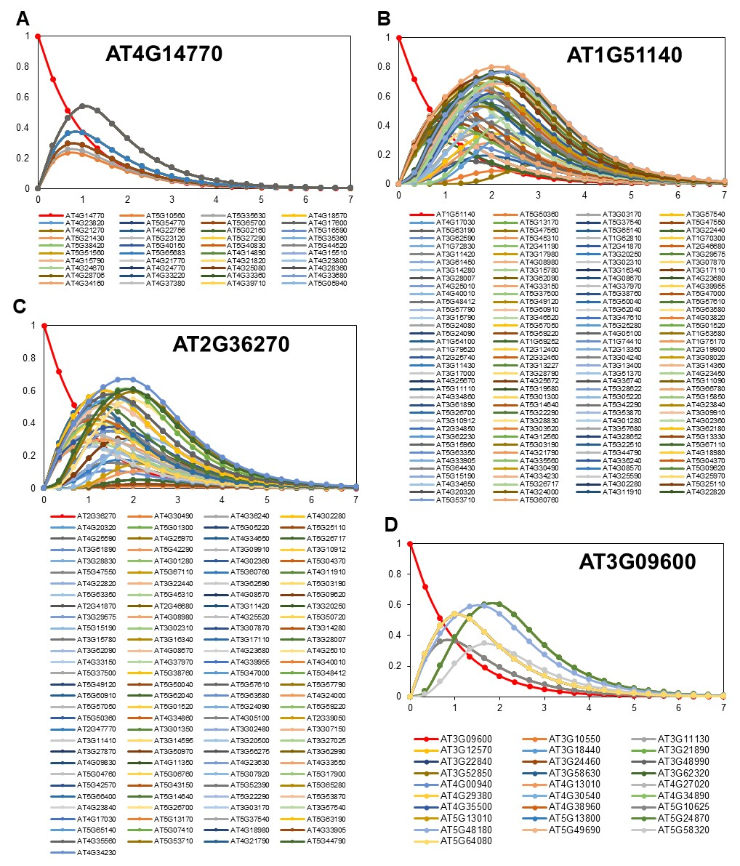
Figure S5. (A-D) The SQUAD simulation of gene activity upon the activation of TFs (AT4G14770, AT1G51140, AT2G36270, AT3G09600) in drought stress.

Supplementary Tables (uploaded as separate files):
Table S1: Gene expression, co-expression and network centrality analyses
Table S2: iDREM and SQUAD analyses
Table S3: Arabidopsis transcription factors and their targets included in experimental analyses; PCR primers list

