Supplementary material

Fig.S1 is the macro morphology of OIM@PAM intelligent inhibitor before and after immersing in different pH solution for168 h. The color and side length change of intelligent inhibitor is analyzed in manuscript.
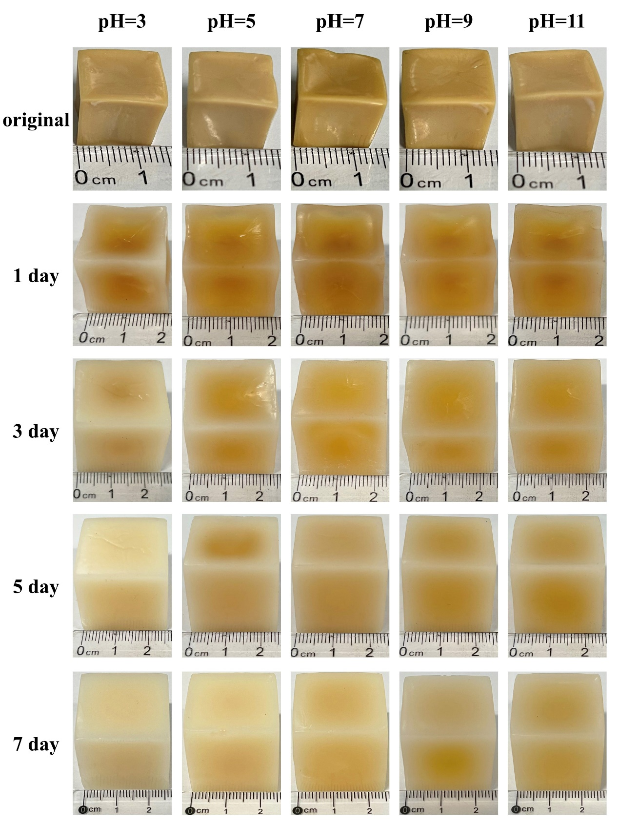
Fig.S1 The macro images of as-prepared OIM@PAM immersed in different time in 3.5%(wt) NaCl with virous pH conditions.
Table A1 is the calculated corrosion rate of L80 and the inhibitor efficiency of OIM@PAM in different pH solutions of 3.5% NaCl with and without OIM@PAM at 25 ℃. The long-term anti-corrosion performance and pH-controlled release characteristics is detailly discussed in manuscript.

Table A1 Average corrosion rate and inhibition efficiency of L80 steel in different pH solutions of 3.5%(wt) NaCl without and with OIM@PAM at 25 ℃

pH | Immersion  time (h) | Corrosion rate (mm/a) |  | Inhibition efficiency (%)
 |  | Without OIM@PAM | With OIM@PAM
3 | 24 | 0.7977 | 0.0551 | 93.09
 | 72 | 0.4124 | 0.0542 | 86.86
 | 120 | 0.2956 | 0.0421 | 85.76
 | 168 | 0.2885 | 0.0434 | 84.96
5 | 24 | 0.6786 | 0.0665 | 90.20
 | 72 | 0.3675 | 0.0530 | 85.57
 | 120 | 0.2731 | 0.0495 | 81.87
 | 168 | 0.2646 | 0.0512 | 80.63
7 | 24 | 0.3697 | 0.0434 | 88.27
 | 72 | 0.2790 | 0.0691 | 75.24
 | 120 | 0.1936 | 0.0518 | 73.24
 | 168 | 0.1921 | 0.0539 | 71.93
9 | 24 | 0.3462 | 0.0292 | 91.58
 | 72 | 0.2484 | 0.0455 | 81.78
 | 120 | 0.2039 | 0.0405 | 80.14
 | 168 | 0.1982 | 0.0464 | 76.61
11 | 24 | 0.3322 | 0.0255 | 92.31
 | 72 | 0.2612 | 0.0355 | 86.39
 | 120 | 0.2205 | 0.0420 | 80.93
 | 168 | 0.2100 | 0.0437 | 79.37

